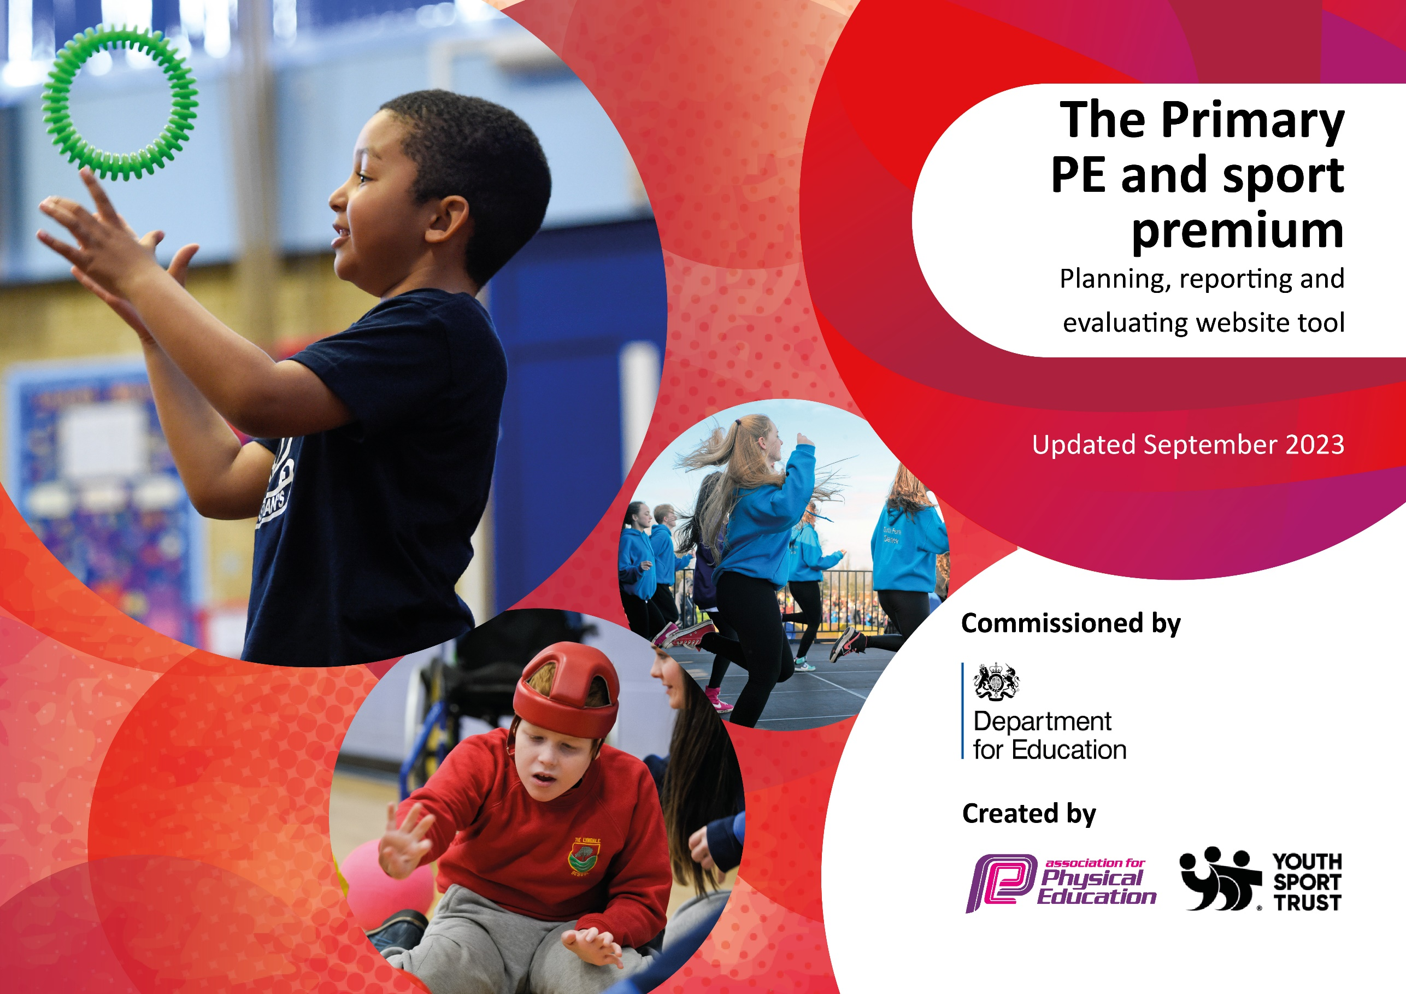

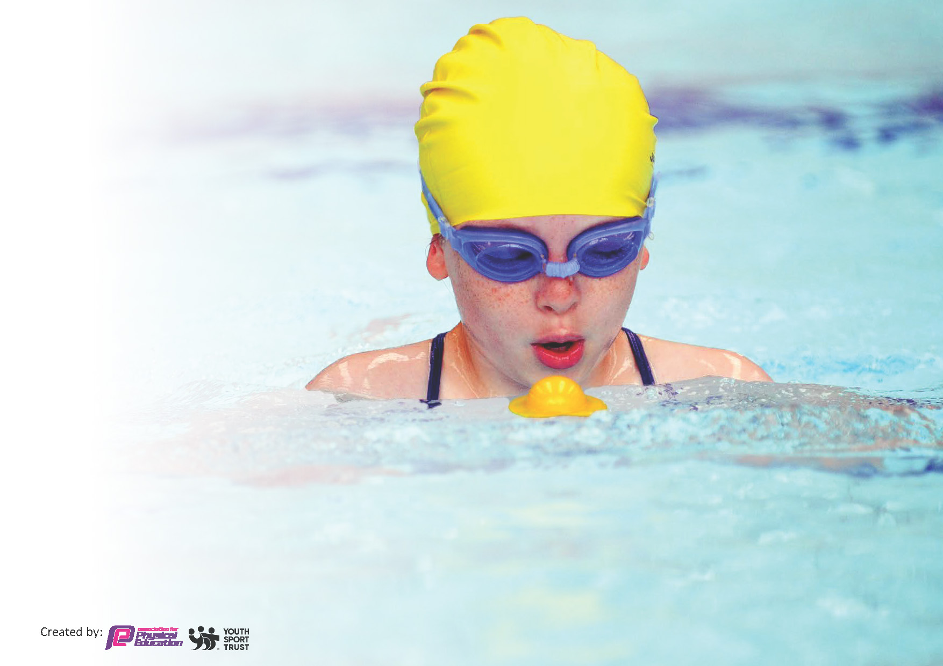
This template can be used for multiple purposes:
by:
- It enables schools to effectively plan their use of the Primary PE and sport premium
- It helps schools to meet the requirements (as set out in guidance) to publish information on their Primary PE and sport premium
- It will be an effective document to support Ofsted inspections enabling schools to evidence progress in Physical Education (PE) and evidence swimming attainment, which forms part of the PE National Curriculum. We would recommend schools consider
the Intent, Implementation and Impact of any spend, as examined within the Education Inspection Framework.

It is important that your grant is used effectively and based on school need.

Schools must use the funding to make additional and sustainable
improvements to the quality of the PE, School Sport and Physical Activity (PESSPA)
they offer. This means that you should use the Primary PE and sport premium to:

- Build capacity and capability within the school to ensure that improvements made now will benefit pupils joining the school in future years
- Develop or add to the PESSPA activities that your school already offers.

The Primary PE and sport premium should not be used to fund capital spend projects; the school’s core budget should fund these. Further detail on capital expenditure can be found in the updated Primary PE and sport premium guidance.

The Primary PE and sport premium guidance, outlines 5 key priorities that funding should be used towards. It is not

necessary that spending has to meet all the key priorities, you should select the priorities that you aim to use any funding towards.

Although completing this template is not a requirement for schools, schools are required to publish details of how they spend this funding. Schools must also outline what the impact this funding has had on pupils’ PE and sport participation and attainment and how any spending will be sustainable in the future. All funding must be spent by 31st July 2024.

The Department for Education has worked closely with the Association for Physical Education (afPE) and the Youth Sport Trust (YST) to develop this template and encourages schools to use it. This template is an effective way of meeting the reporting requirements of the Primary PE and sport premium.
Review of last year’s spend and key achievements (2022/2023)

We recommend you start by reflecting on the impact of current provision and reviewing your previous spend.

Activity/Action | Impact | Comments
62 Level 2 competitions entered this academic year through SHAPES subscription from St Helens Council.  1 Level 3 competition in Netball at Merseyside level. Children were able to access level 2 and 3 competitions/events in football, cricket, tag rugby, contact rugby, netball, boccia, kurling, indoor athletics, outdoor athletics, dodgeball, handball, multi-skills, street football, field hockey, rounders, dance, gymnastics and orienteering. Transport was required for some of these competitions in order to allow the children to participate. | Children from Y1-6 accessing competitive sports at their level. Teachers carefully selecting children for aspire (competitive), inspire (enjoyment) or celebrate (targeting the least active) competitions. Teachers selecting different children for competitions each time to allow access for all – not just the same children always attending competitions. Confidence of children attending competitions increased. Some children went on to join sports clubs as a result of attending competitions at Level 2. Achieved highest levels of participation in Level 2/3 sport during school’s history. | Huge achievement for the school and something that the PE Coordinator, leadership team and school staff are extremely proud to be a part of.
Future Gym (PE Specialists) provided extra PE lessons and interhouse sports festivals suitable for every child throughout the academic year. Class teachers to observe lessons were possible to develop own CPD. | Children received specialist teaching of physical education and were given the opportunity to use a range of equipment to develop their year group skills. The lessons delivered by the sports coaches, who have extensive subject knowledge and qualifications, ensured the children enhanced skills already taught by the class teacher in line with the schools PE Policy/Long Term Plan/Progression of Skills documentation. Provided extra CPD for class teachers who were able to observe good practice from the PE specialist. | Future Gym have complimented the school’s approach to PE brilliantly. When running competitions at Level 2, the coaches have provided an in-house competition or event linked to the same sport/topic. This helps children to feel engaged even if not selected for the school team.
Clare Marsden (Dance Specialist) provided dance lessons suitable for every child throughout the academic year. This enhanced the skills taught by the class teachers but also allowed teacher to observe lessons were possible to develop for own CPD. | Children received specialist teaching of dance to enhance their year group skills/knowledge. The lessons delivered by the dance specialist, who have extensive subject knowledge and qualifications, ensured the children developed skills in line with the schools PE Policy/Long Term Plan/Progression of Skills documentation. Provided extra CPD for class teachers who were able to observe good practice from the PE specialist. | Clare Marsden supported individual year groups in producing a dance for their class performance. Clare provides amazing expertise in this subject but also supported class teacher with extra PE sessions in other topics to allow the children more access to school sport.
Children provided with access to a gymnastic club afterschool. | Children throughout school were able to access an extra-curricular club specifically linked to gymnastics. This raised the profile of PE within the school and encouraged less active children to attend. | Future gym were able to support school further by offering after/before school clubs to again enhance our schools offer of PE.
New equipment purchased based on needs of staff and lessons. | New equipment used during lessons and children were more engaged as they love using new things. Enabled teachers to prepare better quality of lesson. | Teachers feedback helped to prepare equipment needed and is worth completing each year.
Y6 children provided with access to calm me yoga sessions prior to KS2 SAT’s examinations | The focus of the session was to ensure children took a calm approach to the exam process in Y6. The staff at Bleak Hill had promoted a ‘try your best’ culture throughout the year to ensure children were not stressed out or anxious about the exam process. This session helped to reiterate that message in a way that children found fun and unique. | Try to provide sessions again for the next Y6 cohort.

Key priorities and Planning
This planning template will allow schools to accurately plan their spending.

Action – what are you planning to do | Who does this action impact? | Key indicator to meet | Impacts and how sustainability will be achieved? | Cost linked to the action
Future Gym to deliver Sports Festivals in line with Level 2 competitions on offer in school. Future gym to also deliver extra sessions of PE to enhance the delivery from class teachers. | Pupils who take part in sports festivals or extra session of PE during the school day.  Teaching staff who observe the sports festivals or extra session of PE gain improved subject knowledge (CPD).  . | - Key Indicator 1: Increased confidence, knowledge, and skills of all staff in teaching PE and sport.  - Key indicator 2: The engagement of all pupils in regular physical activity – the Chief Medical Officer guidelines recommend that all children and young people aged 5 to 18 engage in at least 60 minutes of physical activity per day, of which 30 minutes should be in school.  - Key indicator 3: The profile of PESSPA being raised across the school as a tool for whole school improvement.  - Key indicator 4: Broader experience of a range of sports and activities offered to all pupils.  - Key indicator 5: Increased participation in competitive sport. | More pupils meeting their daily physical activity goal, more pupils encouraged to take part in PE and Sport Activities.  550+ children benefitting from competitive sports via festivals and extra PE sessions in various topics and sports.  Support for 21 teachers via individual CPD during sessions. Teachers will benefit from expertise of trained coaches and given ideas for future PE lessons. This leads to more confidence amongst teachers when delivering PE lessons and clubs in the future. | £4200.00 (Sept-Dec)  £2940.00(Jan-March) £3780.00 (April – July)  £10,920.00 (Total)
School to subscribe to the SHAPES council sports offer. This provides the school with level 2 and level 3 competitions as well as extra sporting opportunities for target groups of children (e.g. less active children). Mr Morley to keep record of children attending each competition/event and share with teacher so as many children as possible can be selected not just the more active children. | All children who agree to participate in school sport at local level (level 2) and beyond (level 3). | - Key indicator 2: The engagement of all pupils in regular physical activity – the Chief Medical Officer guidelines recommend that all children and young people aged 5 to 18 engage in at least 60 minutes of physical activity per day, of which 30 minutes should be in school.  - Key indicator 3: The profile of PESSPA being raised across the school as a tool for whole school improvement.  - Key indicator 4: Broader experience of a range of sports and activities offered to all pupils.  - Key indicator 5: Increased participation in competitive sport. | Children were able to access 64 level 2 competitions. Increased activities levels within the children who attended competitions. Aspire (competitive) competitions encouraged children to achieve the best they possibly can. Inspire competitions (enjoyment) encouraged the children to enjoy the sport they are participating in with the view to them joining a club or trying this again in school. Celebrate (targeting the least active) competitions are about enjoyment and participation for the children who do not normally participate in sport outside of school or are the least engaged when in comes to physical activity. | £749.00
School to provide transport to local competitions and regional competitions were necessary. | All children who agree to participate in school sport at local level (level 2) and beyond (level 3). | - Key indicator 3: The profile of PESSPA being raised across the school as a tool for whole school improvement.  - Key indicator 4: Broader experience of a range of sports and activities offered to all pupils.  - Key indicator 5: Increased participation in competitive sport. | Children were able to access 64 level 2 competitions. Increased activities levels within the children who attended competitions. Aspire (competitive) competitions encouraged children to achieve the best they possibly can. Inspire competitions (enjoyment) encouraged the children to enjoy the sport they are participating in with the view to them joining a club or trying this again in school. Celebrate (targeting the least active) competitions are about enjoyment and participation for the children who do not normally participate in sport outside of school or are the least engaged when in comes to physical activity. | £3230.45
Renew subscription to GETSET4PE | Pupils who participate in PE lessons at school.  Teachers who deliver the PE lessons as part of the national curriculum. | - Key Indicator 1: Increased confidence, knowledge, and skills of all staff in teaching PE and sport.  - Key indicator 2: The engagement of all pupils in regular physical activity – the Chief Medical Officer guidelines recommend that all children and young people aged 5 to 18 engage in at least 60 minutes of physical activity per day, of which 30 minutes should be in school.  - Key indicator 3: The profile of PESSPA being raised across the school as a tool for whole school improvement.  - Key indicator 4: Broader experience of a range of sports and activities offered to all pupils.  - Key indicator 5: Increased participation in competitive sport. | Primary teachers more confident to deliver effective PE supporting pupils to undertake extra activities inside and outside of school.  Pupils benefit from excellent PE lessons because of confident teaching. More pupils meeting their daily physical activity goal, more pupils encouraged to take part in PE and Sport Activities.  All pupils across experiencing physical activity/education. (550+ children) | £440.00  £495.00 (renewal cost)
Purchase equipment:  shin guards, basketballs, stop watches, footballs, tennis balls, egg and spoons, vortex howlers, sacks, playground balls, bean bags. | Pupils attending competitions have the right equipment. Pupils who engage in PE lessons and active break times benefit from quality equipment to ensure proper skill development. Pupils participating in PE lessons can take ownership of their learning on certain activities. Sports Day equipment to ensure a high-quality experience for the children. | - Key Indicator 1: Increased confidence, knowledge, and skills of all staff in teaching PE and sport.  - Key indicator 2: The engagement of all pupils in regular physical activity – the Chief Medical Officer guidelines recommend that all children and young people aged 5 to 18 engage in at least 60 minutes of physical activity per day, of which 30 minutes should be in school.  - Key indicator 3: The profile of PESSPA being raised across the school as a tool for whole school improvement.  - Key indicator 4: Broader experience of a range of sports and activities offered to all pupils.  - Key indicator 5: Increased participation in competitive sport. | All teachers benefitted from high quality equipment which enabled them to deliver outstanding PE lessons throughout the school year, into the next academic year and beyond.  550+ children benefitted from quality equipment to ensure proper skill development.  2 highly successful Sport’s Days at EYFS/KS1 and KS2. | £796.73
Renew subscription to Dance Notes | Pupils who participate in dance lesson as part of PE curriculum delivered in school.  Teachers who deliver the dance lessons as part of the national curriculum. | - Key Indicator 1: Increased confidence, knowledge, and skills of all staff in teaching PE and sport.  - Key indicator 2: The engagement of all pupils in regular physical activity – the Chief Medical Officer guidelines recommend that all children and young people aged 5 to 18 engage in at least 60 minutes of physical activity per day, of which 30 minutes should be in school.  - Key indicator 3: The profile of PESSPA being raised across the school as a tool for whole school improvement.  - Key indicator 4: Broader experience of a range of sports and activities offered to all pupils. | Primary teachers more confident to deliver effective PE supporting pupils to undertake extra activities inside and outside of school.  Pupils benefit from excellent PE lessons because of confident teaching. More pupils meeting their daily physical activity goal, more pupils encouraged to take part in PE and Sport Activities.  All pupils across experiencing physical activity/education. (550+ children) | £120.00  £216.00
Clare Marsden (Dance Specialist) | Pupils who take part in year group performances and practice dance sessions prior to performance.  Teaching staff who observe the dance sessions gain improved subject knowledge (CPD). | - Key Indicator 1: Increased confidence, knowledge, and skills of all staff in teaching PE and sport.  - Key indicator 2: The engagement of all pupils in regular physical activity – the Chief Medical Officer guidelines recommend that all children and young people aged 5 to 18 engage in at least 60 minutes of physical activity per day, of which 30 minutes should be in school.  - Key indicator 3: The profile of PESSPA being raised across the school as a tool for whole school improvement.  - Key indicator 4: Broader experience of a range of sports and activities offered to all pupils. | More pupils meeting their daily physical activity goal, more pupils encouraged to take part in PE lessons/performances.  550+ children benefitting from extra PE sessions in dance.  Support for 21 teachers via individual CPD during sessions. Teachers will benefit from expertise of a trained coach and given ideas for future dance lessons. This leads to more confidence amongst teachers when delivering PE lessons and clubs in the future.  7 high quality school performances throughout the school year featuring a variety of dances and styles. At least 6 practice sessions for all children prior to school performance. | £3040.82
Dodgeball competition | All children who agree to participate in competition provided by Mr Dagnall. | - Key indicator 3: The profile of PESSPA being raised across the school as a tool for whole school improvement.  - Key indicator 4: Broader experience of a range of sports and activities offered to all pupils.  - Key indicator 5: Increased participation in competitive sport. | 8 pupils given the opportunity to take part in specialist national dodgeball competition.  Led to better attendance at dodgeball club in following terms. | £65.00
Mindfulness – Yoga. | 60 year 6 children to benefit from 2 sessions of mindfulness yoga prior to the start of their SAT’s examinations. | - Key indicator 2: The engagement of all pupils in regular physical activity – the Chief Medical Officer guidelines recommend that all children and young people aged 5 to 18 engage in at least 60 minutes of physical activity per day, of which 30 minutes should be in school.  - Key indicator 3: The profile of PESSPA being raised across the school as a tool for whole school improvement.  - Key indicator 4: Broader experience of a range of sports and activities offered to all pupils. | 60 Y6 children given the opportunity to participate in three 45-minute sessions of mindfulness yoga to encourage a calm approach to the examinations they were due to face in May.  Sustainability: Look to complete again next time but with possible teacher observation to deliver ourselves in future. | £440.00
Total |  |  |  | £20,513.00

Key achievements 2023-2024
This template will be completed at the end of the academic year and will showcase the key achievements schools have made with their Primary PE and sport premium spending.

Activity/Action | Impact | Comments
22 competitions during Autumn Term. | 214 pupils attended level 2 competitions during autumn term. | 64 competitions completed during 23-24 academic year.  657 pupils given the opportunity to represent school from YR-6. Opportunities for level 2 sport increasing as the children get older e.g. fewer competitions at YR, greater amount of competitions offered in Y6.
14 competitions during Spring Term | 131 pupils attended level 2 competitions during autumn term.
28 competitions during Summer Term | 312 pupil attended level 2 competitions during the summer term.
New equipment | All teachers benefitted from high quality equipment which enabled them to deliver outstanding PE lessons throughout the school year, into the next academic year and beyond.  550+ children benefitted from quality equipment to ensure proper skill development.  2 highly successful Sport’s Days at EYFS/KS1 and KS2. | List of new equipment purchased: shin guards, basketballs, stop watches, footballs, tennis balls, egg and spoons, vortex howlers, sacks, playground balls, bean bags.
Future gym enhancement | 8 sports festivals 1A  20 extra PE sessions for YR-6 1A  9 sports festivals 1B  19 extra PE sessions for YR-6 1B  3 sports festivals 2A  17 extra PE sessions for YR-6 2A  3 sports festivals 2B  19 extra PE sessions for YR-6 2B  8 sports festivals 3A  12 extra PE sessions for YR-6 3A  6 sports festivals 3B  2 full days for sports days 3B  18 extra PE sessions for YR-6 3B (Support for subject leaders) | 550+ children benefitting from competitive sports via festivals, extra PE sessions.  Support for 21 teachers via individual CPD during sessions.
Dance Notes subscription | Support for 21 teachers plus ideas for dance specialist when delivering the 12 dance topics stated on the PE long term plan. Teachers feel more confident delivering the dance element of PE. | Review use of this subscription in September 2024 via staff voice to monitor the use of the subscription.
GETSET4PE subscription | Primary teachers more confident to deliver effective PE supporting pupils to undertake extra activities inside and outside of school.  Pupils benefit from excellent PE lessons because of confident teaching. More pupils meeting their daily physical activity goal, more pupils encouraged to take part in PE and Sport Activities.  All pupils across experiencing physical activity/education. (550+ children) | Reviewed via staff voice and has been an essential part of delivering the outstanding PE curriculum.
SHAPES subscription | 64 competitions completed during 23-24 academic year.  Training attended and relevant information fed back to staff via staff meeting 14/11/23. | 64 competitions completed during 23-24 academic year.  657 pupils given the opportunity to represent school from YR-6. Opportunities for level 2 sport increasing as the children get older e.g. fewer competitions at YR, greater amount of competitions offered in Y6.
Dodgeball competition | 8 pupils given the opportunity to take part in specialist national dodgeball competition.  Led to better attendance at dodgeball club in following terms. | Assess the opportunity for next year.
7 school performances from YR-Y6 | All pupils benefited from the expertise of Clare Marsden (dance specialist) who supported class teachers with their delivery of school performances. Clare helped class teachers to choreograph dance tailored to the topic or theme of the performance. 7 memorable performances for parents and the children as well as additional CPD for 21 class teachers as well as support and PPA cover staff. | To continue this offer moving into next academic year.

Swimming Data
Meeting National Curriculum requirements for swimming and water safety.
Priority should always be given to ensuring that pupils can perform safe self-rescue even if they do not fully meet the first two requirements of the National Curriculum programme of study

Question | Stats: | Further context  Relative to local challenges
What percentage of your current Year 6 cohort can swim competently, confidently and proficiently over a distance of at least 25 metres? | 75% | 6D one child was at PACE at the time of the swimming assessment. The understanding is that he completed swimming whilst there. No data was passed between schools for this children.
What percentage of your current Year 6 cohort can use a range of strokes effectively [for example, front crawl, backstroke, and breaststroke]? | 86%

What percentage of your current Year 6 cohort are able to perform safe self-rescue in different water-based situations? | 62% | Based on the data provided by Local Authority. Some dispute over how this matches up to children who can confidently swim 25 metres. The percentage is affected by absentees on the day of the assessment.
If your schools swimming data is below national expectation, you can choose to use the Primary PE and sport premium to provide additional top-up sessions for those pupils that did not meet National Curriculum  requirements after the completion of core lessons. Have you done this? | No
Have you provided CPD to improve the knowledge and confidence of staff to be able to teach swimming and water safety? | Yes | Y6 Staff and support staff given Local Authority swimming training course.

Signed off by:

Head Teacher: | Tony McCoy
Subject Leader or the individual responsible for the Primary PE and sport premium: | Robert Morley
Governor: | Diane Kenny
Date: | 04/07/2024

Key Indicators:
- Key Indicator 1: Increased confidence, knowledge, and skills of all staff in teaching PE and sport.
- Key indicator 2: The engagement of all pupils in regular physical activity – the Chief Medical Officer guidelines recommend that all children and young people aged 5 to 18 engage in at least 60 minutes of physical activity per day, of which 30 minutes should be in school.
- Key indicator 3: The profile of PESSPA being raised across the school as a tool for whole school improvement.
- Key indicator 4: Broader experience of a range of sports and activities offered to all pupils.
- Key indicator 5: Increased participation in competitive sport.

