At Bleak Hill, we promote and educate our key theme of 'No Outsiders!', where we promote equality and celebrate diversity.

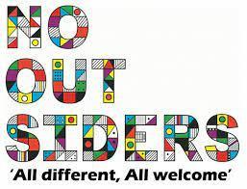
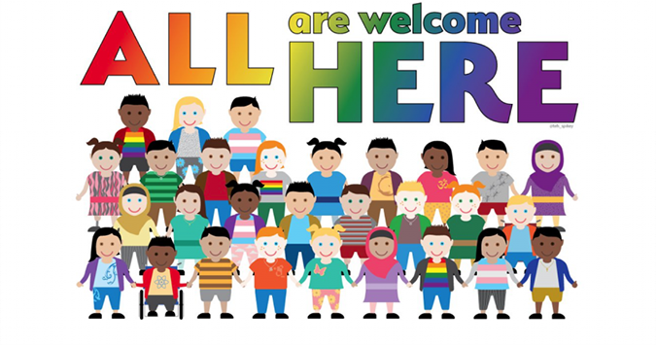
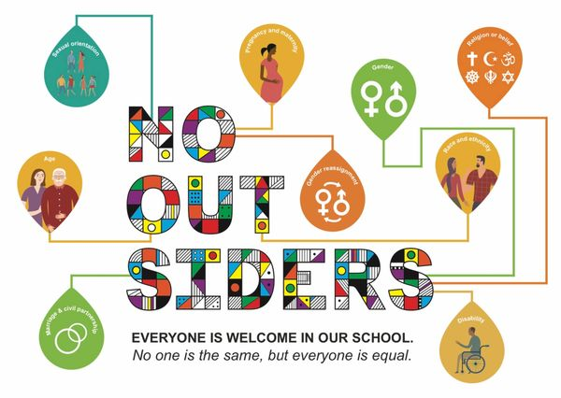

How we will achieve this ethos?

- Shared voice and language  - Weekly collective worships  - Lessons linked to text drivers  - Displays | - Praise and sanction - Behaviour Policy  - All stakeholders actively embracing  - High profile  - Celebrating Diversity

Why is this ethos so important?
The children of Bleak Hill leave us destined for the workplace, for a role in modern Britain. We want our children to champion inclusion and celebrate diversity. To feel that they never are an outsider and to welcome all that they meet. We believe that no one is born to hate - it is learnt - we need to teach another lesson to spread love and show love.

The public sector equality act duty came into force across Great Britain on April 2011 - it means that public bodies have to consider all individuals when carrying out their day to day work - in shaping policy, in delivering services and in relation to their own employees.

No Outsiders Book List Overview

In line with our ‘Golden Thread of Reading’, we support our ‘No outsiders’ themes with a variety of fantastic books.
Below is a full book list with YouTube links, where available, to the No Outsiders books. We encourage our families to look at the books in order to gain a fully informed picture of the No Outsiders scheme in school.

Term | Autumn |  | Spring |  | Summer
EYFS | 1 | 2 | 3 | 4 | 5
Book Title | The Family Book by Todd Parr | You Choose by Nick Sharratt & Pippa Goodheart | Mommy, Mamma and Me by Leslea Newman and Carol  Thompson | Blue Chameleon by Emily Gravett | Red Rockets and Rainbow Jelly by Sue Heap and Nick  Sharratt
 | 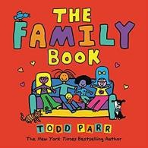 | 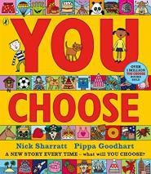 | 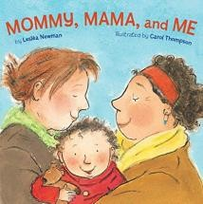 | 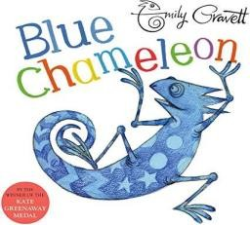 | 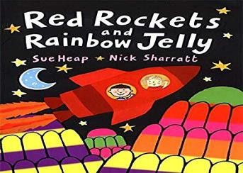
Theme | All families are  different | Pupil voice | All families are  different | Race | Accepting difference
Learning Objective | To understand that all families are  different. | To say what I think. | To celebrate my family. | To make friends with someone who  maybe different | To understand that it’s OK to like  different things.
Additional Resources  / Link | https://www.youtub e.com/watch?v=MI m_H01Z6Ss | https://www.youtub e.com/watch?v=33Jk F82zDsQ | https://www.youtub e.com/watch?v=Lt2V phobB-A | https://www.youtub e.com/watch?v=8Syi B_bcyWg | https://www.youtub e.com/watch?v=kbr Bllu2VyQ
Term | Autumn |  | Spring |  | Summer
Year One | 1 | 2 | 3 | 4 | 5
Book Title | Elmer by David McKee | Ten Little Pirates by Mike Brownlow and  Simon Rickerty | That’s not how you do it by Ariane  Hofman-Maniyar | Max the Champion by S. Stockdale | My World, your World by Melanie  Walsh
 | 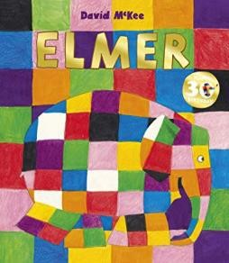 | 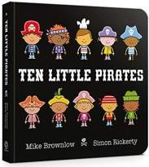 | 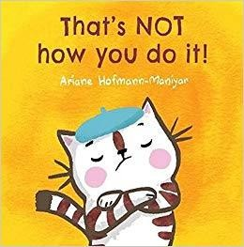 | 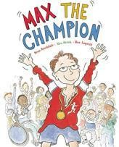 | 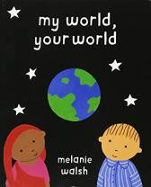
Theme | Race | Gender Equality | Accepting Difference | Disability | Race
Learning Objective | To like the way I am | To play with boys and girls | To accept people are different | To understand that our bodies work in  different ways. | To understand that we share the word  with lots of people
Additional Resources  / Link | https://www.youtub e.com/watch?v=wdy o4ykh2WA | https://www.youtub e.com/watch?v=wo9 z4azK2ZE | N/A | N/A | N/A
Term | Autumn |  | Spring |  | Summer
Year Two | 1 | 2 | 3 | 4 | 5
Book Title | The Great big book of families by M. Hoffman | The First Slodge by Jeanne Willis | The Odd Egg by Emily Gravett | What the Jackdaw saw by Julia Donaldson and Nick  Sharratt | Blown Away by Rob Biddulph
 | 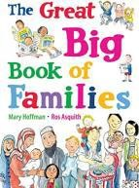 | 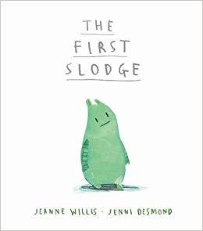 | 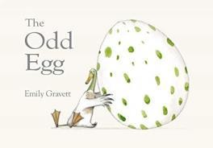 | 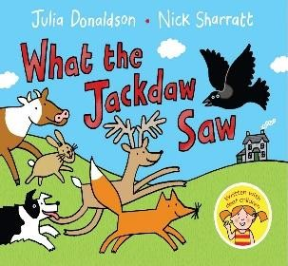 | 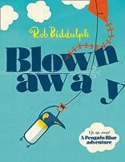
Theme | UK is diverse | Celebrate diversity | Different Families | Disability | Race
Learning Objective | To understand what diversity is | To understand how we share the world | To understand what makes someone feel  proud | To communicate in different ways | To be able to work with everyone in my  class
Additional Resources  / Link | https://www.youtub e.com/watch?v=fDp ckrBl0S8 | N/A | https://www.youtub e.com/watch?v=8LK oji2i7Cw | https://www.youtub e.com/watch?v=IDVt p8nd-zU | https://www.youtub e.com/watch?v=l5cX mbbXcQQ
Term | Autumn |  | Spring |  | Summer
Year Three | 1 | 2 | 3 | 4 | 5
Book Title | Big Bob, Little Bob by James Howe | This is our house by Michael Rosen | Two Monsters by David McKee | The Hueys in the  New Jumper by Oliver Jeffers | Beegu by Alexis Deacon
 | 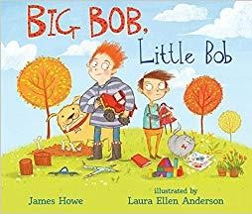 | 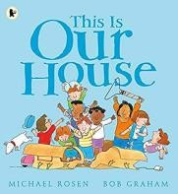 | 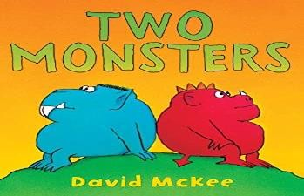 | 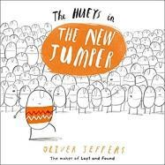 | 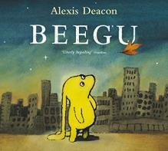
Theme | Having an opinion | Bullying/discriminati  on | Problem Solving | Be yourself/ self  esteem | Bullying, isolation
Learning Objective | To use my pupil voice | To understand what  discrimination means | To find a solution to a problem | Use strategies to  help someone who feels different | To be welcoming
Additional Resources  / Link | https://www.youtub e.com/watch?v=Ryw crzgtFJs | https://www.youtub e.com/watch?v=wf_ n6yjr9T0 | N/A | https://www.youtub e.com/watch?v=0c5l Avmj04A | https://www.youtub e.com/watch?v=D84 WWxBhbn4
Term | Autumn |  | Spring |  | Summer
Year Four | 1 | 2 | 3 | 4 | 5
Book Title | Dogs don't do ballet by A. Kemp and S.  Ogilvie | King and King by L.de Hann and S. Nijland | The Way back home by Oliver Jeffers | The Flower by John Light | Red: A crayon's story by Michael Hall
 | 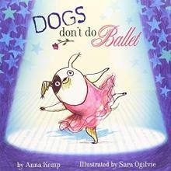 | 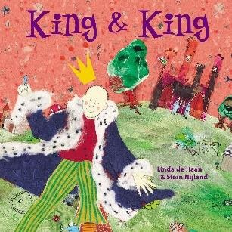 | 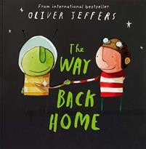 | 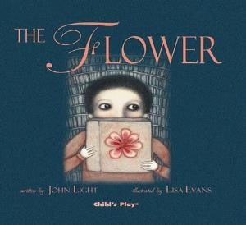 | 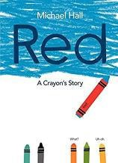
Theme | Self-Confidence | Relationships | Race | Choices | Self-Confidence
Learning Objective | To know when to be assertive | To understand why people choose to get  married | To overcome language as a barrier | To ask questions | To be who you want to be
Additional Resources  / Link | https://www.youtub e.com/watch?v=KrA WpkerZRY | https://www.youtub e.com/watch?v=lQrg WSMChuo | https://www.youtub e.com/watch?v=5bC evkUH_Go | N/A | https://www.youtub e.com/watch?v=aW hO6LY4Lbs
Term | Autumn |  | Spring |  | Summer
Year Five | 1 | 2 | 3 | 4 | 5
Book Title | Where the Poppies Now Grow by H.  Robinson and M. Impey | Rose Blanche by Ian McEwan and R. Innocenti | How to heal a broken wing by Bob Graham | The cow who climbed a tree by Gemma Merino | And Tango make Three by J.  Richardson and P. Parnell
 | 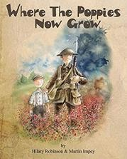 | 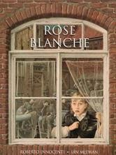 | 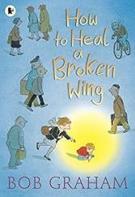 | 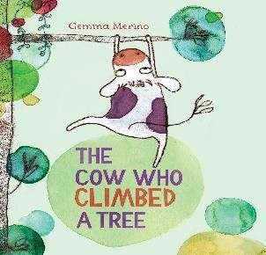 | 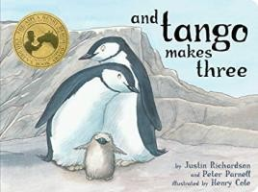
Theme | British values, age | Religion, race prejudice,  discrimination | Choosing to help | Being assertive | Prejudice, different ideas and co-  existence
Learning Objective | To learn from our past | To justify my actions | To recognise when someone needs help | To exchange dialogue | To accept people who are different  from me
Additional Resources  / Link | https://www.youtub e.com/watch?v=ZPtk O5JbTG0 | https://www.youtub e.com/watch?v=cQV gniMcuoE | https://www.youtub e.com/watch?v=- 9iPyfVmpzM | https://www.youtub e.com/watch?v=3gF 1R6QP_cE | https://www.youtub e.com/watch?v=bGZ HD4SKmQU
Term | Autumn |  | Spring |  | Summer
Year Six | 1 | 2 | 3 | 4 | 5
Book Title | My Princess Boy by  C. Kilodavis and S. DeSimone | The Thing by Simon  Puttock and Daniel Egneus | The Island by Armin Greder | Leaf by Sandra Dieckmann | Dreams of Freedom  by Amnesty International
 | 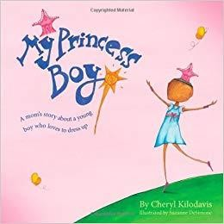 | 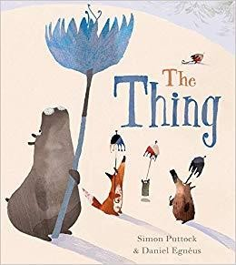 | 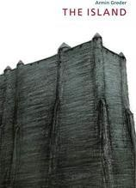 | 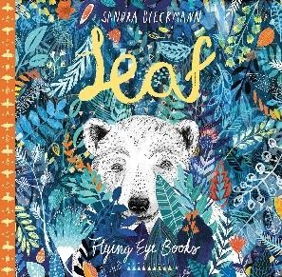 | 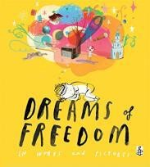
Theme | Diversity | Discrimination | Race, refugees,  prejudice | Celebrate  differences | The Equality Act
Learning Objective | To promote diversity | To welcome  difference | To challenge the  causes of racism | To overcome fears  about difference | To recognise my  freedom
Additional Resources  / Link | https://www.youtub e.com/watch?v=n0v MomKhY2Q | N/A | https://www.youtub e.com/watch?v=IqTt 2KWxZNA | https://www.youtub e.com/watch?v=nJx MruF837I | https://www.youtub e.com/watch?v=iyD7 Z32M1AA

