Below is a full book list with YouTube links, where available, to the No Outsiders books. We encourage our families to look at the books in order to gain a fully informed picture of the No Outsiders scheme in school.

Term | Autumn |  | Spring |  | Summer
EYFS | 1 | 2 | 3 | 4 | 5
Book Title | The Family Book by Todd Parr | You Choose by Nick Sharratt & Pippa Goodheart | Mommy, Mamma and Me by Leslea Newman and Carol  Thompson | Blue Chameleon by Emily Gravett | Red Rockets and Rainbow Jelly by Sue Heap and Nick  Sharratt
 | 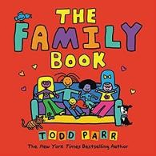 | 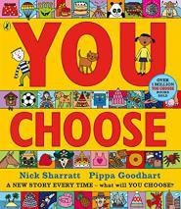 | 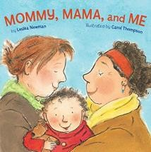 | 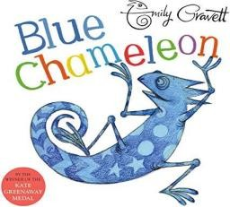 | 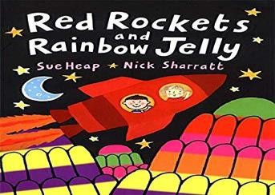
Theme | All families are  different | Pupil voice | All families are  different | Race | Accepting difference
Learning Objective | LO: To understand that all families are  different. | LO: To say what I think. | LO: To celebrate my family. | LO: To make friends with someone who  maybe different | To understand that it’s OK to like  different things.
Additional Resources  / Link | https://www.youtub e.com/watch?v=MI m_H01Z6Ss | https://www.youtub e.com/watch?v=33Jk F82zDsQ | https://www.youtub e.com/watch?v=Lt2V phobB-A | https://www.youtub e.com/watch?v=8Syi B_bcyWg | https://www.youtub e.com/watch?v=kbr Bllu2VyQ

Term | Autumn |  | Spring |  | Summer
Year One | 1 | 2 | 3 | 4 | 5
Book Title | Elmer by David McKee | Ten Little Pirates by Mike Brownlow and  Simon Rickerty | That’s not how you do it by Ariane  Hofman-Maniyar | Max the Champion by S. Stockdale | My World, your World by Melanie  Walsh
 | 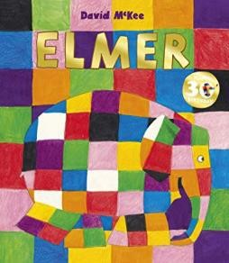 | 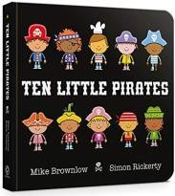 | 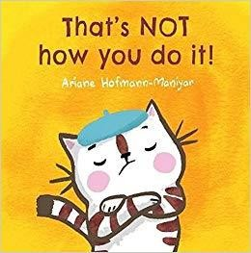 | 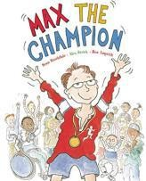 | 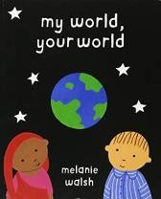
Theme | Race | Gender Equality | Accepting Difference | Disability | Race
Learning Objective | To like the way I am | To play with boys and girls | To accept people are different | To understand that our bodies work in  different ways. | To understand that we share the word  with lots of people
Additional Resources  / Link | https://www.youtub e.com/watch?v=wdy o4ykh2WA | https://www.youtub e.com/watch?v=wo9 z4azK2ZE | N/A | N/A | N/A

Term | Autumn |  | Spring |  | Summer
Year Two | 1 | 2 | 3 | 4 | 5
Book Title | The Great big book of families by M. Hoffman | The First Slodge by Jeanne Willis | The Odd Egg by Emily Gravett | What the Jackdaw saw by Julia Donaldson and Nick  Sharratt | Blown Away by Rob Biddulph
 | 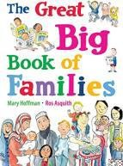 | 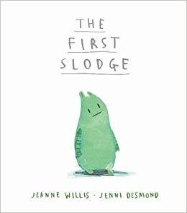 | 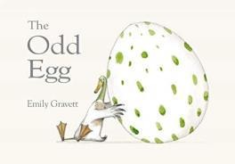 | 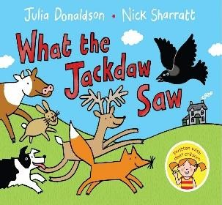 | 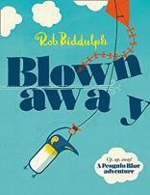
Theme | UK is diverse | Celebrate diversity | Different Families | Disability | Race
Learning Objective | To understand what diversity is | To understand how we share the world | To understand what makes someone feel  proud | To communicate in different ways | To be able to work with everyone in my  class
Additional Resources  / Link | https://www.youtub e.com/watch?v=fDp ckrBl0S8 | N/A | https://www.youtub e.com/watch?v=8LK oji2i7Cw | https://www.youtub e.com/watch?v=IDVt p8nd-zU | https://www.youtub e.com/watch?v=l5cX mbbXcQQ

Term | Autumn |  | Spring |  | Summer
Year Three | 1 | 2 | 3 | 4 | 5
Book Title | Big Bob, Little Bob by James Howe | This is our house by Michael Rosen | Two Monsters by David McKee | The Hueys in the  New Jumper by Oliver Jeffers | Beegu by Alexis Deacon
 | 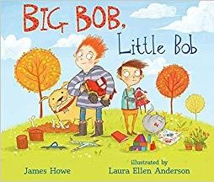 | 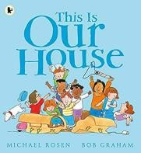 | 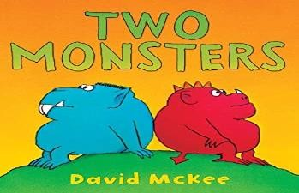 | 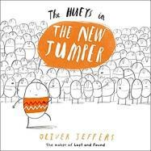 | 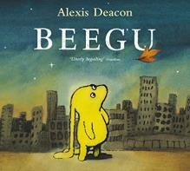
Theme | Having an opinion | Bullying/discriminati  on | Problem Solving | Be yourself/ self  esteem | Bullying, isolation
Learning Objective | To use my pupil voice | To understand what  discrimination means | To find a solution to a problem | Use strategies to  help someone who feels different | To be welcoming
Additional Resources  / Link | https://www.youtub e.com/watch?v=Ryw crzgtFJs | https://www.youtub e.com/watch?v=wf_ n6yjr9T0 | N/A | https://www.youtub e.com/watch?v=0c5l Avmj04A | https://www.youtub e.com/watch?v=D84 WWxBhbn4

Term | Autumn |  | Spring |  | Summer
Year Four | 1 | 2 | 3 | 4 | 5
Book Title | Dogs don't do ballet by A. Kemp and S.  Ogilvie | King and King by L.de Hann and S. Nijland | The Way back home by Oliver Jeffers | The Flower by John Light | Red: A crayon's story by Michael Hall
 | 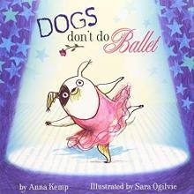 | 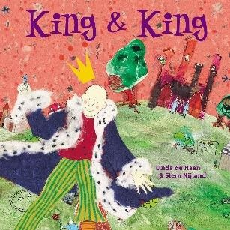 | 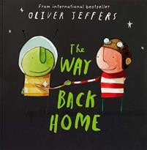 | 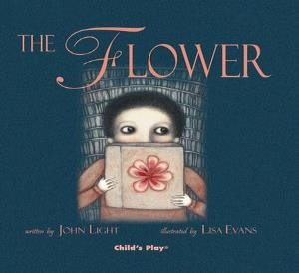 | 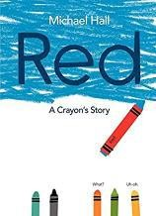
Theme | Self-Confidence | Relationships | Race | Choices | Self-Confidence
Learning Objective | To know when to be assertive | To understand why people choose to get  married | To overcome language as a barrier | To ask questions | To be who you want to be
Additional Resources  / Link | https://www.youtub e.com/watch?v=KrA WpkerZRY | https://www.youtub e.com/watch?v=lQrg WSMChuo | https://www.youtub e.com/watch?v=5bC evkUH_Go | N/A | https://www.youtub e.com/watch?v=aW hO6LY4Lbs

Term | Autumn |  | Spring |  | Summer
Year Five | 1 | 2 | 3 | 4 | 5
Book Title | Where the Poppies Now Grow by H.  Robinson and M. Impey | Rose Blanche by Ian McEwan and R. Innocenti | How to heal a broken wing by Bob Graham | The cow who climbed a tree by Gemma Merino | And Tango make Three by J.  Richardson and P. Parnell
 | 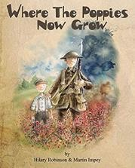 | 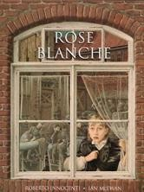 | 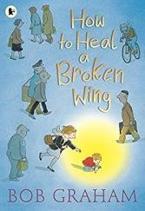 | 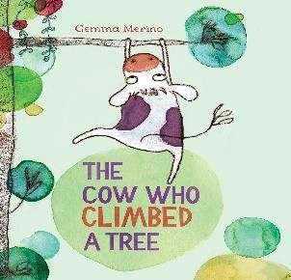 | 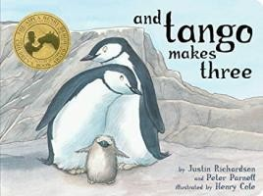
Theme | British values, age | Religion, race prejudice,  discrimination | Choosing to help | Being assertive | Prejudice, different ideas and co-  existence
Learning Objective | To learn from our past | To justify my actions | To recognise when someone needs help | To exchange dialogue | To accept people who are different  from me
Additional Resources  / Link | https://www.youtub e.com/watch?v=ZPtk O5JbTG0 | https://www.youtub e.com/watch?v=cQV gniMcuoE | https://www.youtub e.com/watch?v=- 9iPyfVmpzM | https://www.youtub e.com/watch?v=3gF 1R6QP_cE | https://www.youtub e.com/watch?v=bGZ HD4SKmQU

Term | Autumn |  | Spring |  | Summer
Year Six | 1 | 2 | 3 | 4 | 5
Book Title | My Princess Boy by  C. Kilodavis and S. DeSimone | The Thing by Simon  Puttock and Daniel Egneus | The Island by Armin Greder | Leaf by Sandra Dieckmann | Dreams of Freedom  by Amnesty International
 | 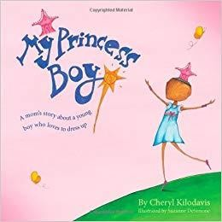 | 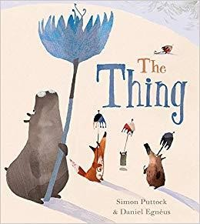 | 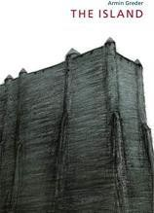 | 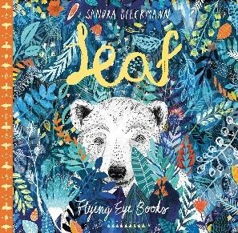 | 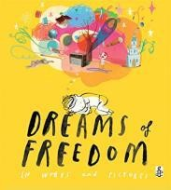
Theme | Diversity | Discrimination | Race, refugees,  prejudice | Celebrate  differences | The Equality Act
Learning Objective | To promote diversity | To welcome  difference | To challenge the  causes of racism | To overcome fears  about difference | To recognise my  freedom
Additional Resources  / Link | https://www.youtub e.com/watch?v=n0v MomKhY2Q | N/A | https://www.youtub e.com/watch?v=IqTt 2KWxZNA | https://www.youtub e.com/watch?v=nJx MruF837I | https://www.youtub e.com/watch?v=iyD7 Z32M1AA

