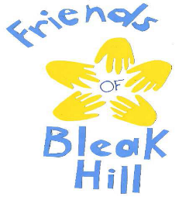

Friend of Bleak Hill Primary School
PTA Annual report & accounts 2022-2023

Introduction from the PTA Chair

This year has seen a number of events running in a more "business as usual" fashion following the interruptions from Covid over the last couple of years.

We held a number of successful events with the Easter & Christmas bingo being sold out quickly, the gala went well despite the rain, the introduction of discos has proved popular too. The Christmas fair also went well with the Santa Grotto.

We committed expenditure to Ipads, a new pergola, some miscellaneous items and the wellbeing area. We have also committed to cover expenditure for Altru to do a performance for the whole school in December 2023. We bought a mud kitchen for the EYFS years which was partially funded by them. We agreed to fund a PA system for sports day and other events.

Thanks to the staff that continue to support the Friends of Bleak Hill and the very small number of parents that are involved in making events happen.

I have enjoyed my time as Chair of the Friends of Bleak Hill over the last 9 years and due to other commitments will be stepping down at the end of this year. I will of course pop in to help out where I can but it’s time for parents that have children in school to become more involved. I really hope that the new intake of children sees an influx of new committee members for the group.

Lisa Marsh (Chair)

Our financial donations to the school
In total the PTA gave £14,298 during the 2022-2023 year. The school invested these funds in:
- Ipads £4,928
- Pergola £6,319 (inc. £2000 grant from Windle United Fund- thank you for their contribution)
- Wellbeing area £134
- Misc- £174
- New PA system £2,144
- Javelins for sports day £95 and £152 for basketball hoop (from a sports day grant from Spar, thank you for their contribution)
- Bookmarks to celebrate the Kings coronation £352

Fundraising
As set our above, one of the significant ways the PTA can support the school is by generating additional funds- but we combine our efforts with fun whenever possible, to enrich our children’s experiences at school. This section provides an update on key fundraising initiatives across the last academic year.
Glow fit disco
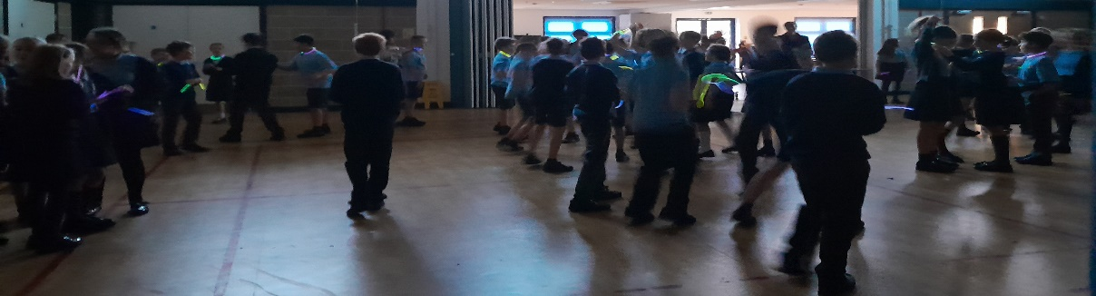
This was the first time we’ve run this event and everyone seemed to have lots of fun. Thanks to Lisa, Lisa and Helena for helping at the event.
To the staff that stayed for the disco- may we also extend a big thank you as we appreciate that you were staying to help the event run smoothly. For this event we raised £1,497.
Christmas shopping night
This is always a great night for everyone involved including the local community. We’d like to extend a special thanks to Marina Cottam for all her hard work in organising and making the event such a success. Father Christmas was in attendance to give his seal of approval and the event raised £1662 as well as being lots of fun. Lots of positive feedback received from the 29 paid stalls and from parents of the school
Christmas/Easter Bingo
As usual the Christmas bingo was well attended, it is always a sell out event. Everyone seems to have lots of fun- adults and children. Thanks to the teachers who helped at this event and we’d be lost without Mr Morley being the bingo caller so thank you all. We made £1353 at the Christmas event. Roll on Easter!
Easter bingo was great, although sad for our yr 6 children and parents as this will be their last one unless they have siblings in the school. Well attended, lots of teachers helping so thank you. We made £1511 at this event.
Eco-School uniform
Huge thanks to Mike and Esther for taking this on and organising the sales from their home and at all school events attended within the year. It’s a great way to recycle and reuse and also raise some money for school whilst being kind to the environment and parents pockets. This Financial year we have raised £825.50
Summer Fair
The weather wasn’t on our side this year, after 6 weeks of glorious weather, it rained all day. Thanks to the handful of parents who helped set it up, it’s a long day but the smiles on the childrens faces make it all worth while. We utilised both halls and 3 classrooms for this event. Lots of positive feedback in spite of the weather. We made £2434 for the school at this event plus £177 at an after school sale.

Regular fundraising throughout the year, other funds
We can’t conclude the fundraising report without thanking everyone who has supported us with donations this year. Thank you for donations through schoolpay that can be added at any time through the year (did you know we can claim a further 25% on this amount through gift aid? Please see reception to fill out a form)
We would like to thank everyone who uses Easy Fundraising- this site has raised £800 for the PTA since we’ve started via everyone’s online shopping. This is an ongoing source of funds throughout the year. If you haven’t signed up, you can access our case page here and build up funds for the PTA whenever you shop online.
https://www.easyfundraising.org.uk/causes/friends-of-bleak-hill-st-helens/?invite=7NZFK9&referral-campaign=c2s&utm_source=ew5sharebox
Plus every time you shop on Amazon, we receive a donation which doesn’t cost you a penny. So win win you get great deals on Amazon and we get a donation to help school. Please sign up below if you haven’t already. CEASED AS OF APRIL 2023
https://smile.amazon.co.uk/ch/702242-0
Stikins- These are useful stickers that can be put on school clothes, shoes, lunchboxes, etc. They are not limited to children either, they’re great to label clothes for care home residents etc aswell.
https://www.stikins.co.uk/
School number 35817
Amazon wishlist- items have been added that would be used in classrooms or for whole school use, please check it out https://www.amazon.co.uk/hz/wishlist/ls/2AX8U3RM4NGZD?ref_=wl_share

The 2022-2023 PTA team
We really need some more additional active members of the PTA to enable us to carry on providing fun activities and raising much needed money for the school. This year most of the events were run by 5 or less people, this cannot be sustained long term. Supporting even one event will help us considerably.

Chair & charity trustee Lisa Marsh
Treasurer & charity trustee Laura Ashton
Buying officer & charity trustee Lisa Moore
Head & Charity trustee M Lawrenson
School Business Manager & Charity trustee L Knapper
Deputy head & charity trustee C Dagnall
Committee members Mike Hindley, Emma Oakes, Helena Constantinou, Janice Herbert

Accounts for the financial year ending 31st August 2023
Income £29,728.57
Donations received £1,529.75
Uniform donations £825.50
Gross takings from events £24,896.23
Other income £2,477.09

Payments £21,738.33
Money to school £14,298.62
Admin Costs (insurances, etc) £190.25
Purchases/prizes for events £7,249.46

Assets at year end £24,474.36
Cash in hand and in bank £24,474.36
Debtors £0

