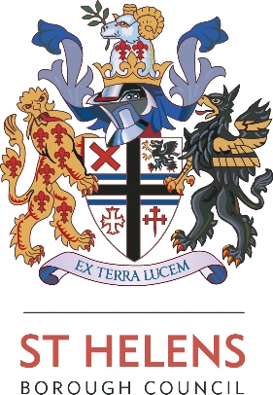

BEING THE LOCAL EDUCATION AUTHORITY

INSTRUMENT OF GOVERNMENT: COMMUNITY PRIMARY SCHOOL

1. The name of the school is Bleak Hill Primary School.

2. The school is a Community Primary School.

3. The name of the Governing Body is The Governing Body of Bleak Hill Primary School.

4. The Governing Body shall consist of:-

(a) 2 Parent Governors

(b) 1 LA Governors

(c) 1 Staff Governor

(d) The Head Teacher

(e) 7 Co-opted Governors

5. Total number of Governors : 12

6. The Head Teacher to give written notice that s/he chooses not to be a Governor).

7. The term of office of all Governors is four years.

8. This Instrument of Government comes into effect on 1st October 2020.

9. This Instrument was made by order of the St. Helens Council Local Education Authority on 22nd October 2020 to comply with Part 5 (Regulations 26-31) of the School Governance (Constitution) (England) Regulations 2012.

