Year 5
Anglo Saxons and Vikings

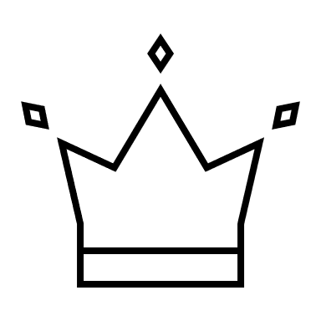
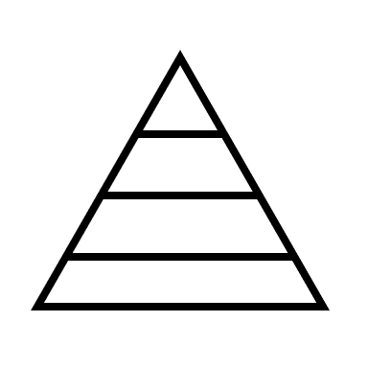
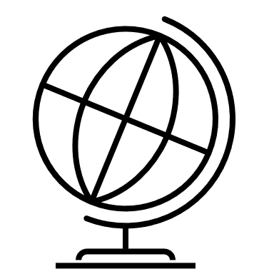
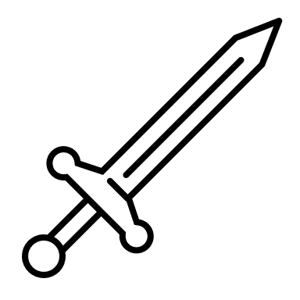

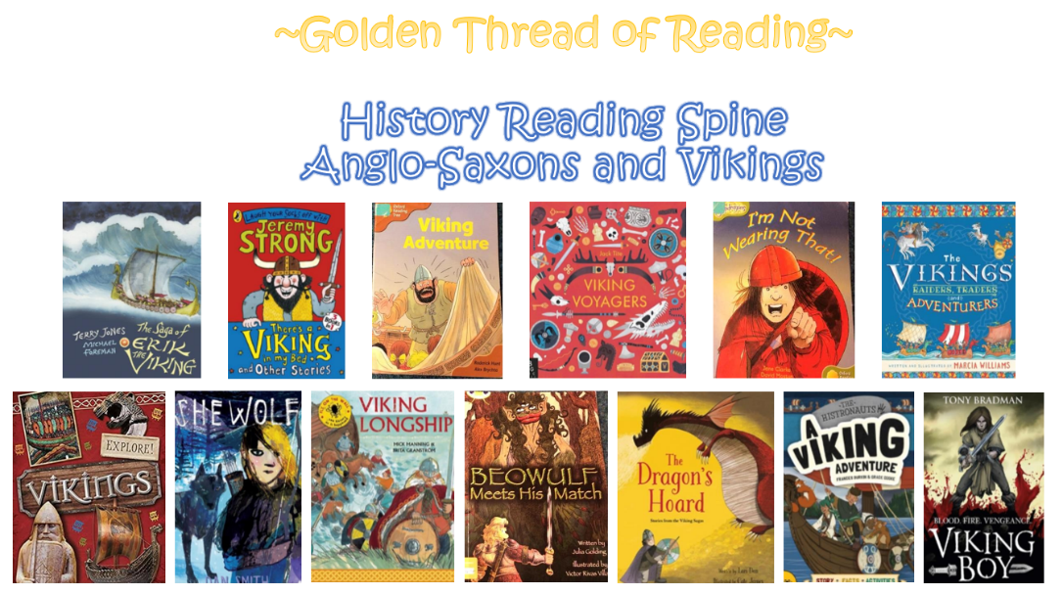

Where am I in History?
What came before?
What comes next?

Key words

History | Year 5 | Vikings and Anglo Saxons
Skills covered this half term:
- Compare two or more historical periods, explaining things which changed and things which stayed the same.
- Explain how Britain may have learned from other countries and civilisations – the Vikings or Anglo-Saxons.
- Understand that historical sources might reflect different viewpoints and explain the arguments for and against each point of view.

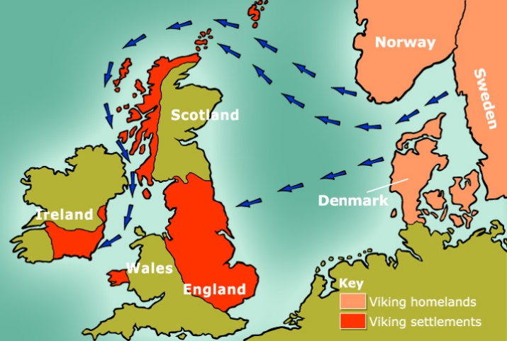
The Vikings came from the modern Scandinavian countries Denmark, Sweden, and Norway.

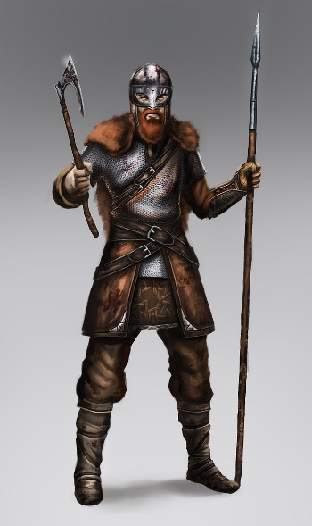

The Vikings raided places like monasteries as they looked for expensive items to pillage so they could trade them away. They were looking for valuable goods like gold and jewels.

Key Vocabulary
Danegeld | Paying the Dane. King Ethelred paid the Vikings 4500kg of silver but they kept coming back for more and were paid 22,000kg altogether.
Exile | To be sent away.
Invade | To enter and occupy land.
Kingdom | An area rules by a king.
Longship | A long, wooden narrow boat used by the Vikings.
Outlawed | Having all property reoved and no longer being able to live in the community.
Pagans | A religion where many gods and goddesses are worshipped.
Pillaged | To violently steal something.
Raid | A surprise attack.
Wergild | A payment system used to settle disputes between a criminal and the victim or their family.

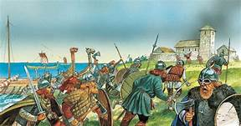
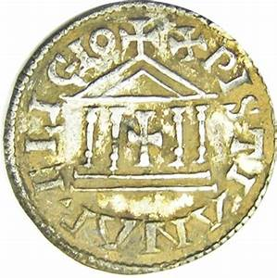

The kings of Anglo-Saxon Britain each ruled their own kingdom. They fought to defend their kingdoms or take control of others. When they first settled there were 7 kingdoms but by AD 878 only Wessex was left as the Vikings had overrun the others.

