Year 4
The Romans

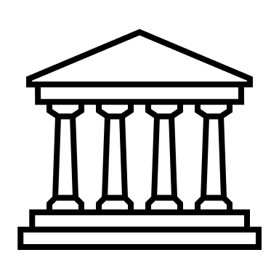
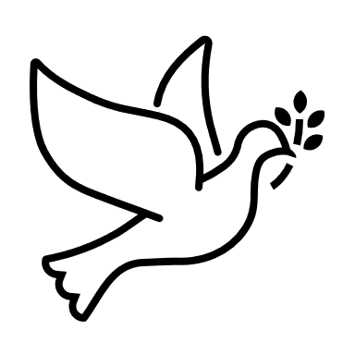
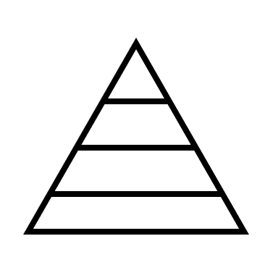
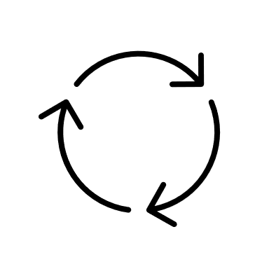

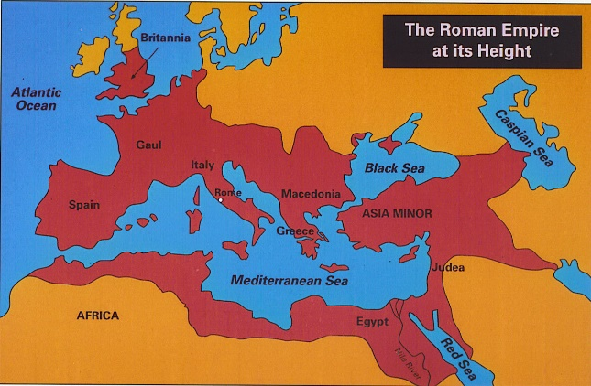

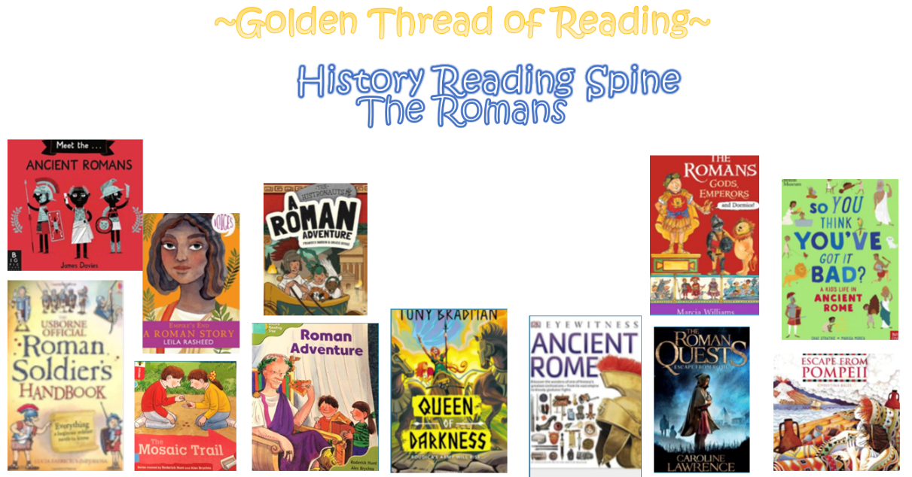

Where am I in History?
What came before?
What comes next?

Key words

History | Year 4 | Romans
Skills covered this half term:
- Research what it was like for children in a given period of history and present my findings to an audience.
- Plot events on a timeline using centuries.
- Round up time differences into centuries and decades.
- Explain some of the times when Britain has been invaded.
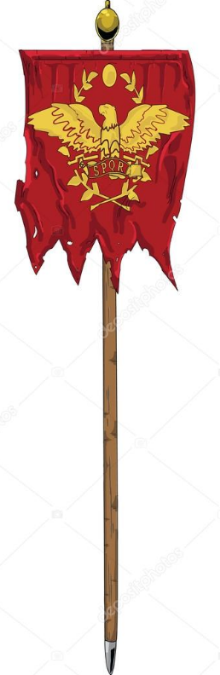
The Romans built elaborately designed Roman baths where people would go to relax and socialise. Some of these impressive buildings remain today.
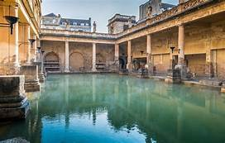

The Romans were famous for building long, straight roads to transport legions, supplies, trading goods and messages from the Emperor. You can still see some Roman roads today, 2000 years after they had been built.

Early in Roman times many people believed in different gods and goddesses whom they believed control things like time, love and the seas.

Key Vocabulary
Celts | People living in Britain
Conquer | When a country or group takes control over land and people
Emperor | A man who rues an Empire
Fort | A strong building with a wall or fence around it to keep safe from enemies
Invade | To enter another country by force with an army
Legion | A large group of soldiers who form one part of an army
Legionary | A soldier who belongs to a legion
Romans | Citizens of the Roman Empire
Rome | Capital of the Roman Empire
Tribe | A group of people who share language, location and customs

