Year 4
Ancient Greece

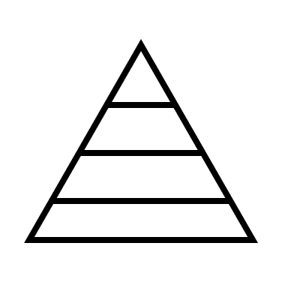
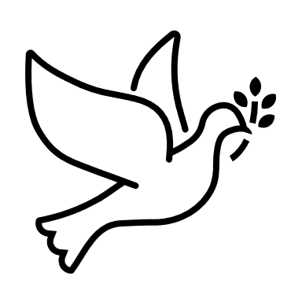

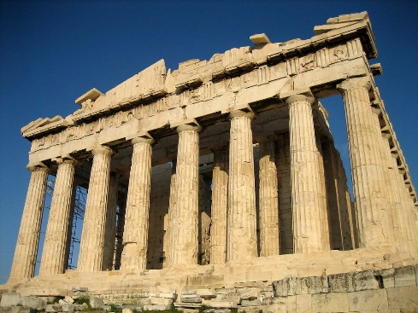

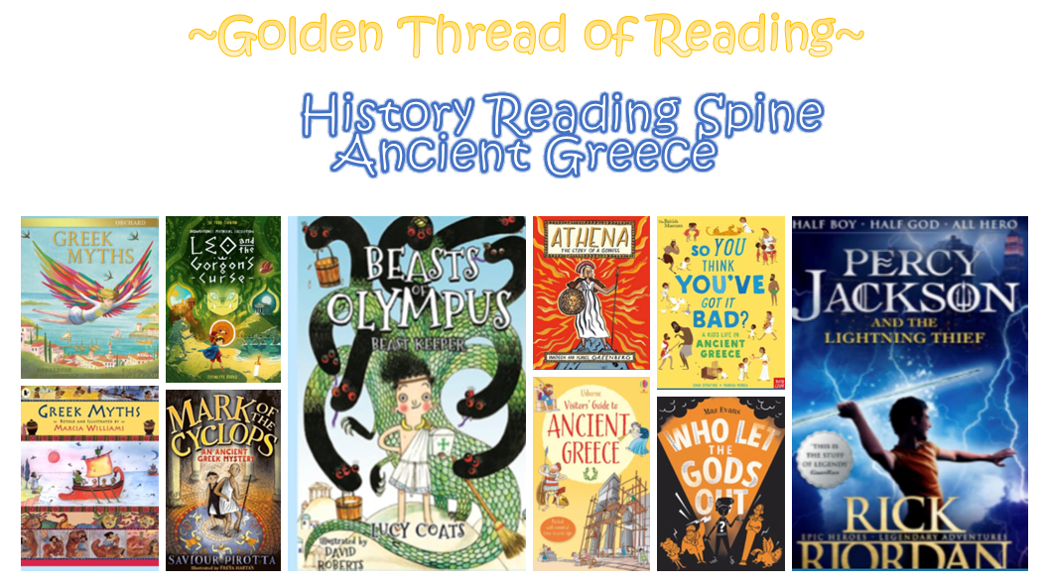

Where am I in History?
What came before?
What comes next?

Key words
History | Year 4 | Ancient Greece
Skills covered this half term:
- Plot events on a timeline using centuries.
- Round up time differences into centuries and decades.
- Research two versions of an event and show how they differ.
- Explain how historical items can be used to help build up a picture of life in the past.
Men had a much better life than women. Only men were involved in government and permitted to take part in the Olympic games. Women were expected to look after the home and children.

Greece is made up of the mainland and many islands. Its position by the sea meant that Greeks were seafaring people.
The Ancient Greeks can be credited with many inventions and discoveries. They invented government, democracy, the Olympics and early medicine.

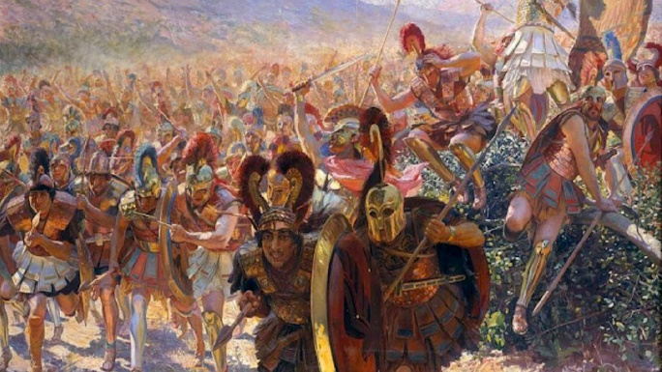

Key Vocabulary
Acropolis | A large hill in the centre of Athens
City State | A city that had its own government and rules the area around it e.g. Athens, Sparta, Corinth, Delphi & Thebes
Democracy | A type of government where people can vote
Greek | Someone or something from Greece
Mount Olympus | The highest mountain in Greece and the mythological home of the Greek Gods
Mythology | A collection of ancient stories known as myths
Olympics | Sporting event and sacrifice held every four years in honour of Zeus
Parthenon | Temple dedicated to Athena located on the Athenian Acropolis
Philosopher | Someone who thinks and writes about the meaning of life and living

