**Year 2**

**Significant Explorers**

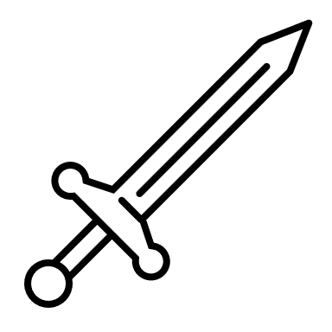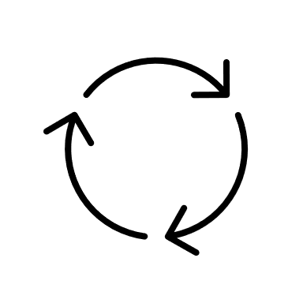

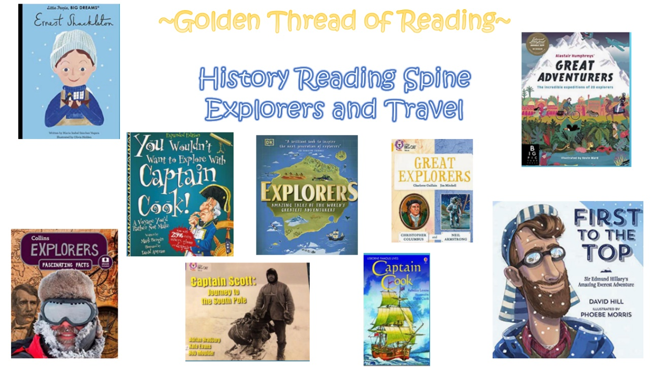

What came before?

What comes next?

Where am I in History?

|  |  |  |  |
| --- | --- | --- | --- |
| Key words | | | |
|  |  |  |  |
|  |  |  |  |

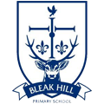

|  |  |  |
| --- | --- | --- |
| History | Year 2 | I am a Time Traveller – great explorers |

|  |
| --- |
| Skills covered this half term: |
| * Know where events they study fit within a chronological framework * Identify similarities and differences between ways of life in different periods * Use common words and phrases relating to the passing of time. * Understand some of the ways in which we find out about the past |

|  |  |
| --- | --- |
| **Key Vocabulary** | |
| Rigging | A system of ropes and cables used to move and lift things. |
| Crow’s nest | A structure in the upper part of the main mast of a ship used as a look out point. |
| Mast | A tall part of the ship, often carries sails. |
| Bail | To frantically remove water. |
| Gruel | A very watery type of porridge. |
| Continent | A main body of land. |
| Commander | The person in charge. |
| Quote | Something said by someone before. |
| NASA | The National Aeronautics and Space Administration |

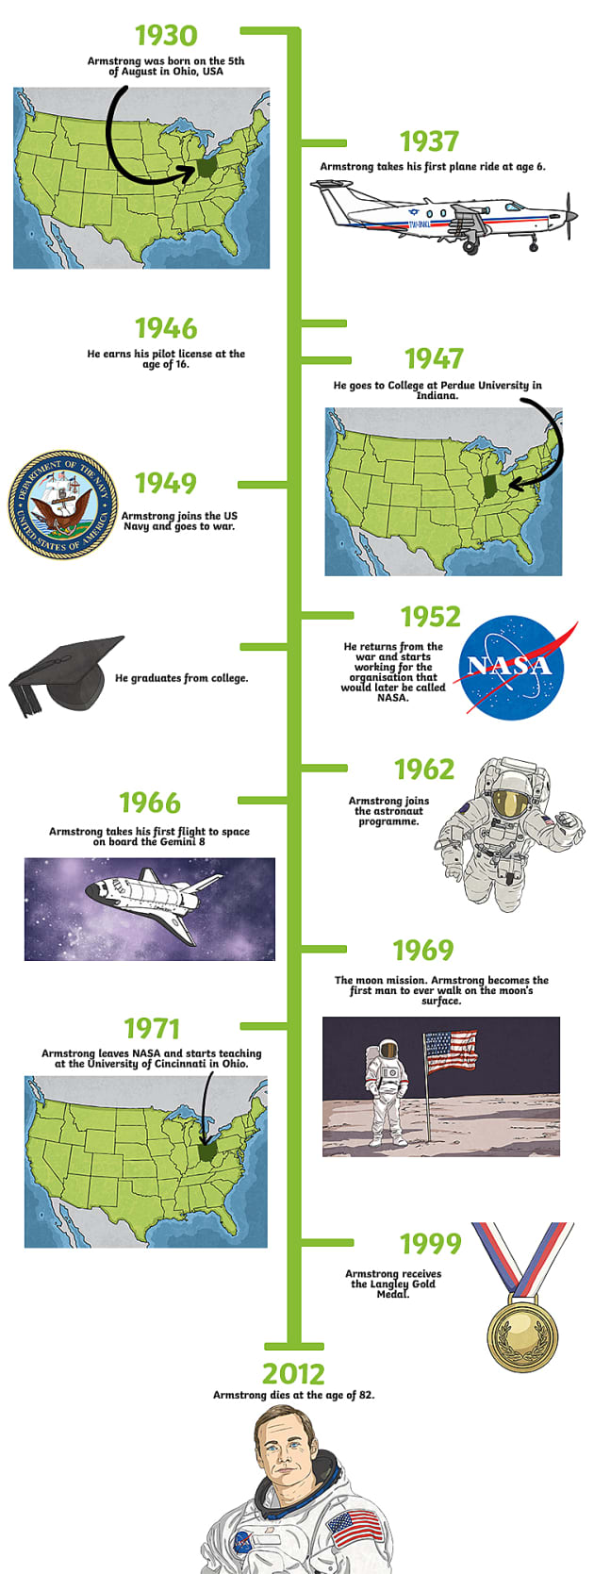

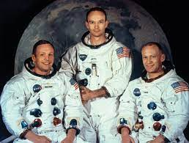

Apollo 11 Crew:

Neil Armstrong

Michael Collins

Buzz Aldrin

Christopher Columbus



