Year 5
The Mayans

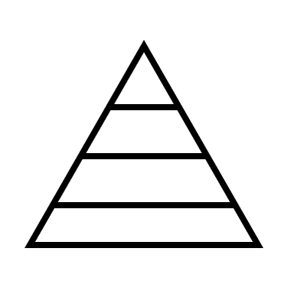
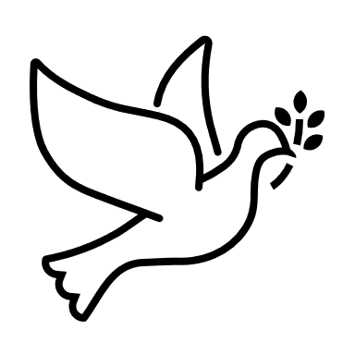

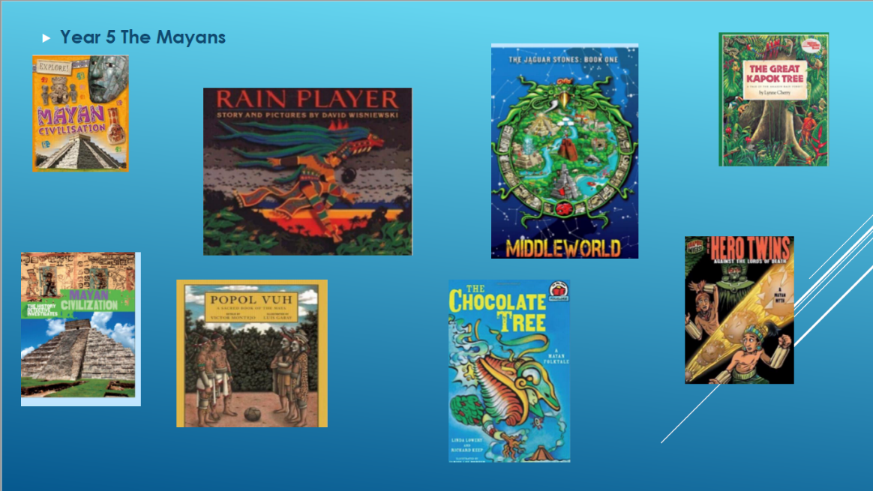

Where am I in History?
What came before?
What comes next?

Key words

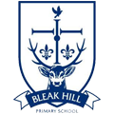
History | Year 5 | The Mayans
Skills covered this half term:
- Draw a timeline with different historical periods showing key historical events and important historical figures.
- Understand that historical sources might reflect different viewpoints and explain the arguments for and against each point of view.
- Test out a hypothesis to answer questions.
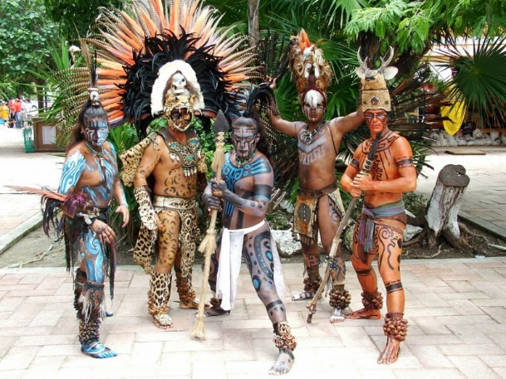
The Maya believed and worshipped several different gods. They believed that the gods had a good side and bad side and that gods could help or hurt them.
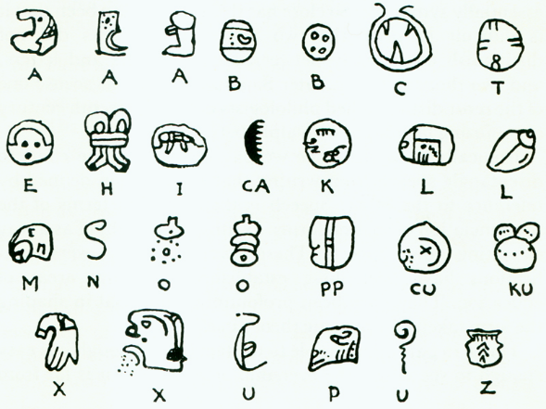

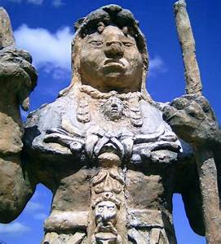
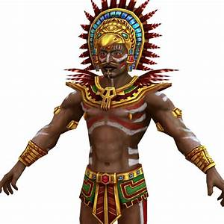

Priests were very important in Maya society as it was believed that they could communicate directly to the gods. They would perform different rituals during special festivals or ceremonies.

Key Vocabulary
Cacao beans | Cacao trees sprout pods directly from their trunks. When ripe the pods can be broken to reveal the beans.
Civilisation | An organised society living with its own culture and way of life, existing in a particular place over a period of time.
Codices | Ancient handwritten text. One text is called a codex.
Drought | A period of very little rain.
Jaguar | A big cat with yellowish fur and black spots.
Maize | Another word for sweetcord or corn on the cob. It can be made into dough or baked into tortillas.
Ritual | A ceremony, often religious, performed with set actions.
Scribes | People paid to write things down to keep as records or for people who couldn’t write.

Maize was a very important crop that formed around 80% of the Maya diet. The Mayans believed the first humans were made by the gods from maize dough!

