Year 3
Ancient Egypt

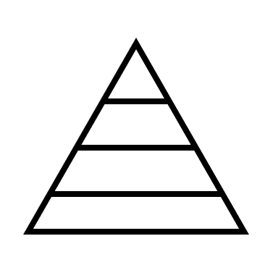
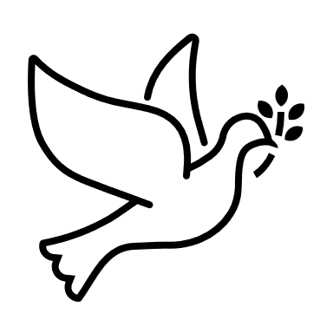

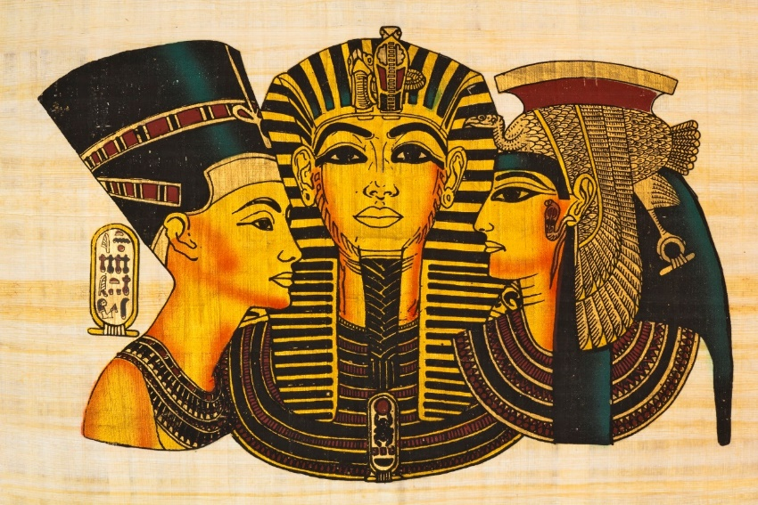

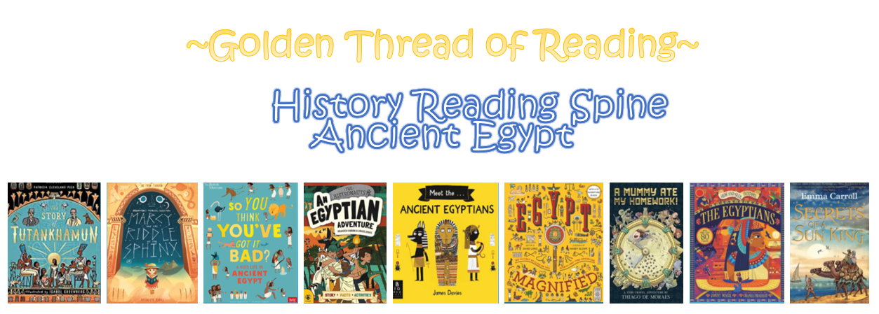

Where am I in History?
What came before?
What comes next?

History | Year 3 | St. Helens
Skills covered this half term:
- Describe events from the past using the correct dates when they happened.
- Use a timeline within a specified period of history to set out the order of things that happened in that period.
- Use my mathematical knowledge to work out how long ago events took place.
- Use research skills to find answers to specific historical questions.

Howard Carter discovered Tutankhamun’s burial chamber in the valley of Kings.

Why did Ancient Egyptians mummify their dead?
Eternal life was not just about preserving the spirit. The deceased’s body also had to preserved, as the Ancient Egyptians believed the soul (ba) and life force (ka) had to return to it regularly to survive.
To prevent the body decaying, it underwent a lengthy and gruesome mummification process.

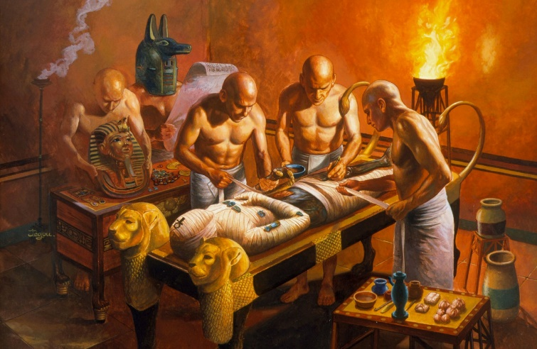
The Rosetta Stone, discovered in 1799, is written in two languages (Greek and Egyptian). It helped researchers to decipher hieroglyphics and find out much more about what life was like for the Ancient Egyptians.

Howard Carter

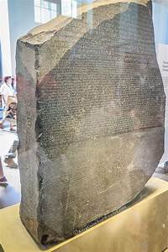

Hieroglyphics are symbols used by the Egyptians to convey messages to each other.

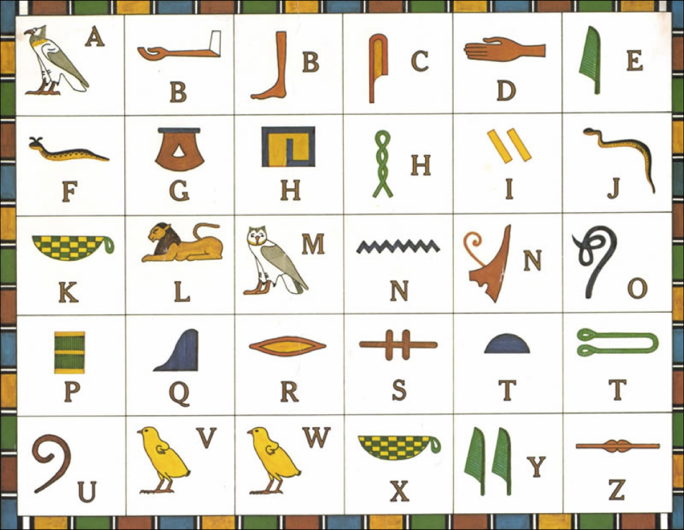
The Ancient Egyptians worshipped many different Gods and Goddesses including:
Rosetta Stone

Key Vocabulary
Ancient | From a long time past.
Artefacts | Objects made by humans.
Canopic jar | A jar used during the mummification proces
Excavation | To dig in the ground to discover old buildings or objects that have been buried for a long time.
Mummification | A way of preserving a body after death.
Papyrus | Paper made from the stems of a papyrus plant.
Pharaoh | A ruler of Ancient Egypt.
River Nile | The longest river in Africa which flows through Egypt.
Sarcophagus | A dtone coffin.

