Year 2
The Great Fire of London

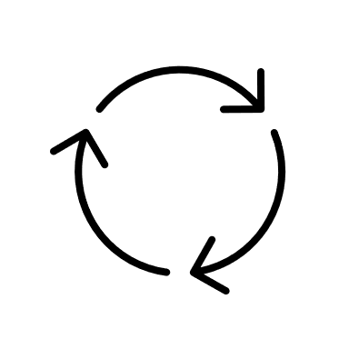
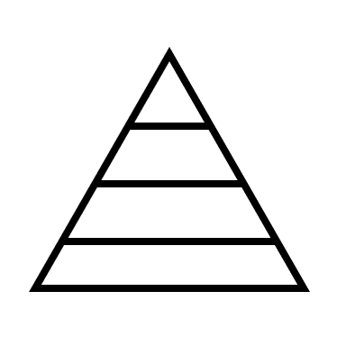

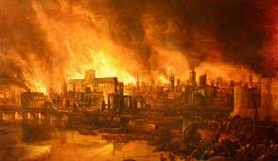

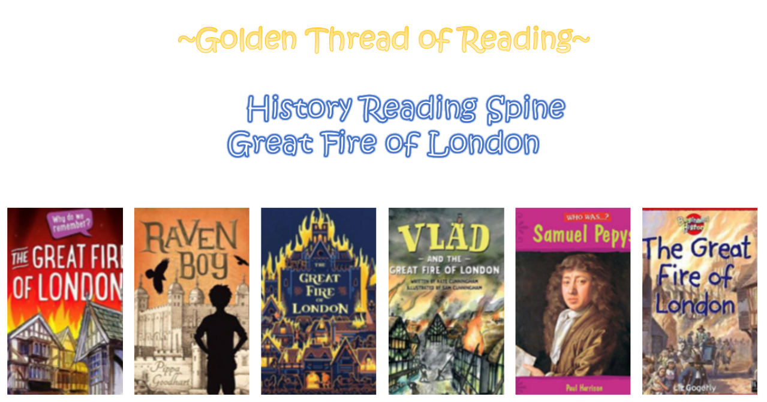

What came before?
What comes next?
Where am I in History?

Key words

History | Year 2 | Great Fire of London
Skills covered this half term:
- Research the life of a famous person from the past using different sources of evidence.
- Recount the life of someone famous from the past and explain what they did earlier and what they did later.
- Use words and phrases such as before/ after, past/ present, then/now.
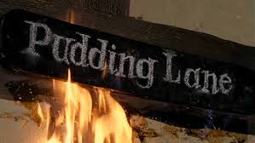
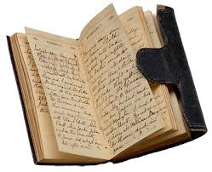
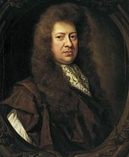
The fire started on 2nd September 1666 in Thomas Farriner’s bakery on Pudding Lane.

The fire spread so quickly because the houses where very close together and made of wood and straw. The buildings were very dry, and the strong winds helped to blow the flames.

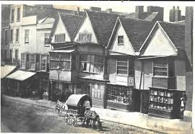

Key Vocabulary
Bakery | A place that makes bread and cakes etc.
Diary | A book that people about their lives in.
Firebreak | A gap that stops the fire from spreading to nearby buildings.
Fire hook | A stout pole having a hooked metal head and used especially in firefighting for tearing down walls or ceilings.
London | Capital city of England
St.Paul’s Cathedral | A very large church. A new one was built after the fire.
Water Squirt | A pump used to suck up water and then squirt it at the fire.

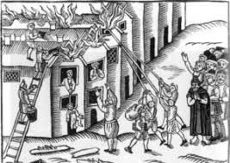

People used leather buckets of water to try and put the fires out, but it did not work. King Charles II ordered that the buildings be pulled down to prevent the fire from spreading further.

