Year 3
Stone Age to Iron Age

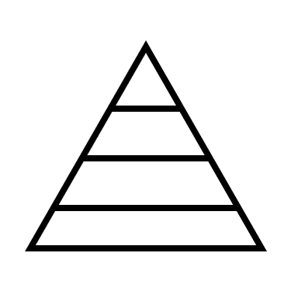
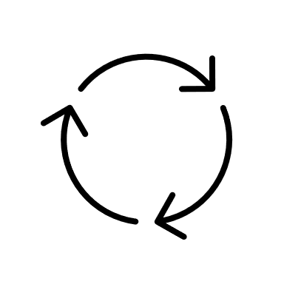

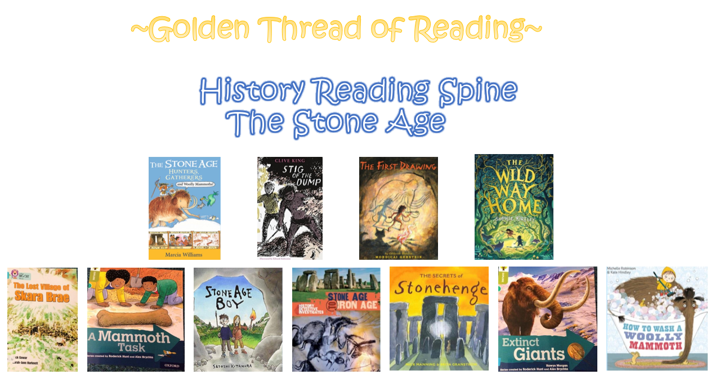

Where am I in History?
What came before?
What comes next?

Key words

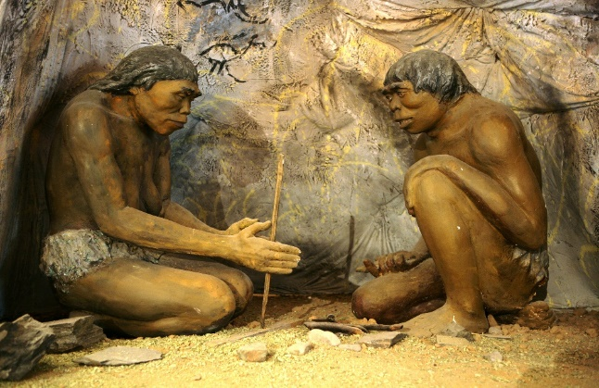
History | Year 3 | Stone Age
Skills covered this half term:
- Describe events from the past using the correct dates when they happened.
- Use a timeline within a specified period of history to set out the order of things that happened in that period.
- Use my mathematical knowledge to work out how long ago events took place.
- Use research skills to find answers to specific historical questions.

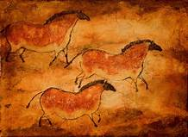
Cave Paintings – Early humans may have used art as a way of communicating in their struggle for survival. Paintings of animals are very common. The famous paintings at Lascaux are over 18,000 years old.

One of the most complex Iron Age hillforts in Europe is Maiden Castle in Dorset, England. It was built around 100 BC and helped protect hundreds of residents.

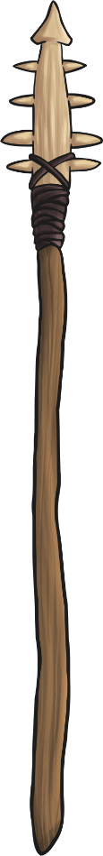
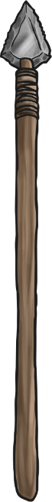
The first early humans used stone axes, rocks and wooden spears that were hardened at the tips with fire. Later, spears were developed that had sharp bone or flint tips.

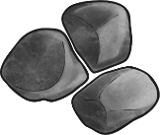

Key Vocabulary
Agriculture | The raising of crops and animals for human use
Bronze Age | The time period when Bronze replaced stone as the preferred material for tools and weapons
Flaking | A process of shaping stone by chipping pieces off the edges
Forage | To search for food to eat
Hunter-Gatherer | A person who meets their needs by hunting animals and gathering plants
Microlith | Small, sharp stones used as arrow and spear heads
Neolithic Era | The last period of the Stone Age when humans began to develop agriculture and use tools and weapons
Paleolithic Era | The earliest part of the Stone Age characterised by tools made of crudely chipped stone and by cave art
Settlement | A place where people live and build homes
Tools | Objects used to improve the performance of a task

The Stone Age was a time of many weird and wonderful animals. Land animals were generally much bigger than humans in prehistoric times.

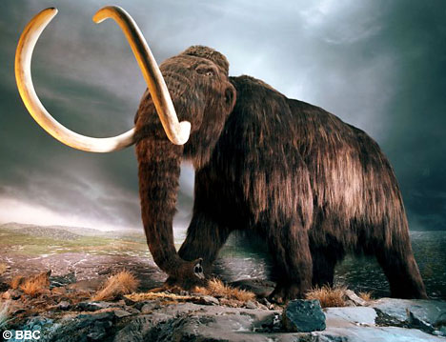
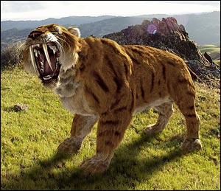
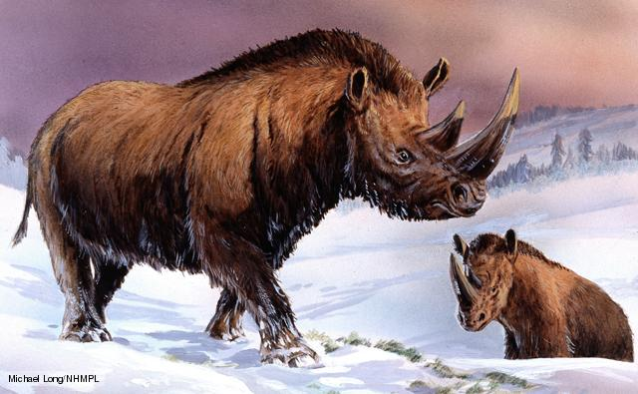
Smilodon
Woolly Rhino
Woolly Mammoth

