Year 4
The Anglo-Saxons, Picts and Scots

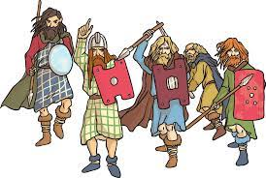

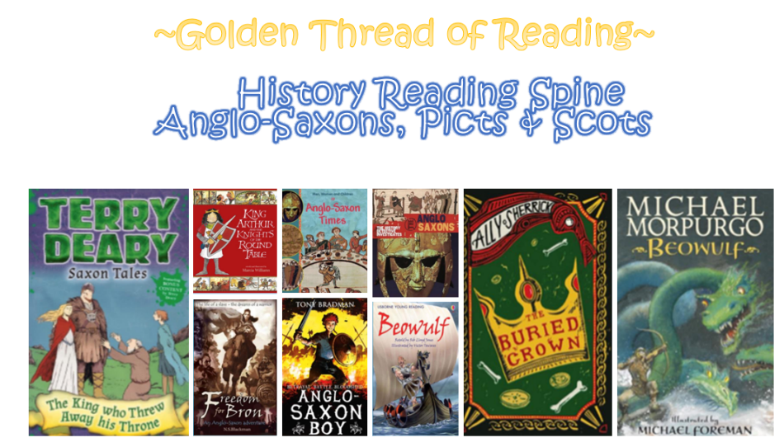

Where am I in History?
What came before?
What comes next?

Key words

History | Year 4 | The Anglo-Saxons, Picts and Scots
Skills covered this half term:
- Continue to develop a chronologically secure knowledge.
- Note connections, contrasts and trends over time.
- Develop the appropriate use of historical terms.
- Address and sometimes devise historically valid questions about change, cause, similarity and difference, and significance.
- Construct informed responses that involve thoughtful selection and organisation of relevant historical information.
- Understand how our knowledge of the past is constructed from a range of sources. Using more than one source of information. Understanding different accounts of a historical event and explaining some of the reasons why the accounts may differ.

Key Vocabulary
Angles | Tribes from modern day Denmark.
Christianity | A religion based on the teachings of Jesus
Missionary | A person from a religion sent to spread the faith.
Pagan | A religion that involves worshipping many gods and goddesses.
Picts | Tribes originally from Scotland who were ‘foul’ and had a ‘lust for blood’.
Romans | The Romans invaded and settled in Britain for over 400 years, starting with their first successful raid in 54 BC.
Saxons | German – Dutch tribes who settled in Britain from around 450 AD.
Scots | People from Ireland, who, like the Picts, were fierce and powerful fighters.

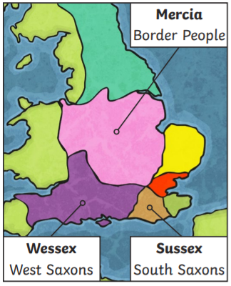
In 597 AD, a Roman monk was sent to tell the Anglo Saxons about Christianity.

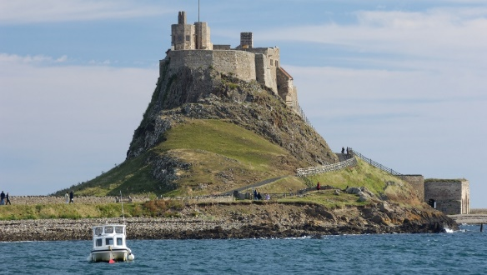
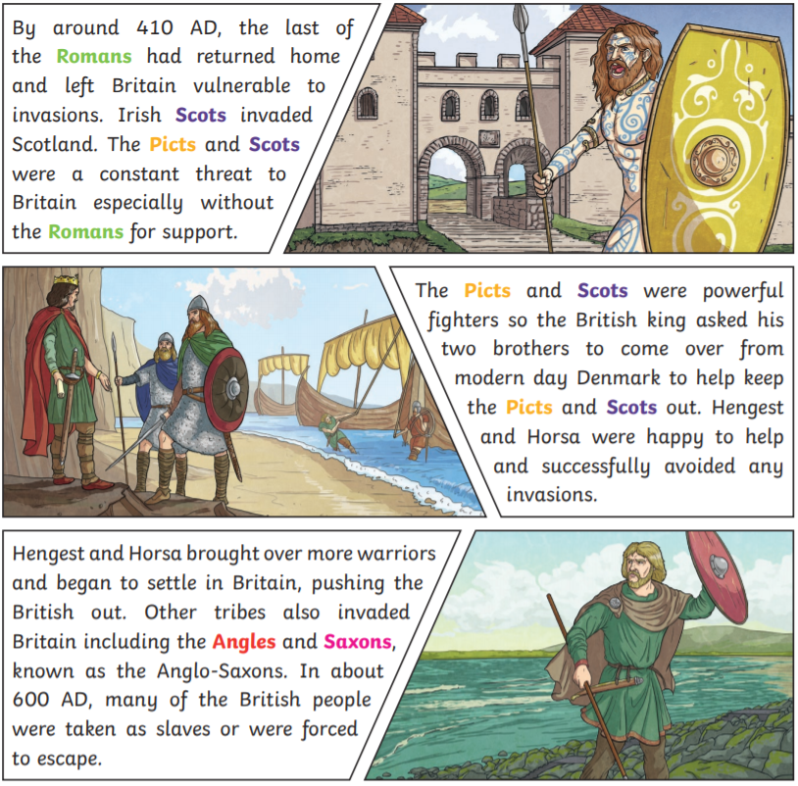
Oswald gave Aiden the island of Lindisfarne where he built a monastery. This Holy Island was very influential, and the monks here were successful at spreading Christianity across the North of England.
Over the next 100 years, the rest of Britain converted to Christianity too.
The King of Kent was the first to be converted and was baptised along with 10,000 of his subjects.

