Year 6
The Atlantic Slave Trade

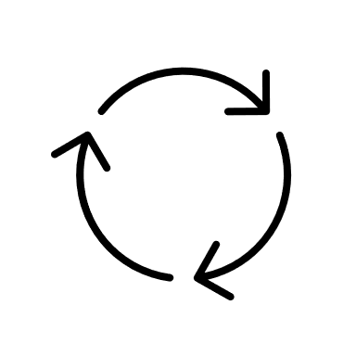
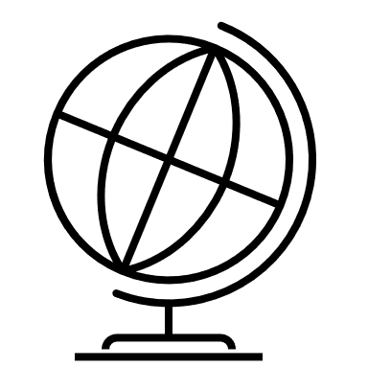

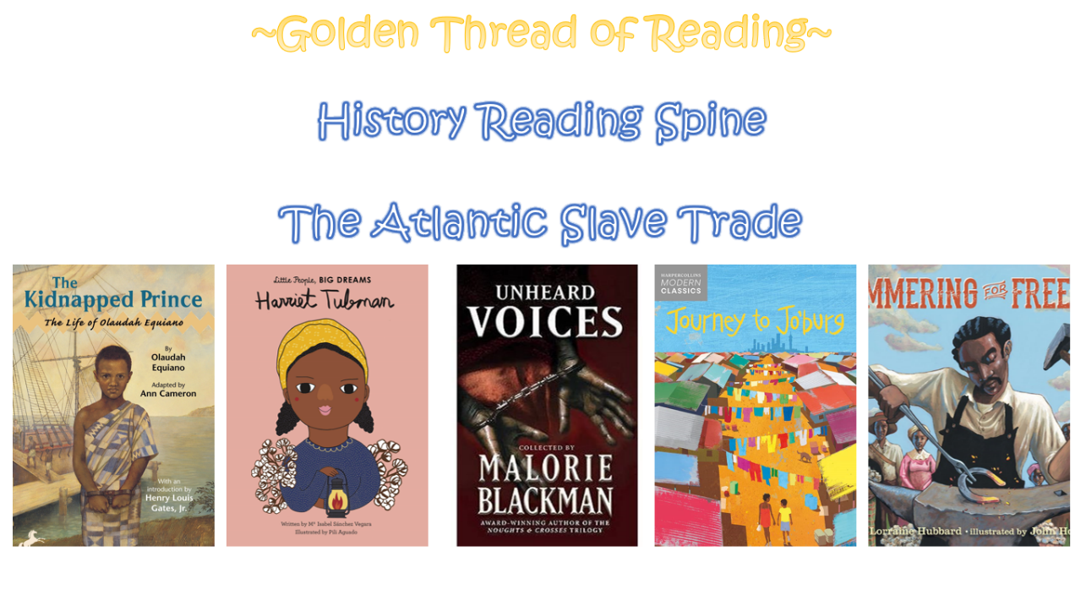

Where am I in History?
What came before?
What comes next?

Key words

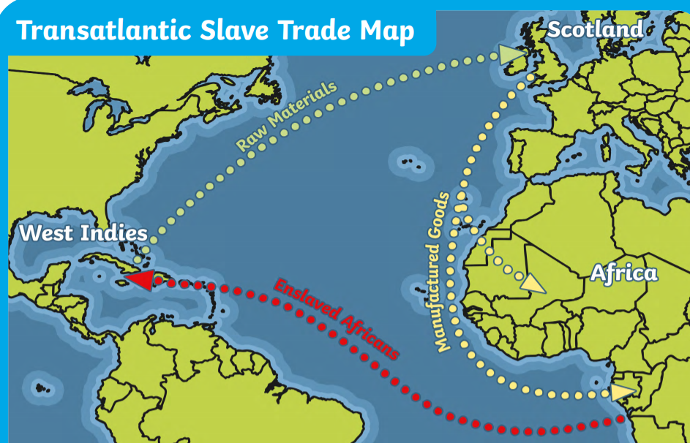
The 'Triangular Trade' was the sailing route taken by British slave traders. It was a journey of three stages. The trade traffic flowed to and from three general areas on either side of the Atlantic Ocean. These areas form a rough triangle when viewed on a map. They were in Europe, Africa, and the Americas.
History | Year 6 | The Atlantic Slave Trade
Skills covered this half term:
- Continuing to develop a chronologically secure knowledge and understanding of world history.
- Constructing informed responses that involve thoughtful selection and organisation of relevant historical information.
- Address and devise historically valid questions about change, cause, similarity and difference and significance.
- Understand how our knowledge about the past is constructed from a range of sources and that different versions of the past may exits, giving some evidence for this.
- Identify what Africa was like before the arrival of Europeans and how and why European slave trade began.

Key Vocabulary
Auction | Where people bid money for an item, in this case, slaves
Branding | Burning a mark into the skin to show ownership and stop slaves being able to escape
British Empire | Terrirtories in other parts of the world ruled over by Britain
Dysentery | An infection of the bowel which causes diarrhoea containing blood and/or mucus
Forced labour | Any work or service that people are forced to do against their will
Manufactured goods | Prodcuts made from raw materials e.g. guns made from metal
Middle passage | Route between Africa and America, the middle part of the triangle
Raw materials | Basic materials from which other products are made e.g. cotton
Slavery | Being forced to work hard without payment
Slave trade | Ownership, transporting and selling of slaves from Africa to America and Europe
Transatlantic | Crossing the Atlantic Ocean
Kinship | A relative or someone from the same place that has a bond with you
Mansa | A word that means king
Plantation | A large piece of land where crops such as coffee, cotton, tpbacco and sugar are grown
Colony | A country or part of a country that is under the control of another country and operated by settlers from that country
Dialect | A language that is unique to a certain country, area or tribe
Abolistionist | A person who actively fights against slavery or capital punishment
Underground railroad | A network of people who helped slaves escape slavery.
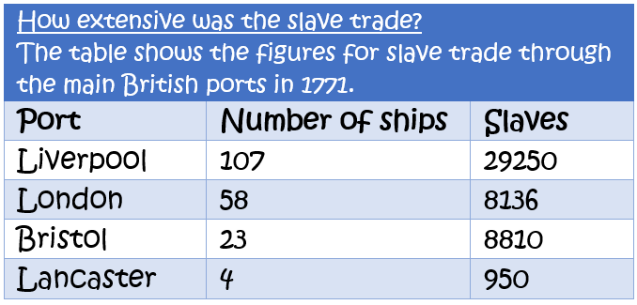

Slave ships were large cargo ships specially built or converted from the 17th to the 19th century for transporting slaves. Such ships were also known as "Guineamen" because the trade involved human trafficking to and from the Guinea coast in West Africa.

A cross-section of a slave ship

