Year 3
The Victorians

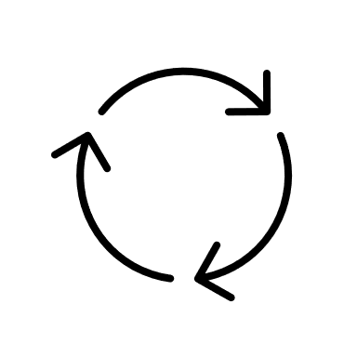

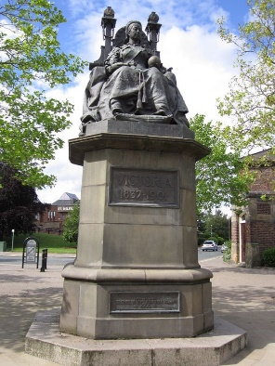

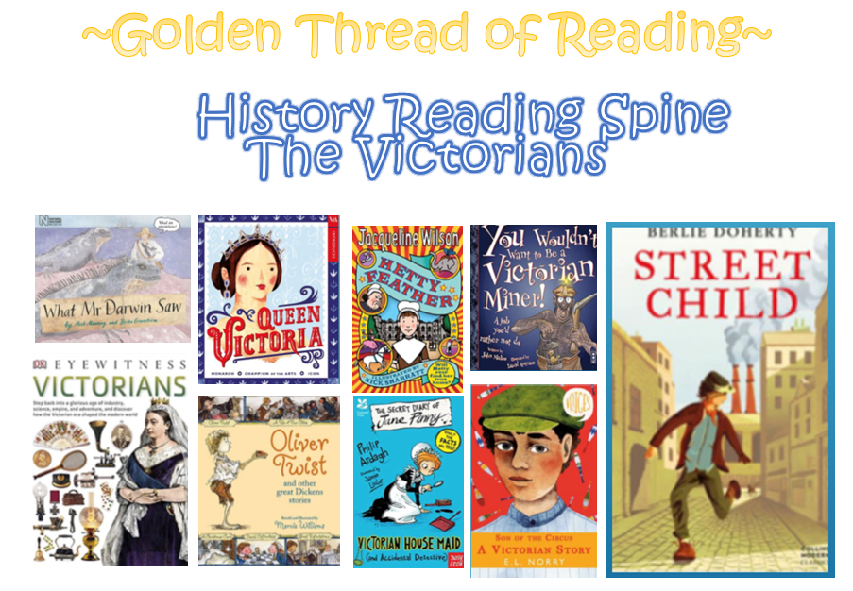

What came before?
What comes next?
Where am I in History?

Key words

History | Year 3 | Victorian St. Helens
Skills covered this half term:
- Research to find similarities and differences between two or more periods of history.
- Explain how an event from the past has helped shaped our lives today.
- I can explain how our locality has changed over time.
- Use research skills to find answers to specific historical questions.

St Helens takes its name from a chapel, which was first mentioned in 1552. It was built where the road from Ormskirk to Warrington crossed the road from Prescot to Ashton. At that time the area that is now St Helens was divided into 4 townships. They were Eccleston, Windle, Parr and Sutton.

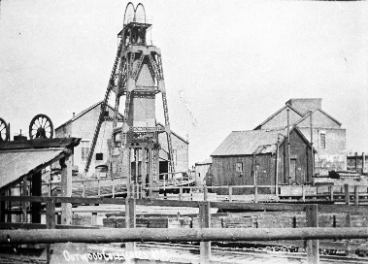

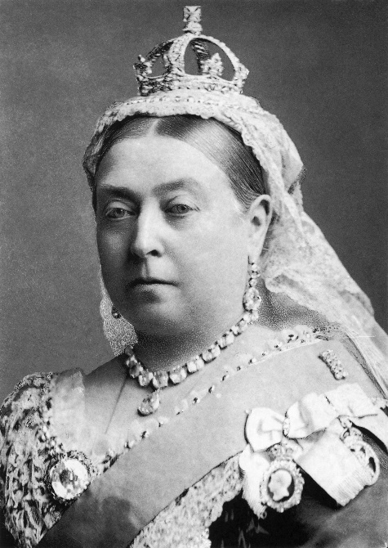
The Victorian era: The period of time between 1837 and 1901 when Queen Victoria reigned over Britain. During her 63-year reign, there was a huge contrast between the rich and poor Victorians lived.

Davey Lamp

St. Helens began to develop quickly because of its large supplies of coal, the fuel which powered the Industrial Revolution. The area played a significant role in industrial and social change.
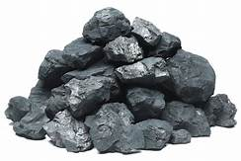

Key Vocabulary
Borough | A town or district which is an administrative unit.
Coal | Formed when dead plant matter decays into peat and is converted into coal by the heat and pressure of deep burial over millions of years.
Continent | A large expanse of land.
Heritage | Features belonging to the culture of a particular society.
Industrial Revolution | The rapid development of industry that occurred in Britain in the late 18th and 19th centuries, brought about by the introduction of machinery.
Landmark | An object or feature of a landscape or town that is easily seen and recognized from a distance.
Mining | The process or industry of obtaining coal or other minerals from a mine.
Privies | Wooden or brick non-flushing toilets, built far from the house to keep the smell away.

St Helens Town Hall was built in 1839. In 1871 the old town hall burned down. A new Town Hall was built in 1876. Its clock tower originally had a steeple, but this was destroyed in a fire in 1913.

