Year 6
Shang Dynasty

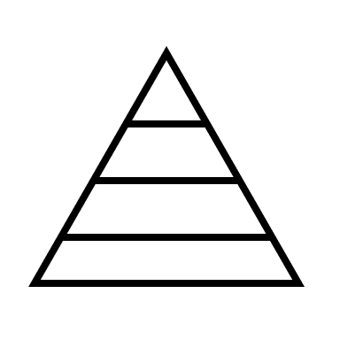

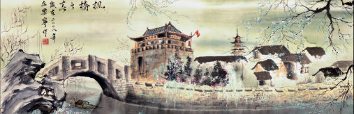

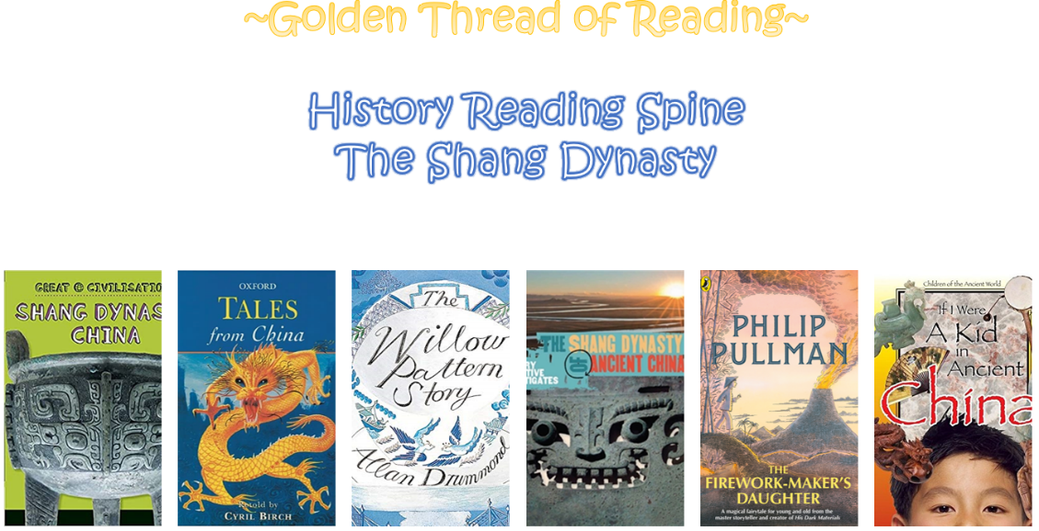

Where am I in History?
What came before?
What comes next?

Key words

Skills covered this half term:
- Continuing to develop a chronologically secure knowledge and understanding of world history.
- Constructing informed responses that involve thoughtful selection and organisation of relevant historical information.
- Address and devise historically valid questions about change, cause, similarity and difference and significance.
- Understand how our knowledge about the past is constructed from a range of sources and that different versions of the past may exits, giving some evidence for this.
Key Vocabulary
Orcale bones | Usually the shoulder bones of animals or the belly shells of turtles. Dug up centuries later by farmers, they were thought to be dragon bones and were ground up to be used in traditional Chinese medicine. In 1889, Wang Yirong and his friend Liu E worked out that the ‘dragon bones’ had been used in ancient ceremonies.
Fu Hao | Not only the first known female military leader, but also the most influential military leader of her time, either male or female, responsible for leading 13,000 soldiers into battle. She was also a high priestess, which was very unusual for a woman at the time.
Intact | Complete, not robbed by looters.
Jade | A hard mineral stone, usually green.
Bronze | A metal mad from a mixture f copper and tin.
Cowrie shells | Small, flat, yellowish seashells, used like coins in trading.
History | Year 6 | Shang Dynasty

The Shang Dynasty, also known as the Yin Dynasty, ruled the Yellow River Valley in the second millenium BCE (approx 1675-1046BCE).

The Shang Dynasty succeeded the Xia Dynasty and was followed by the Zhou Dynasty.

It was the first Chinese Dynasty for which there is written and archaeological evidence.

The Dynasty expanded its territory and moved its capital city on several occasions.

The Dynasty has become famous for the artistry of its bronze and jade work.
