Key words

Year 6
World War II (Liverpool)

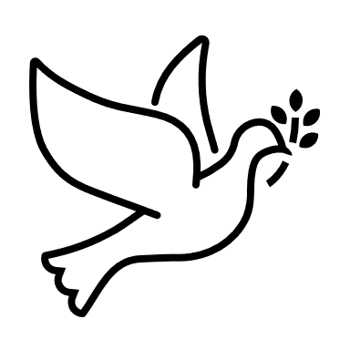
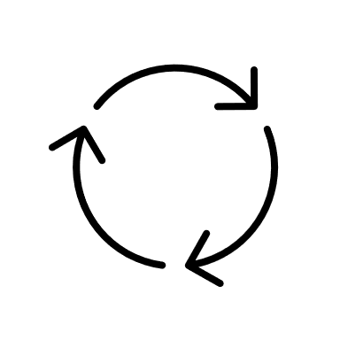
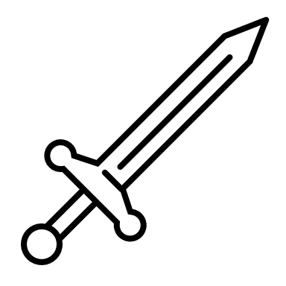

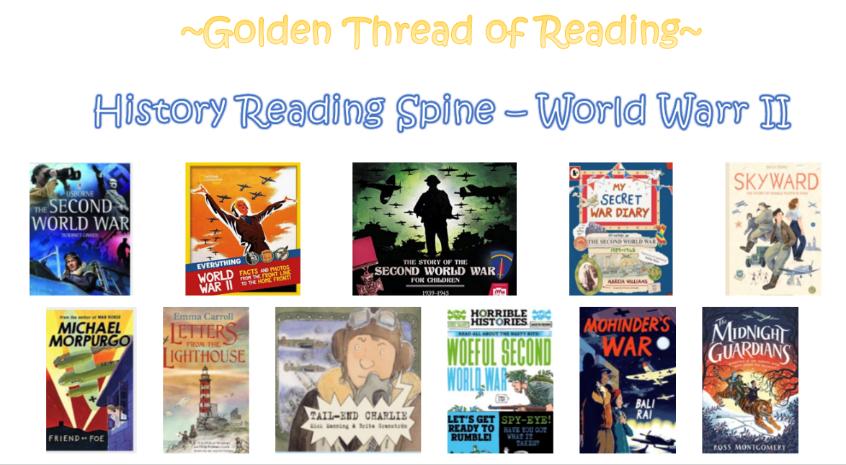

Where am I in History?
What came before?
What comes next?

Key Vocabulary
Air-raid | An attack by enemy planes dropping bombs
Allies | Countries (including Britain, France, the Soviet Union and the USA) who fought the Axis Powers
Atomic bomb | A powerful weapon that uses nuclear reactions as a source of explosive energy
Axis Powers | Germany. Japan, Italy and other countries that fought against the Allies.
Concentration camps | Prisons where Jewish people and other prisoners where held by the Nazis
Evacuation | Moving people from dangerous places to areas of safety. E.g., from the city into the countryside
Fascism | A political system where the strength of a country is more important than the well-being of the people. Often ruled by dictators with unlimited power through the suppression of any opposition and strict control of society.
Führer | German word meaning ‘leader’ or ‘guide’. The title Hitler gave himself in 1934 when he gained absolute authority in Germany.
Genocide | Deliberate action to destroy a people (usually described as ethnic, national, racial or religious group)
Holocaust | The mass murder of around six million Jewish people by the Nazis, as well as other persecuted groups
Luftwaffe | The German air force during the war
Occupied | Taken over by enemy forces
Nazi | Short for National Socialist Party (in Germany) and the name given to supporters of Hitler
Persecution | Systematic mistreatment of an individual or groups, especially because of race, religion or political affiliation
Propaganda | Information, especially of a biased or misleading nature, used to promote a political cause or point of view
Rationing | Controlling the supply of food, clothes, petrol and other products to avoid or reduce shortages
Spitfire | A British aircraft, particularly used during the Battle of Britain and known for its speed and agility
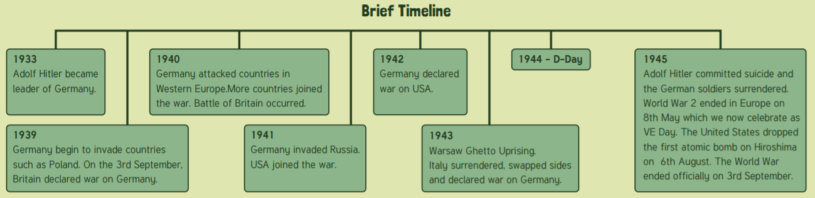
History | Year 6 | World War Two (Liverpool)
Skills covered this half term:
- Developing a chronologically secure knowledge and understanding of world history, establishing clear narratives within and across periods of study.
- Constructing informed responses that involve thoughtful selection of relevant historical information.
- Address and devise historically valid questions about change, cause, similarity and difference and significance.
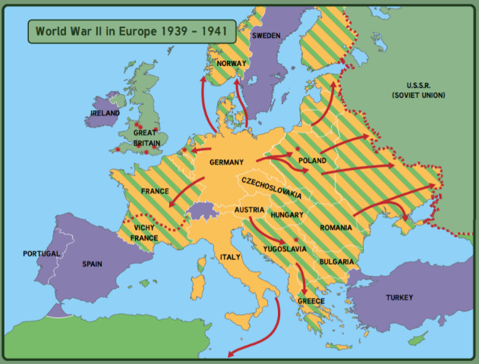
UK World War 2 Soldiers

When the war started, some men volunteered to join the army. But it was not enough. In 1940, two million British men aged between 19 and 27 were ordered to fight. Soldiers carried a water-bottle, ammunition pouches, entrenching tool (spade), a groundsheet and a haversack containing; mess-tin, tinned rations, extra iron rations, spare socks and laces.

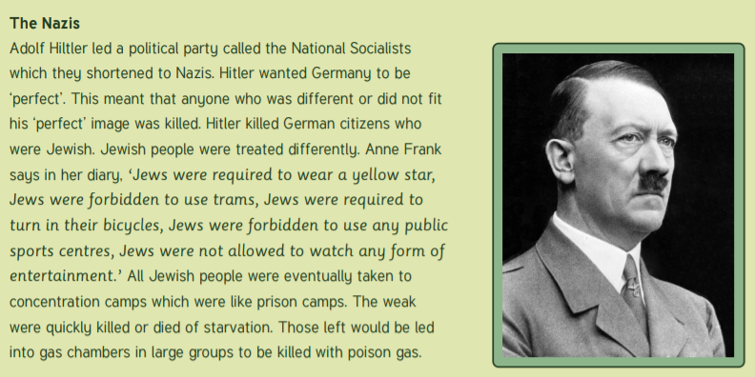
The Blitz

Blitz is short for the German word Blitzkrieg (lightning war). The Blitz happened from September 1940 - May 1941 when Germany frequently bombed London and other British cities. Night after night Germany would drop bombs from planes on ports, harbours and industrial areas. Over one third of London was destroyed. People were warned of an air raid by loud sirens. During the blitz, they became an almost daily part of life. When people heard the siren, they would stop what they were doing and make for a shelter.

