Skills covered this half term:
- Use words and phrases such as old/ new/ a long time ago.
- Recognise that some objects belonged to the past.
- Ask and answer questions about old and new houses or toys.
- Pick out old and new things in a picture.
- Explain what an object from the past might have been used for.
Key Vocabulary
20th Century | The 20th century was between 1900 - 1999
21st Century | We are in the 21st century. It started in 2000 and will end in 2099.
Metal toys
Paper toys | Some toys like paper windmills were made from paper.
Plastic toys | Modern toys such as dolls, soldiers and cars are ade of plastic.
Metal toys | Tin soldiers and model cars were made from metal.
Victorian | The time when Queen Victoria ruled between 1837 and 1901.
Wooden Toys | Lots of toys were made from wood. Toys such as boats, trains, ball and cup and blocks used wood. Some are still made of wood today.
Key Vocabulary
20th Century | The 20th century was between 1900 - 1999
21st Century | We are in the 21st century. It started in 2000 and will end in 2099.
Plastic toys | Modern toys such as dolls, soldiers and cars are ade of plastic.
Metal toys | Tin soldiers and model cars were made from metal.
Victorian  What came before?  What comes next?  Where am I in History? | The time when Queen Victoria ruled between 1837 and 1901.
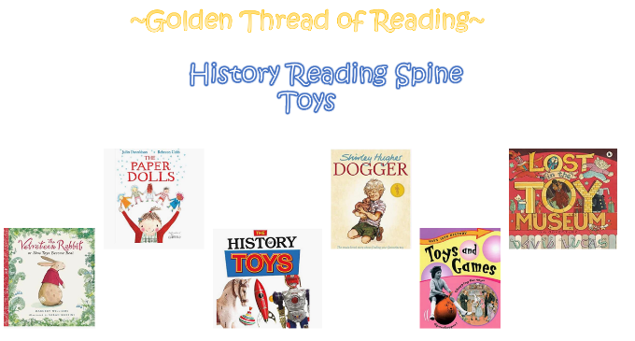
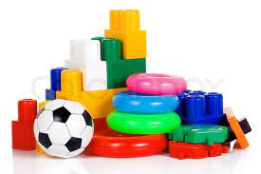
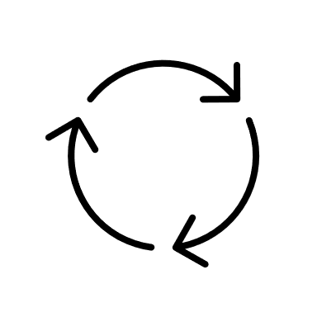
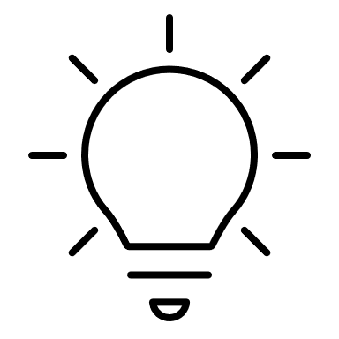
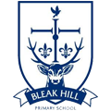
Year 1 - Toys
Your ideas:

