Year 5
The Tudors

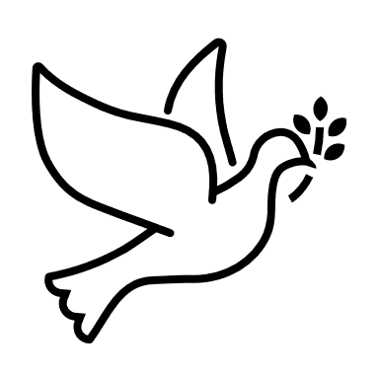
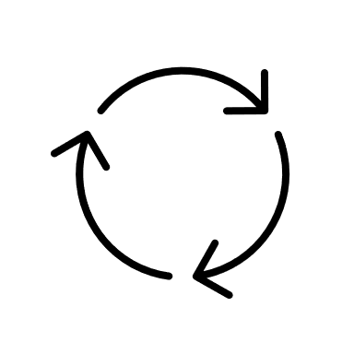
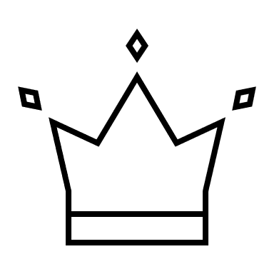

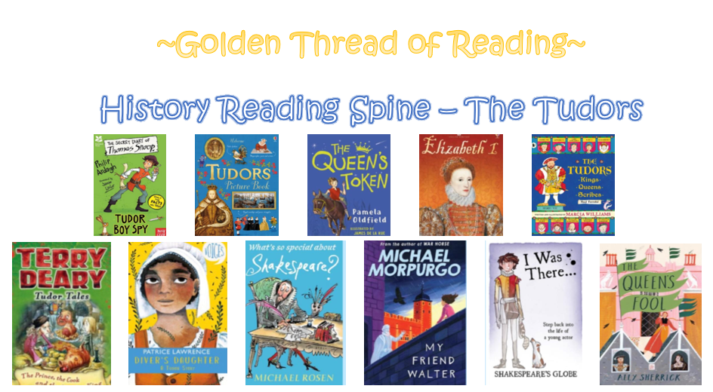

Where am I in History?
What came before?
What comes next?

Key words

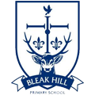
History | Year 5 | The Tudors
Skills covered this half term:
- Continue to develop a chronologically secure knowledge.
- Note connections, contrasts and trends over time.
- Develop the appropriate use of historical terms.
- Address and sometimes devise historically valid questions about change, cause, similarity and difference, and significance.
- Construct informed responses that involve thoughtful selection and organisation of relevant historical information.
- Understand how our knowledge of the past is constructed from a range of sources. Using more than one source of information. Understanding different accounts of a historical event and explaining some of the reasons why the accounts may differ.

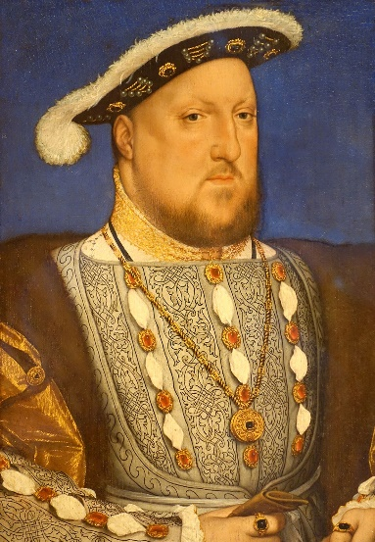
Edward VI
Henry VIII
Henry VII
Lady Jane Grey
Tudor clothing was lavish. Wealthy Tudors’ clothes would be decorated with gold and jewels. Middle class Tudors’ clothes were much plainer and poor Tudors would wear simple, loose fitting cotton clothes.
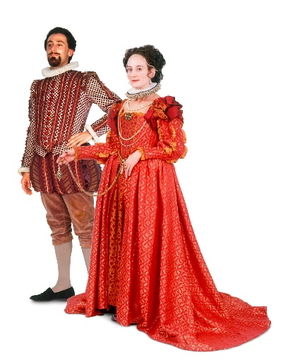

Mary I

Elizabeth I

Ordinary Tudor houses were made from a framework of wooden beams with wattle and daub (sticks and twigs mixed with clay and dung) attached between the frame. The wattle and daub was painted white leaving the beams exposed.
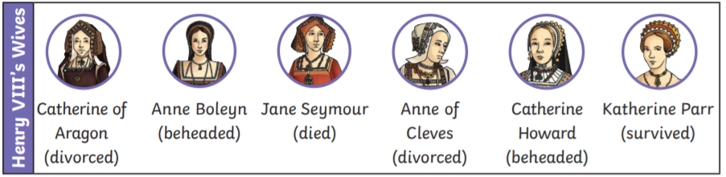
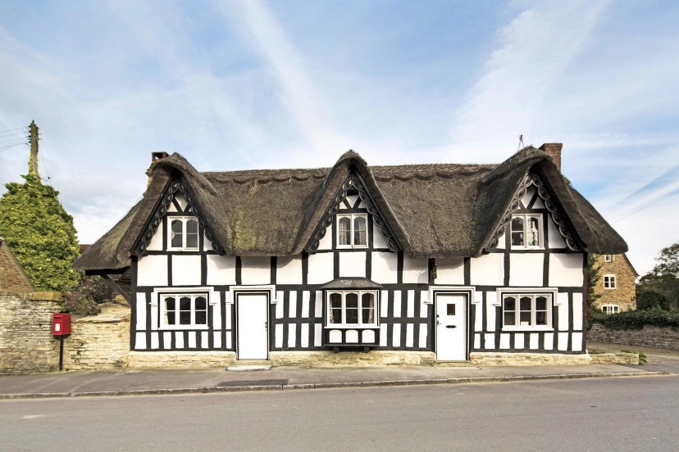

Key Vocabulary
Heir | A person who will inherit the throne when the current King or Queen dies.
Monarch | A person who rules over a place, usually a king or queen.
Reign | To rule over a country as a monarch.
Throne | The position of a king or queen.
The Age of Exploration | A time when European nations began exploring the world. Also known as the Age of Discovery. This was from the 1400s to 1600s.

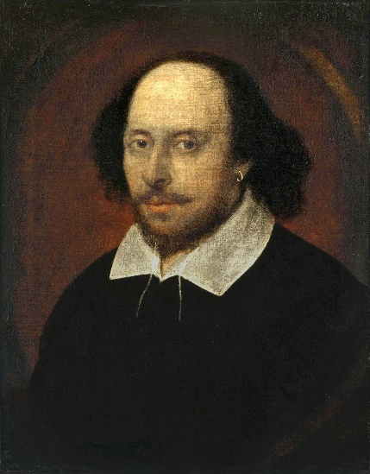

William Shakespeare was a famous poet, playwright and actor of the Tudor times. He wrote many plays including Romeo and Juliet and A Midsummer Night’s Dream which were performed at the Globe Theatre in London.

