Skills covered this half term:
- Know about changes within living memory. Where appropriate, these should be used to reveal aspects of change in national life.
- Know about the lives of significant individuals and compare these.
- Know about significant historical events, people and places.
Key Vocabulary
20th Century | The 20th century was between 1900 - 1999
21st Century | We are in the 21st century. It started in 2000 and will end in 2099.
Metal toys
Paper toys | Some toys like paper windmills were made from paper.
Plastic toys | Modern toys such as dolls, soldiers and cars are ade of plastic.
Metal toys | Tin soldiers and model cars were made from metal.
Victorian | The time when Queen Victoria ruled between 1837 and 1901.
Wooden Toys | Lots of toys were made from wood. Toys such as boats, trains, ball and cup and blocks used wood. Some are still made of wood today.
Key Vocabulary
Monarch | A King or Queen.
Significant | Important.
Reign | The time when a monarch rule.
Decision | Choice.
Succession | The order in which a monarch’s family will take over the throne.
Parliament | This is where politicians meet to decide laws.
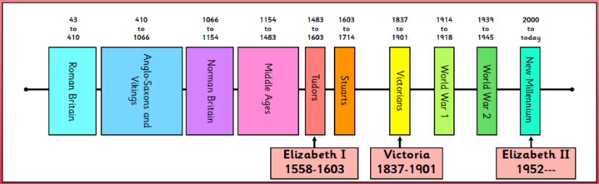
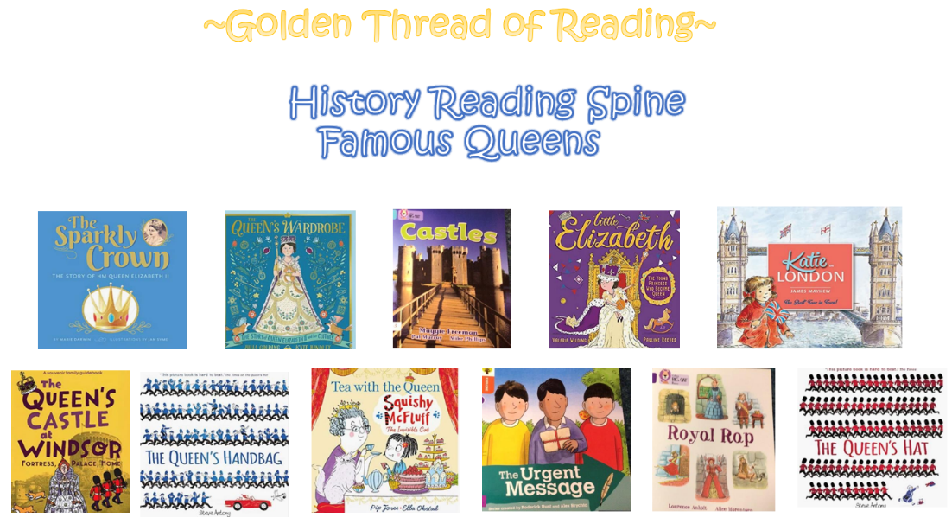
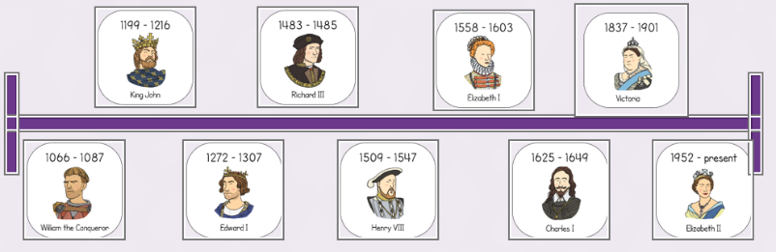
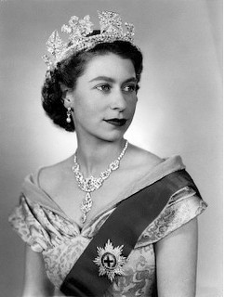
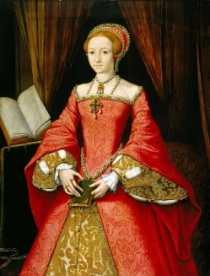
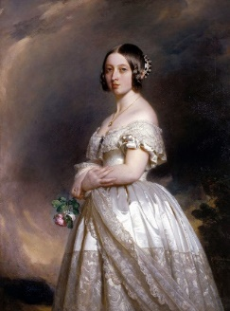
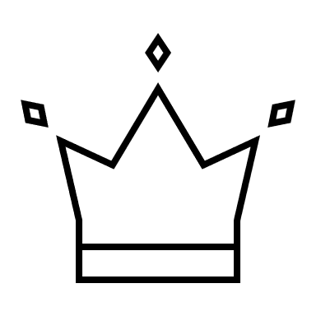
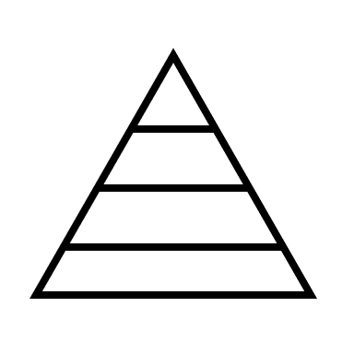
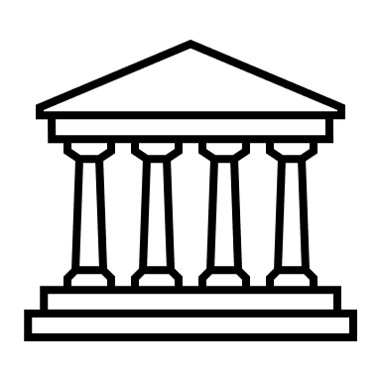
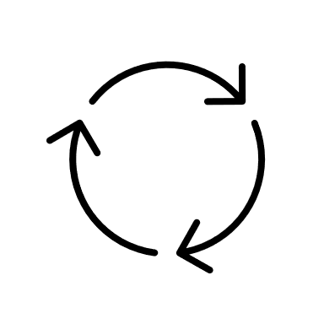
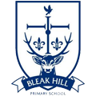
Your ideas:
Young Elizabeth2
Young Elizabeth1
Young Victoria
What came before?
What comes next?
Where am I in History?
Year 1 – Famous Queens

