Skills covered this half term:
- Demonstrate an understanding of the ways in which travel and transport has changed throughout history.
- Talk about what they know about the inventions of cars, trains and aeroplanes.
- Know some of the significant people involved in the development of different types of transport.
Key Vocabulary
20th Century | The 20th century was between 1900 - 1999
21st Century | We are in the 21st century. It started in 2000 and will end in 2099.
Metal toys
Paper toys | Some toys like paper windmills were made from paper.
Plastic toys | Modern toys such as dolls, soldiers and cars are ade of plastic.
Metal toys | Tin soldiers and model cars were made from metal.
Victorian | The time when Queen Victoria ruled between 1837 and 1901.
Wooden Toys | Lots of toys were made from wood. Toys such as boats, trains, ball and cup and blocks used wood. Some are still made of wood today.
Key Vocabulary
Longboat | Longboats were used by the Vikings to travel to other countries.
Penny Farthing | The Penny Farthing was a bicycle that had one large wheel at the front and a smaller one at the back.
Sedan Chair | A person would sit in a chair inside a cabin and would be carried by servants.
The Rocket | A steam train built for the Rainhill Trials of the Liverpool and Manchester Railway.
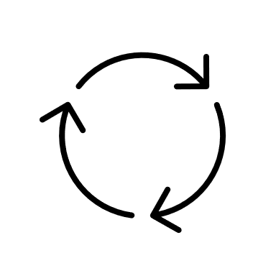
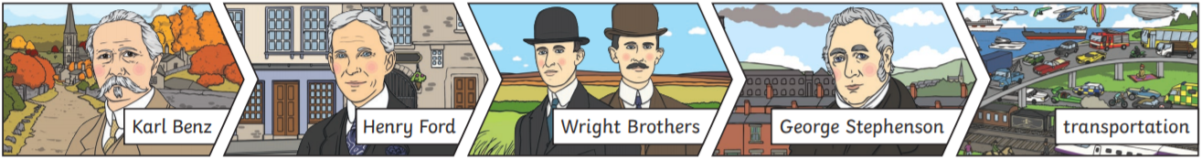
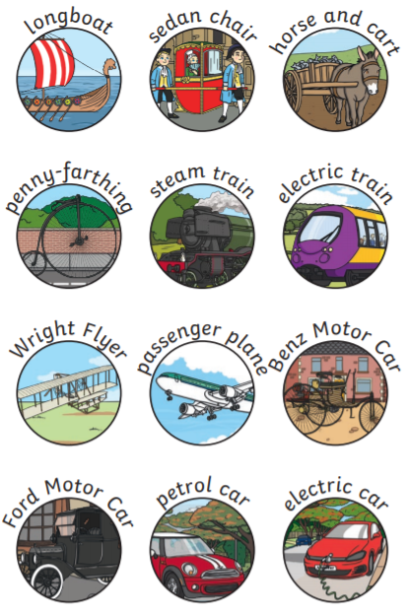
Year 1 - Transport
What came before?
What comes next?
Where am I in History?
Your ideas:

