Key Vocabulary
20th Century | The 20th century was between 1900 - 1999
21st Century | We are in the 21st century. It started in 2000 and will end in 2099.
Metal toys
Paper toys | Some toys like paper windmills were made from paper.
Plastic toys | Modern toys such as dolls, soldiers and cars are ade of plastic.
Metal toys | Tin soldiers and model cars were made from metal.
Victorian | The time when Queen Victoria ruled between 1837 and 1901.
Wooden Toys | Lots of toys were made from wood. Toys such as boats, trains, ball and cup and blocks used wood. Some are still made of wood today.
Key Vocabulary
Local Area | The area around where you live.
Map | A drawing of an area shown from above.
Address | The place where someone lives or a business is found.
Passport | A travel document needed to travel to other countries overseas
Route | How you get to somewhere.
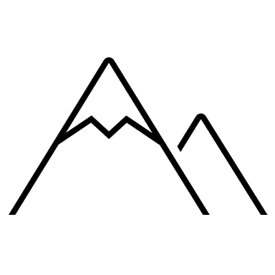
#
Year 1 – Our School

Skills covered this half term:
- Name and give examples of some of the key features of their local area.
- Use observational skills to sort physical and human features using aerial photographs.
- Construct a map of the classroom using fieldwork observations.
- Use and recognise some basic map symbols and begin to understand how these can be used in a key.
Your ideas:

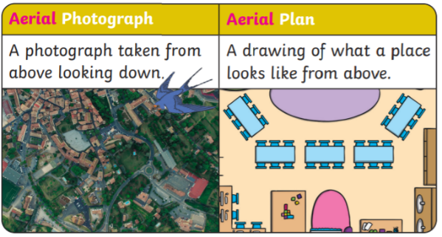
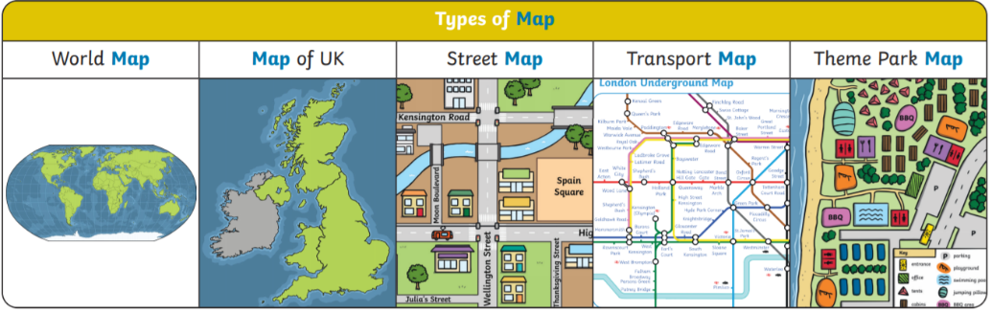

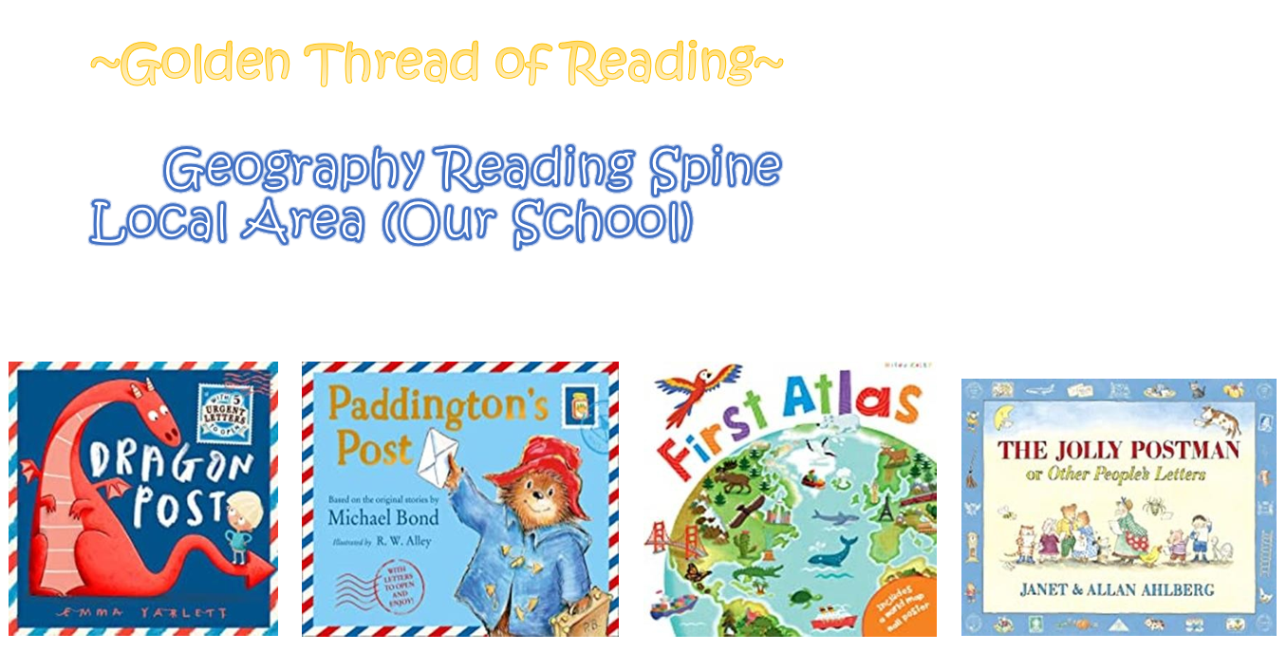
Hamilton Road,
Windle,
St Helens,
WA10 6HG

kkk

