**Year 2**

**Kenya**

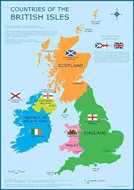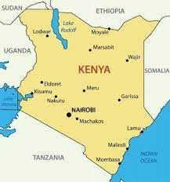

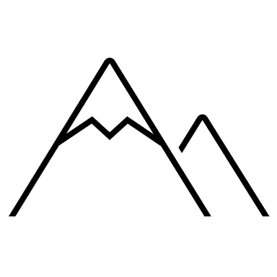



|  |  |  |  |
| --- | --- | --- | --- |
| Key Vocabulary | | | |
|  |  |  |  |
|  |  |  |  |



|  |  |  |
| --- | --- | --- |
| Geography | Year 2 | Kenya |



|  |
| --- |
| Skills covered this half term: |
| * To identify and recognise human and physical features of their locality from aerial photographs and relate these to maps (includes using google maps and satellite images). * To be able to use a compass to navigate * To be able to locate Kenya on a world map and relate the concept of north, south, east and west to a map of the world and a globe. * To be able to recognise geographical similarities and differences between their local area and a non-European small area through the analysis of photographs, maps, aerial photographs and film clips. * To be able to compare their lives to those of children in Kenya through observations of film clips, reviews of children’s work/textbooks and consideration of geographical features. * To be able to use basic geographical vocabulary to refer to human and physical features |

**Where is Kenya?**

* Located in east Africa.
* Population of around 44 million.
* The capital city is Nairobi.
* Mombasa, situated on the coast, is one of Kenya’s largest cities.
* The Tana river is the longest river in Kenya.
* Mount Kenya is the highest mountain (5200m).
* Kenya’s coastline is on the Indian Ocean.
* Swahili and English are the official languages.

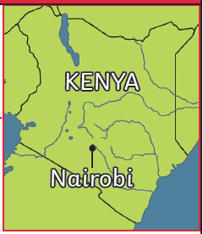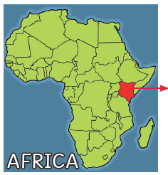

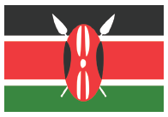

**Weather and Climate**

* Kenya lies on the equator.
* Hot, dry deserts in the north.
* The highlands are cool.
* Climate is hot, sunny and dry for most of the year.
* Hot and humid in the west.
* Mount Kenya is high enough to be covered in snow all year round.

**The Maasai Tribe**

* Maasai people traditional live in mud huts made from mud, sticks, grass and cow dung.
* Many Maasai are farmers and own large herds of cows, goats and sheep.
* The Maasai people love music and dance. They often sign and dance and the men perform a special dance with lots of jumping.

**Game Parks and Reserves**

* There are over 50 national parks and game reserves.
* The include different types of wildlife and habitats including wetlands, grasslands, forest and savannah.
* The Maasai Mara National Reserve is one of the most popular reserves for tourists to visit.
* Millions of tourists visit the reserve to go on safari, explore the landscape and to see the amazing wildlife including the ‘Big Five’.
* The big five: African lion, African elephant, Cape buffalo, African leopard, White/black rhino.
* Each year, visitors come to watch the huge migration of wildebeest.
* Some animals in Kenya are endangered and are protected within the park and reserves.

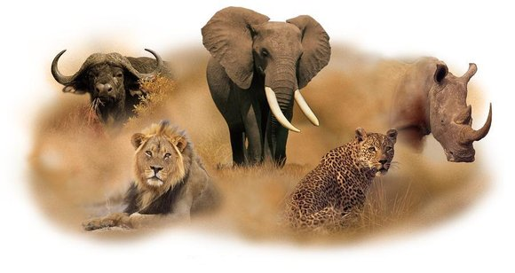

**Facts about school life**

Most children in Kenya go to school, but not all of them.

• Some children, especially in ruralareas, are too busy helping their families by working on the farm, cooking or fetching water.

• At school, some children may be different ages but in the same year group.

|  |  |
| --- | --- |
| Key Vocabulary | |
| Endangered | A species of animal or plant that is at risk of becoming extinct (no longer existing). |
| Game reserve | A protected area of land where humans are allowed to live and carry out some different activities. |
| Habitat | The natural home of a plant or animal. |
| Migration | When animals move from one area to another, often to find food, water or shelter. |
| National park | A protected area of land where only tourism and research is allowed. No humans live there. |
| Rural | Areas away from towns or cities, also known as the countryside. |
| Savannah | Tropical grasslands with shrubs and trees but not much rainfall. |
| Tourists | People who travel for fun. |

