Year 3
The UK

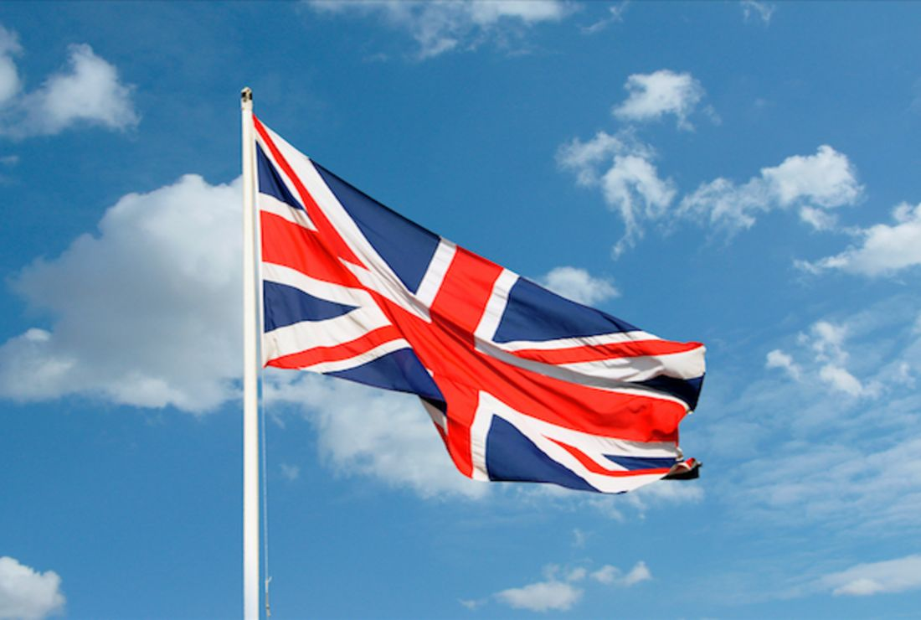

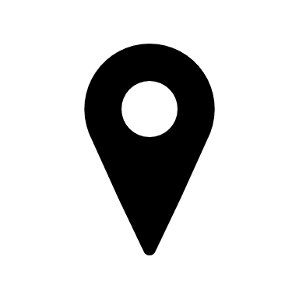

Key vocabulary

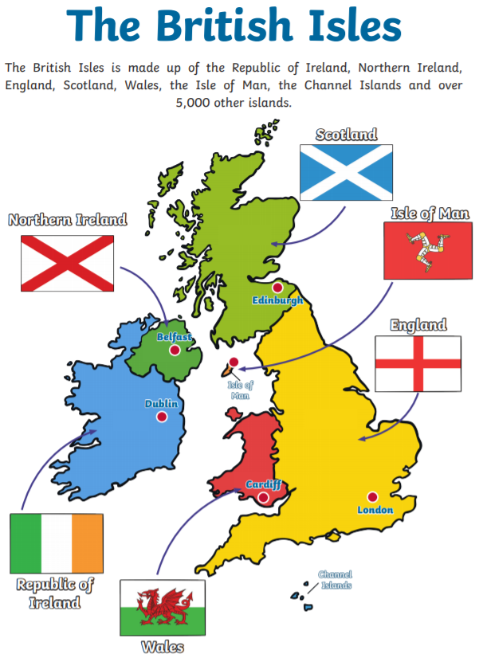
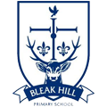
Geography | Year 3 | The UK
Skills covered this half term:
- Use maps, atlases, globes and digital/computer mapping to locate countries and describe features studied
- Use the 8 point compass points to describe a location relative to another place.
- Use a legend to find areas of higher ground on a map
- Use the eight points of a compass
- Interpret symbols and keys to develop knowledge of the United Kingdom
- use fieldwork to observe, measure, record and present the human and physical
- features in the local area using a range of methods, including sketch maps, plans and graphs, and digital technologies
Key Vocabulary
Country | A nation with its own government occupying a particular space.
County | A division of England/ Wales and formerly also of Scotland and Northern Ireland.
City | A large human settlement.
Town | A built up area with a name, local government that is larger than a village but smaller than a city.
Village | A group of houses and associated buildings, larger than a hamlet and smaller than a town, situated in a rural area.
Rural | Countryside.
Urban | An urban area is the area surrounding a city, they are usually very developed and can also refer to towns, cities and suburbs.
Prime meridian | The starting point for measuring distance both east and west around the Earth.
Compass | An instrument containing a magnetised pointer which shows the direction of magnetic north and bearings of it.
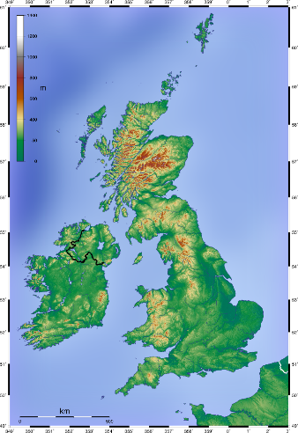
London!

London is the capital and largest city of England and the United Kingdom. The city stands on the River Thames in southeast England, at the head of its 50-mile (80 km) estuary leading to the North Sea. London has been a major settlement for two millennia. The City of London, London's ancient core and financial centre, was founded by the Romans and originally called Londinium.
The colours show the different heights of the ground above sea level. Green areas are the lowest and red areas are the highest.
