.
Year 4
North America

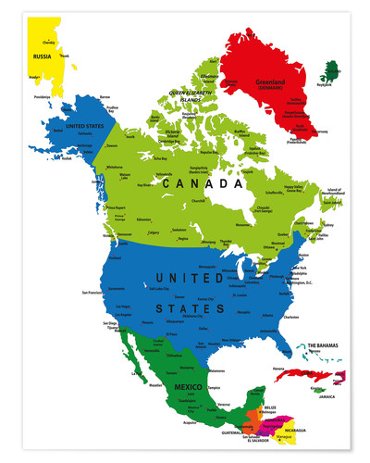

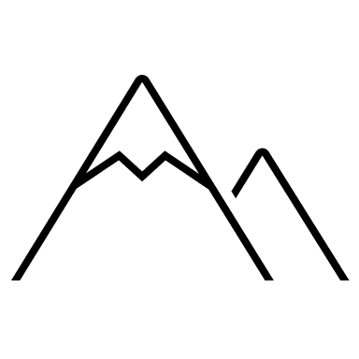
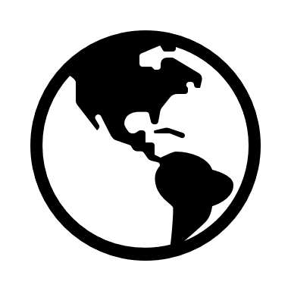

Key Vocabulary

Key Vocabulary
State | An organised political community.
Territory | an organised division of a country that is not yet admitted to the full rights of a state.
Capital city | A capital city (or capital town or just capital) is a city or town, specified by law or constitution, by the government of a country, or part of a country, such as a state, province or county. It usually serves as the location of the government's central meeting place and offices.
Time zone | A time zone is an area that observes a uniform standard time for legal, commercial and social purposes.
Biome | Biomes are areas of our planet with similar climates, landscapes, animals and plants.
Indigenous | Originating or occurring naturally in a particular place – native.
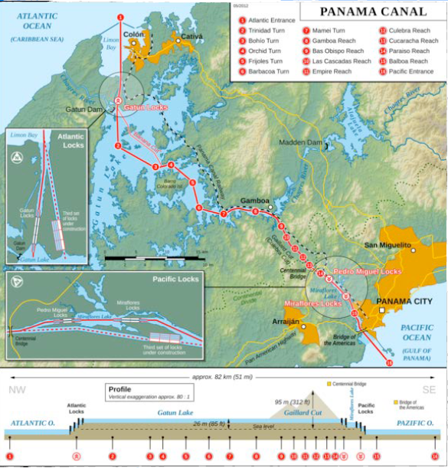
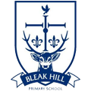
The Panama Canal is a shipping canal that is used to allow cargo ships to cut through Panama instead of having to go around the tip of South America to cross from the Atlantic to the Pacific. It took more than 30 years to build and was officially opened in 1914.

Geography | Year 4 | North America
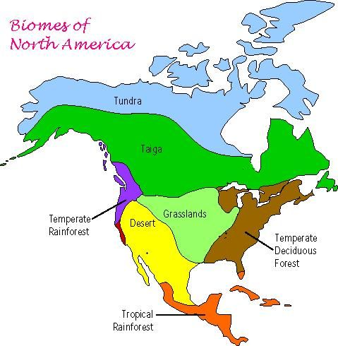
Human and physical features.
The landscape of America varies so much due to its incredible size.

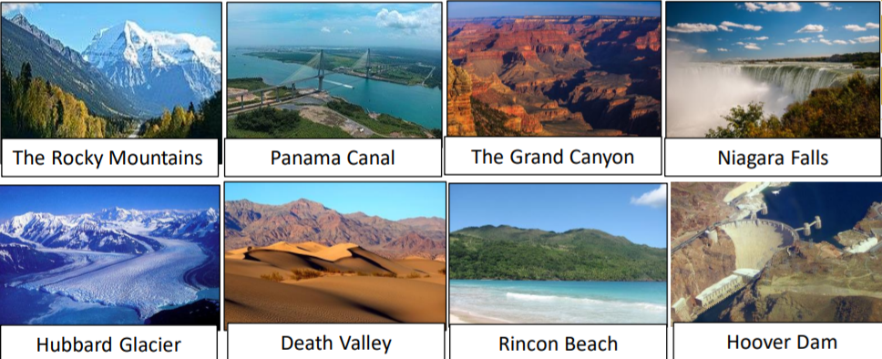

Skills covered this half term:
- Use maps, atlases, globes and digital/computer mapping to locate countries, states and geographically significant land features (including Niagara Falls and the Grand Canyon).
- To use a map scale to understand the significance of the size of Britain compared to the size of the USA.
- To identify flags of countries in North America using an atlas.
- To locate the panama canal on a map and identify its significance to trade to the rest of the world.

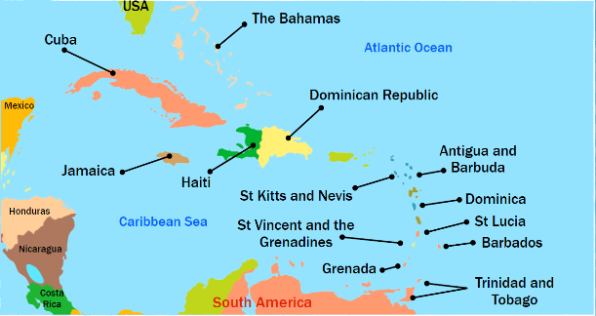
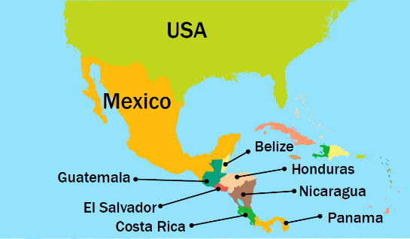
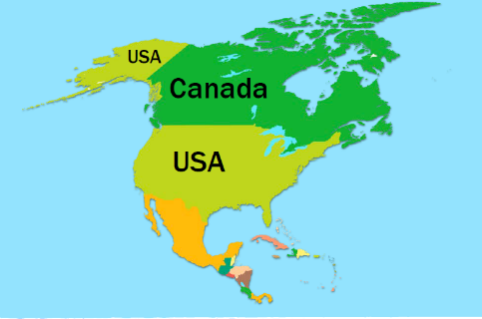
Before the Europeans arrived, the indigenous and native Americans lived in the continent. Today, only about 2% of US Americans consider themselves as descendants from native Americans.

