Year 6
South America

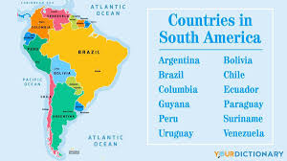

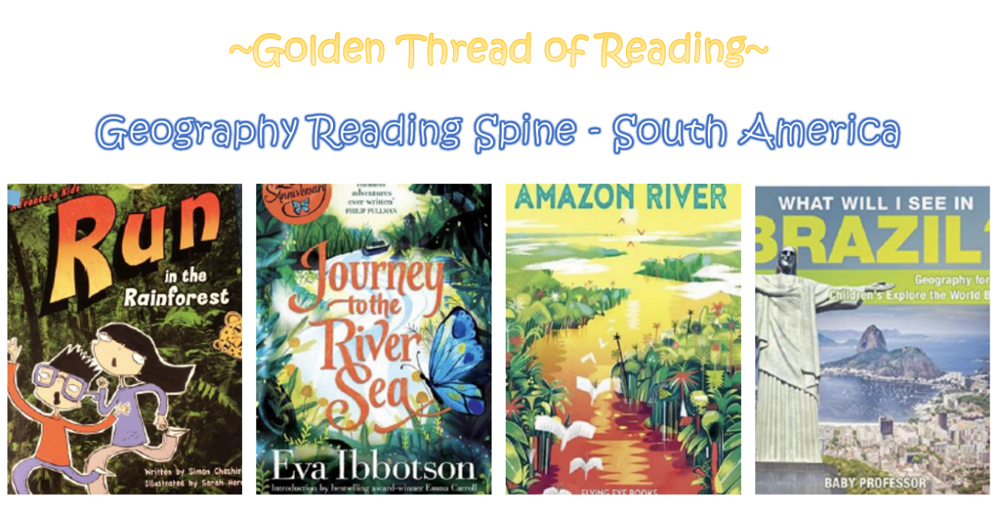

Key Vocabulary

Geography | Year 6 | South America
Key Vocabulary
Trade | The action of buying and selling goods and services.
Location | A particular place or position.
Economics | Information about the production, consumption and transfer of wealth including the condition of a region or group’s material prosperity (wealth).
Climate | The weather conditions in an area in general or over a long period of time.
Import | Bring goods or services into a country from abroad for sale.
Export | Send goods or services to another country for sale.
Culture | The ideas, customs and social behaviours of a particular people or society.
Temperate | A climate zone with mild temperatures.
Sub-tropical | Climate zones bordering on the tropics that are slightly cooler than tropical regions.
Skills covered this half term:
- Use an atlas to identify countries, states and regions of geographical interest.
- understand the necessity of a key and use this to help read maps of increasing complexity.
- Use computer/digital mapping to locate countries and regions, as part of own research to support description of features studied.
- Understands how aspects of the human and physical features of Rio are similar and different to London and the wider UK.
