Year 4
Rivers and the Water Cycle

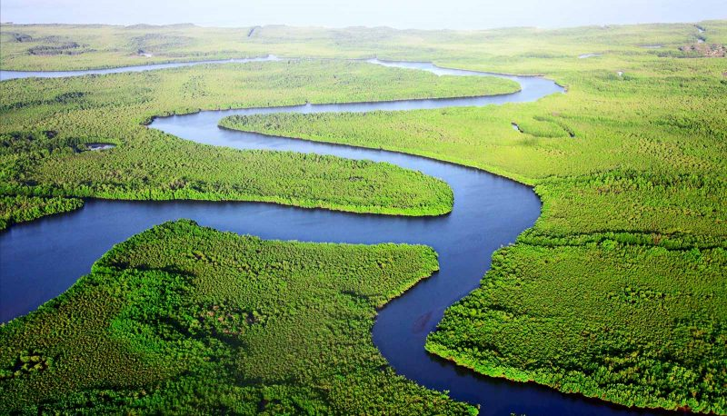

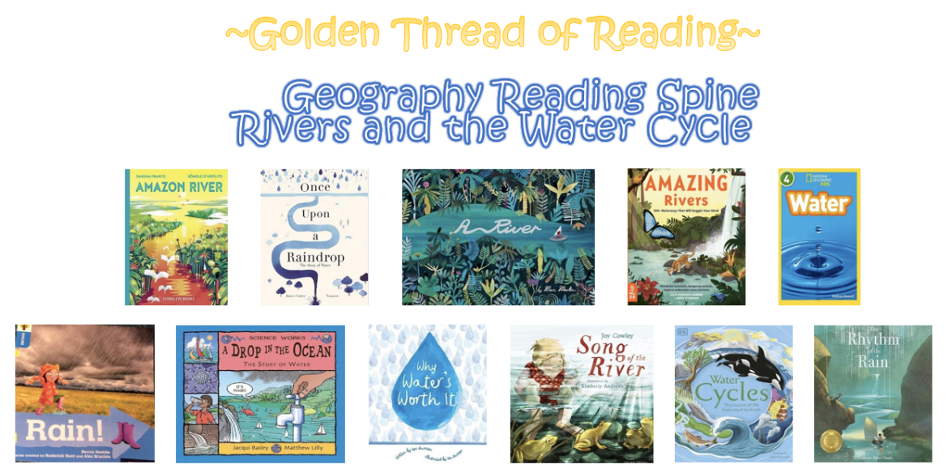

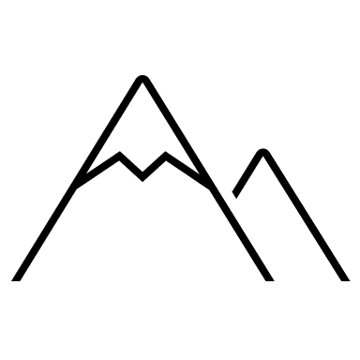

Key Vocabulary

Geography | Year 4 | Rivers and the Water Cycle
Skills covered this half term:
- Explain what a river is and locate the world’s longest rivers on a map, using coordinate grids and referring to map features such as lines of longitude and latitude
- Use fieldwork to observe, measure, record and present the human and physical features in the local area using a range of methods, including sketch maps, plans and graphs, and digital technologies
- Use a compass correctly to map the direction/location of our local canals and the direction water flows in
- Locate local canals on a range of maps, including ordnance survey

Key Vocabulary
Channel | The course in the ground that a river or water flows through.
Dam | A barrier built to hold back water.
Deposition/deposit | When rocks and other materials that have been eroded are dropped off further along the river.
Discharge | The amount of water flowing along a river per second.
Erosion | Rocks and other river materials are picked up by the water and moved to another place along the river.

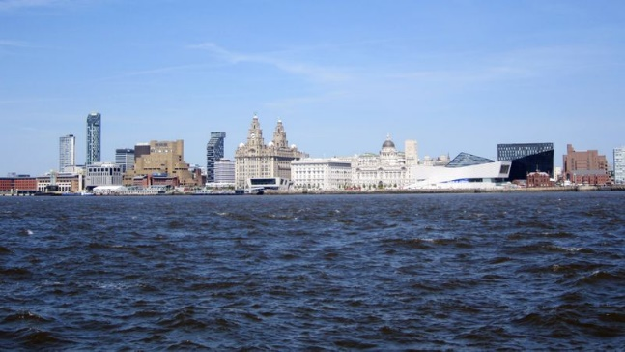

The River Mersey
It is 70 miles (112 km) long, it stretches from Stockport, Greater Manchester, and ends at Liverpool Bay, Merseyside. Water quality in the River Mersey has been severely affected by industrialisation.
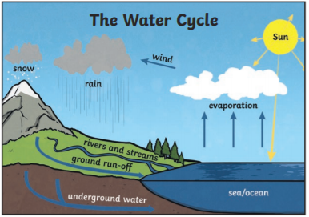
Key Vocabulary
Mouth | The point where a river joins the sea.
Source | The place where a river begins
Tidal bore | A strong tide from the coast that pushes the river against the current causing waves along the river.
Tributaries | Rivers that join up with another river
Valley | A long ditch in the earth’s surface between ranges of hills or mountains

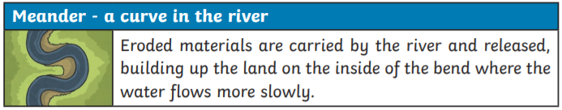
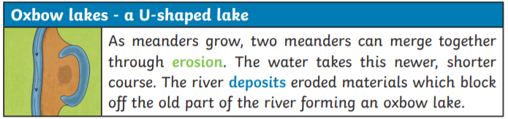

How do we use rivers?

