Year 2
Fieldwork on a local area

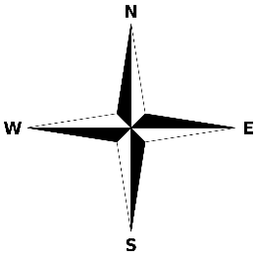

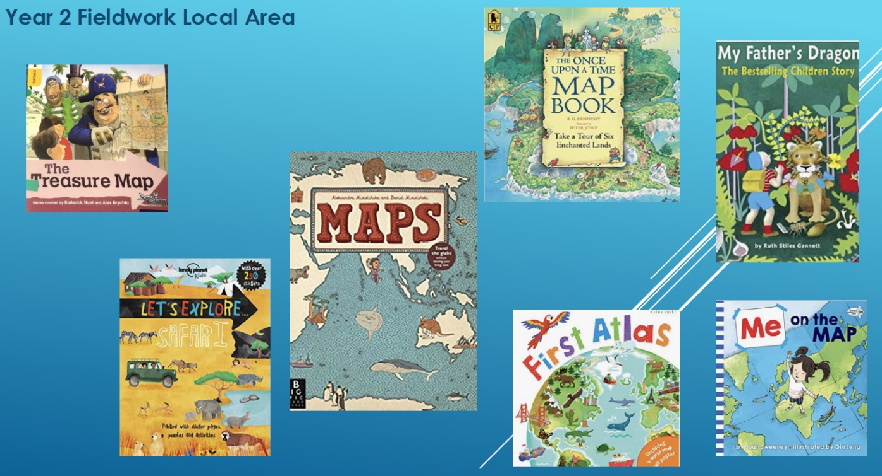

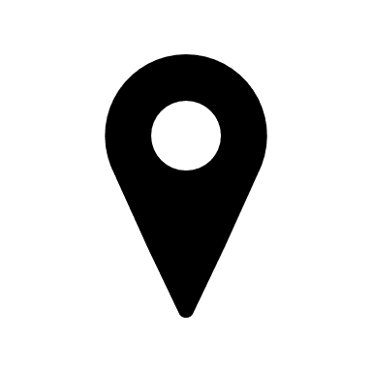
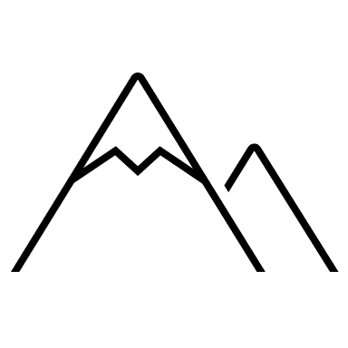

Key Vocabulary

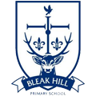
Geography | Year 2 | Fieldwork on a local area
Skills covered this half term:
- Use simple compass directions
- Plot and navigate a simple route on a map (around St Helens).
- Recognise basic map symbols and use these in a key
- Compare the land use of Liverpool to more agricultural places
- Express views about the environment and begin to suggest improvements with reasoning
- Use a growing range of subject specific vocabulary
- Use presentation skills with growing confidence
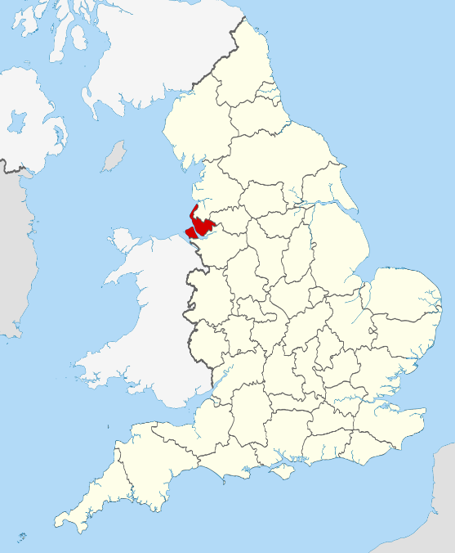
St Helens Borough covers roughly 30 km² (12 sq miles) of soft rolling hills used primarily for agricultural (farming) purposes.
Merseyside is a county in the north west of England.

St Helens is a large town in Merseyside.

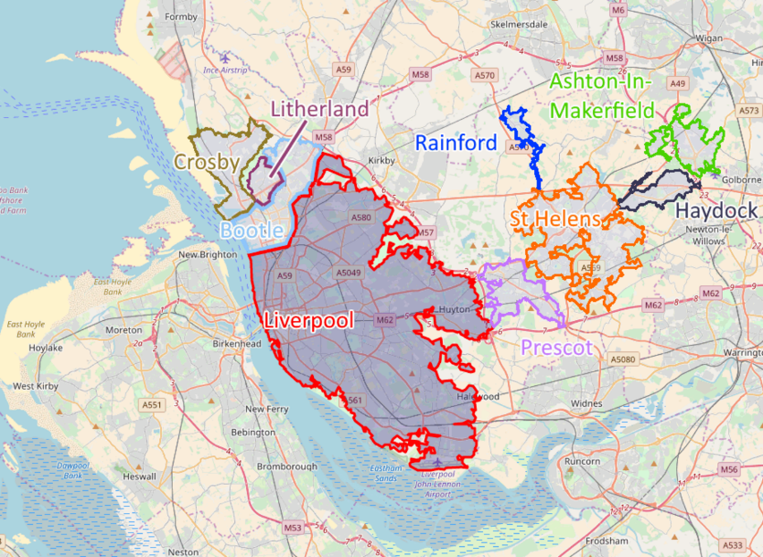
A compass has four main directions: north, east, south and west. Part of the compass (the needle) will always point to the north. You have to work out which direction you are facing depending on which way north is.

Liverpool is a large city in Merseyside.

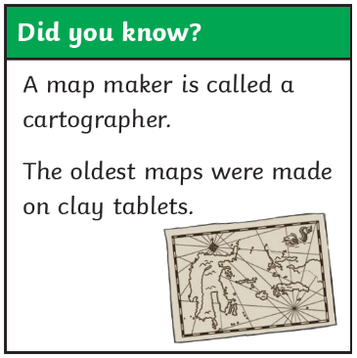
Maps are usually drawn from an aerial view. We can look at aerial photographs to see the main physical and human features of places. Aerial photos are photos taken by aircraft or other flying objects, e.g. drones. A satellite photo is taken from a satellite in space.
Liverpool is the tenth largest English district based on how many people live there.

St Helens developed rapidly in the Industrial Revolution of the 18th and 19th centuries into a significant centre for coal mining and glassmaking.
Liverpool is famous for culture, architecture, transport links.
Liverpool has the second highest number of art galleries, national museums, listed buildings, and listed parks in the UK; only the capital, London, has more.

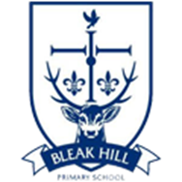

Key Vocabulary
Compass | A special tool that helps you know which direction you are facing.
Compass rose | This is printed on a map to show different directions.
Direction | Where someone or something is pointing or moving.
Fieldwork | Using maps to go out and about to get a practical understanding of something.
Map | A specially drawn picture of a place from above.
Symbol | A picture that represents a group of words. They are used on maps to make things clear and easier to find.
Town | A human settlement, bigger than a village but smaller than a city.
City | A very large town.
Countryside | A rural area with agricultural (farming) land.
Key | Helps us to understand map symbols. Also known as a legend.
Route | A way of getting from start to finish.
Ordnance survey | A survey organisation in the UK which prepares very detailed maps of the country.
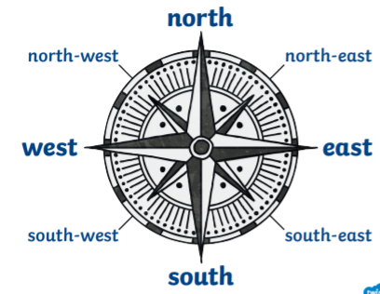
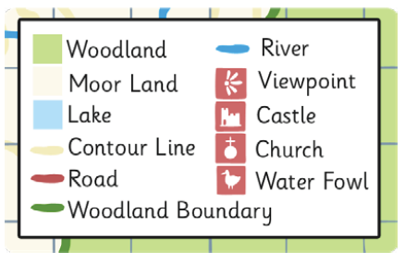
Key features of maps include: a title, a compass rose, symbols, a key and different colours for important things such as green for forests and blue for rivers.

