~Golden Thread of Reading~
Geography Reading Spine
Seven Continents and Five Oceans

Year 2
Seven Continents and Five Oceans

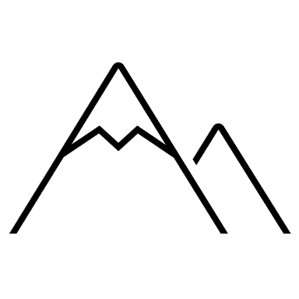

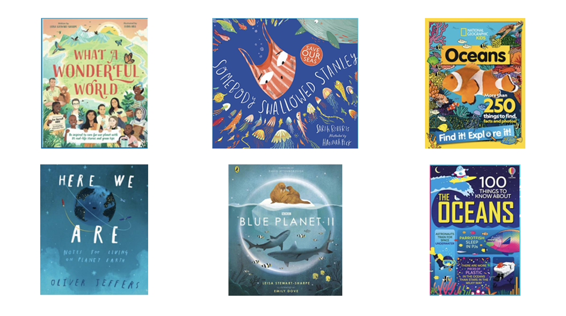

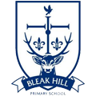
Geography | Year 2 | Seven Continents and Five Oceans
Skills covered this half term:
- Use world maps, atlases and globes to identify the locations of the United Kingdom and its countries, continents and oceans of the world
- Make comparisons between different continents and oceans (animals, temperature, clothing, jobs, houses)
- Use basic geographical vocabulary e.g. north, south, east and west
- Research and write facts about a country, continent and ocean
Seven Continents

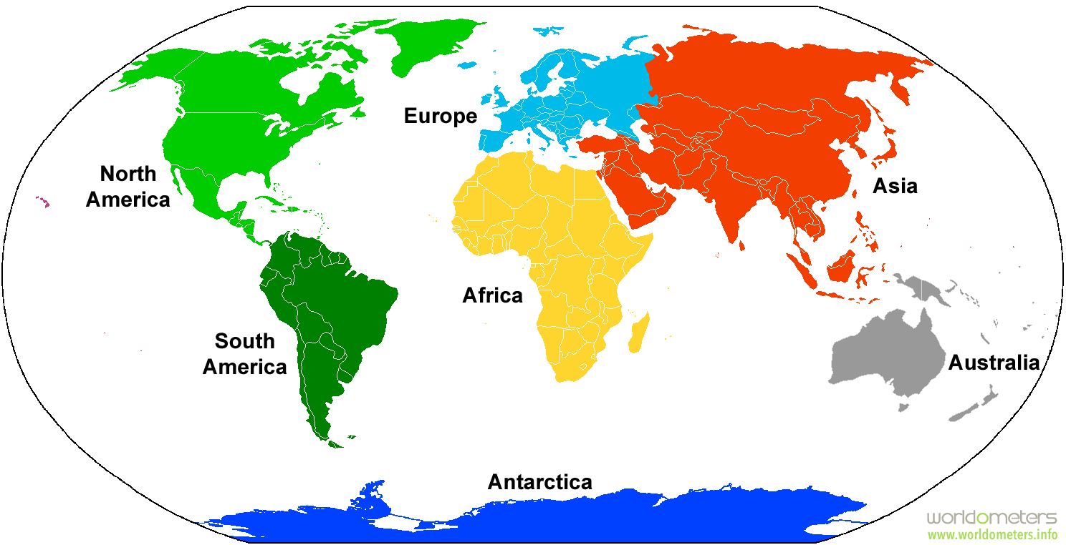
Five Oceans

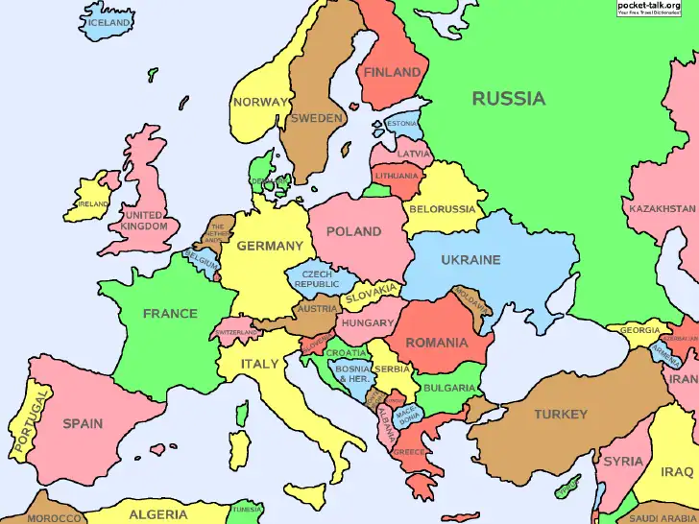
Europe

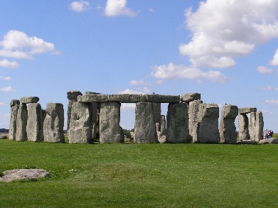
Europe is the second smallest continent.

Europe has many famous landmarks, including Stonehenge in England, the Matterhorn in Switzerland and the Eiffel Tower in France.
It has around 44 countries, including England.

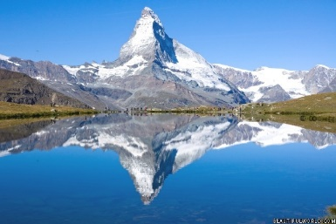
About 740 million people live in Europe.

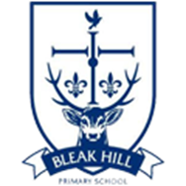
Key Vocabulary
Continent | A very large area of land that includes all the islands with it.
Ocean | A large area of sea.
Population | The number of people that live in a particular place
Landmark | A well-known building or place.
Australasia | The continent of Australasia is often referred to as just Australia. It has about 28 countries and island groups.
Desert | A large area of land that has very little rainfall and where not much grows.
Rainforest | A large area of land with lots of tall trees and plenty of rainfall.

