Year 5
Climate Zones and Tectonic Plates

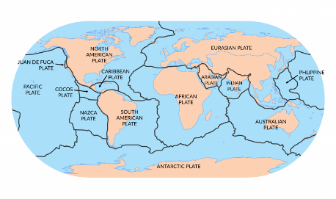

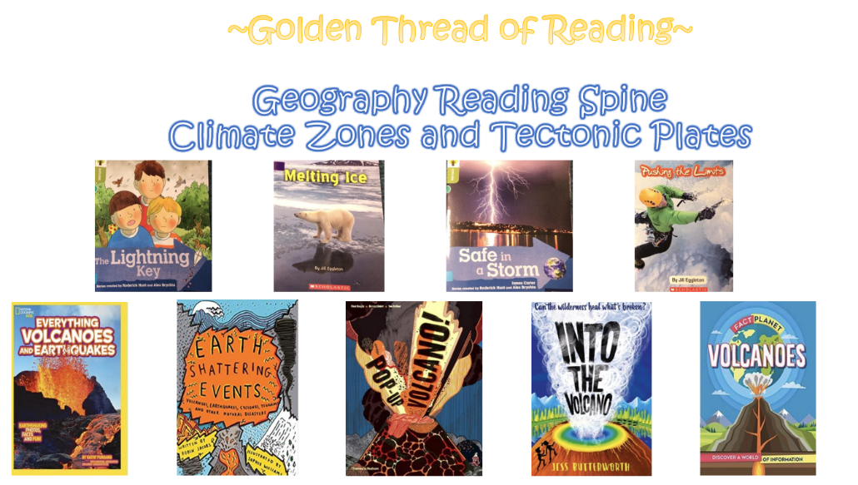

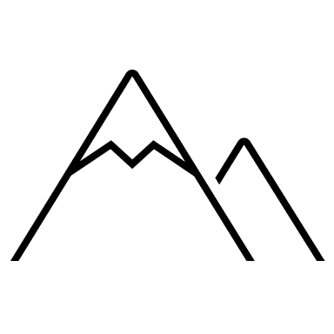
Key vocabulary

Geography | Year 5 | Climate Zones and Tectonic Plates
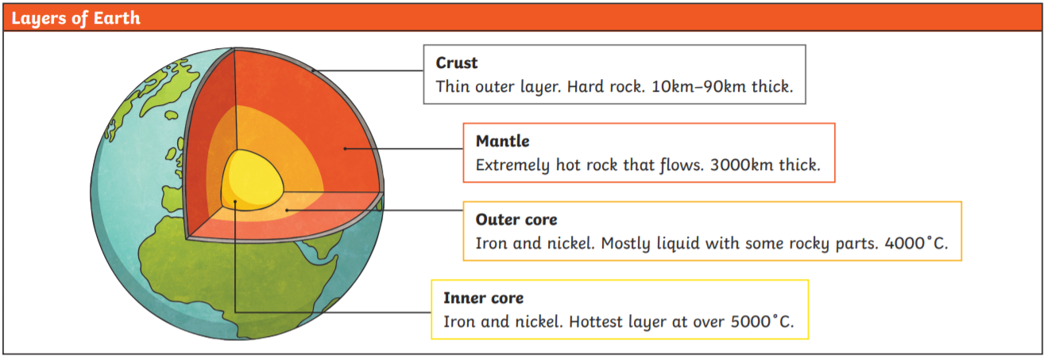
Skills covered this half term:
- Use ordnance survey resources verify predications about the climate in a specific location according to its geographical location
- Label the different climate zones and biomes around the world using geographical knowledge to identify which countries are in which zones/biomes.
- Use atlases to identify where the Andes and other mountain ranges are and predicted what their climate will be
- Compare and contrast the two ways of measuring earthquakes - the Richter and Mercalli scales
- Identify and describe which countries are most likely to experience earthquakes based on their geographical location
- Make connections between their geographical understanding and their knowledge of scientific changes of state
- To give the location of places of geographical interest (including those represented by maps with symbols) using four and six- figure grid references
Key Vocabulary
Cumulonimbus cloud | Large thunderstorm clouds.
Erupt | To suddenly burst out causing lava to explode out of the earth’s surface.
Fossils | The remains of plants or animals that lived a long time ago which can be found deep in the earth.
Magma | Extremely hot, liquid rock.
Tectonic Plates | The earth’s crust is made up of large areas called tectonic plates that join together
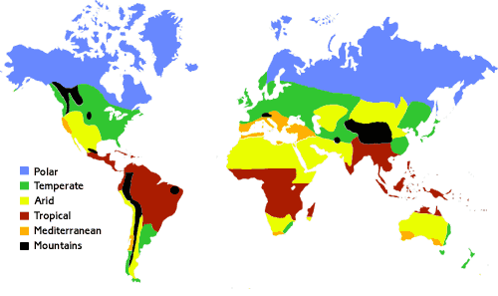
1. Tropical - Around the Equator we have tropical climates which are hot and humid, this is where you’ll find the world’s rainforests.
2. Arid - Dry climates – like you’d find in deserts.
3. Mediterranean - Hot dry summers, and cooler wetter winters.
4. Temperate - What we have in the UK, where summers are mild and winters aren’t too cold.
5. Continental - In areas that are a very long way from the sea, the climate is continental with long, cold winters and short, hot summers.
6. Polar - Experience long periods of extreme cold

Volcanoes are made when pressure builds up inside the earth. This affects the earth’s crust causing magma to sometimes erupt through it.  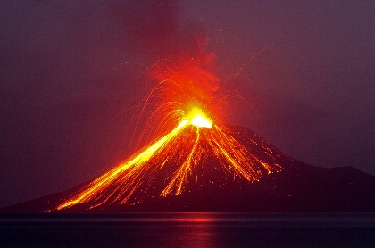  Active volcanoes have erupted in the last 10 000 years.  Dormant volcanoes haven’t erupted in the last 10 000 years but may erupt again.  Extinct volcanoes aren’t expected to erupt again. | A tornado is a swirling funnel of air that forms when warm air rises from near the ground into big cumulonimbus clouds.  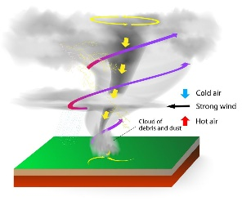  There can be thunder and lightning at the same time.  You can see tornadoes due to the dust and water droplets caught in the clouds.  Storm chasers are film makers and scientists who head towards the storms. They film the tornadoes and collect data about them.  Most tornadoes happen in Tornado Alley in America – more than 500 each year.  Tornadoes can happen in the UK but only around 30 per year.
A tsunami is a giant wave caused by a huge earthquake under the ocean.  The earthquake causes a large amount of water to be displaced very quickly causing a series of waves.  As the waves travel through shallower water near land, they get bigger and bigger. The wave crashes onto the land causing devastation to buildings and sometimes even lives.  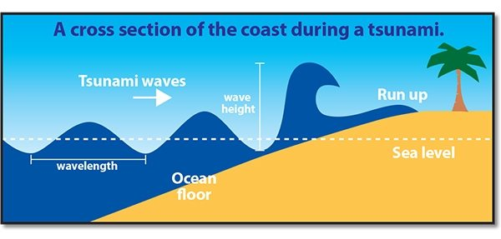 | Earthquakes are caused when the earth’s tectonic plates suddenly move.  Most earthquakes occur near the tectonic plate boundaries.  Earthquakes can cause lots of damage to roads, buildings and property.  