Year 5
Enough for Everyone

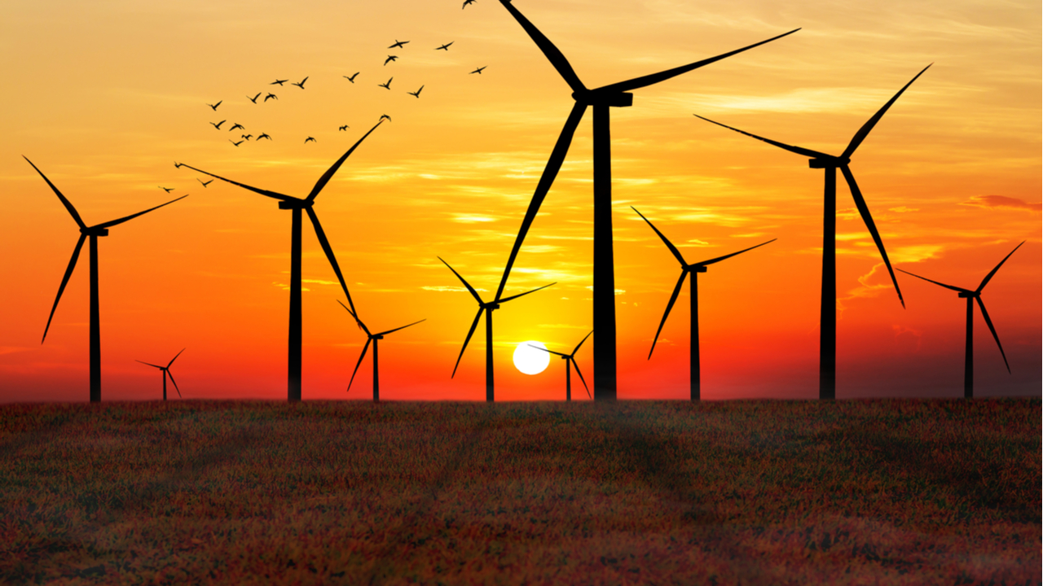

Key vocabulary

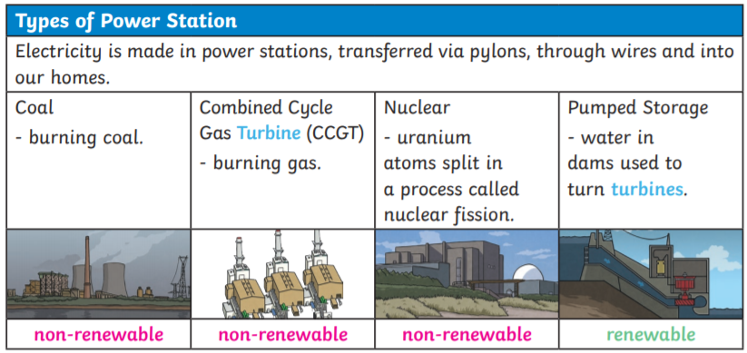
Geography | Year 5 | Enough for everyone
Skills covered this half term:
• Identify important features of a settlement site.
• Rank human needs by importance to me.
• Tell you the main stages of electricity distribution.
• Use an atlas to locate a given place.
• Label a map using a key.
• Identify what makes an energy source renewable.
• Find the country or town of origin on a food label.
• List some foods that are produced in the UK.
• Tell you what food miles are.
• Identify ways to reduce food wastage.
• Tell you that food shortages are a global problem.
• Tell you about the causes of food shortages in a country in South or Central America.
• Reflect on my own role in reducing resource shortages around the world.
Key Vocabulary
Conserve | Use as few resources as possible.
Consume | To use, eat or drink something.
Fertile land | Land that is rich in nutrients and very good for growing crops
Food miles | The distance an item has travelled from where it was produced to where it was consumed.
Import | Buying products and goods from abroad.

Key Vocabulary
Non-renewable energy | A source of energy that will eventually run out as it cannot be made as quickly as it is consumed, such as coal.
Produced | Where something was made.
Renewable energy | Renewable energy is created by resources that nature can replace, such as wind, water and sunlight.
Solar energy | Energy that comes from the sun, using solar panels to generate electricity.
Turbine | An engine that can turn movement into energy.

Where does our food come from?
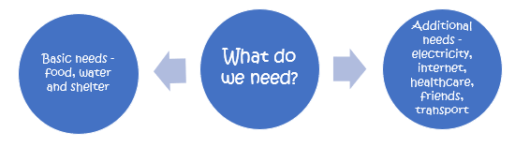
Our food comes from all over the world. How far our food has travelled is called food miles. The further our food travels from where it is produced, the more CO2 is likely to be released, contributing to climate change.

However, there are many benefits of importing food:
- More variety which supports a healthy diet
- Boosts foreign economies by providing a market for foreign farmers
- Protects against possible poor harvests
- Supermarkets can negotiate lower prices
- Foods that only grow seasonally in the UK are available all year round

For the very first settlers, finding the right place to settle was essential for survival, their four main areas of need were:

Site: flat ground, easy to defend
Links: transport links
Resources: food and water supply, woods nearby for food and materials, fertile land.
Aspect: sheltered from weather

