Year 5
Marvellous Maps

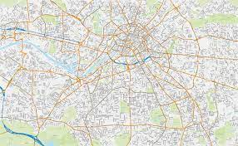

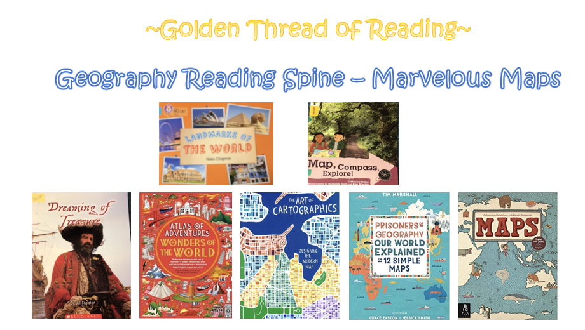

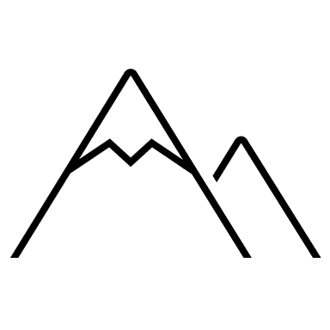
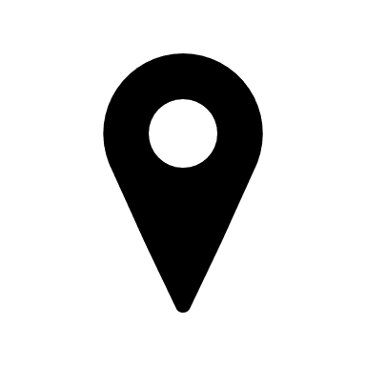

Key vocabulary

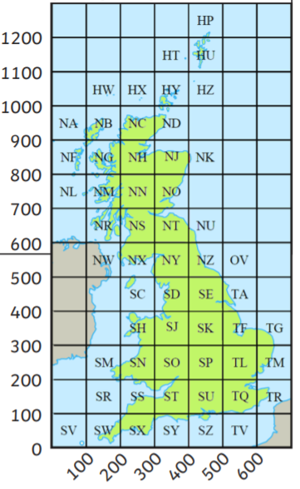
Geography | Year 5 | Marvellous Maps
The National Grid is a grid reference system for the whole of Great Britain. It splits Great Britain into squares - each is 100km. The spaces can be identified by using two letters e.g. SK
A map is criss-crossed with horizontal and vertical lines that create a grid.
Skills covered this half term:
- Locate and name key lines of latitude and longitude on a map
- Use the eight points of a compass to build knowledge of the UK and the wider world on a map.
- Use four and six figure grid references to build knowledge of the UK and wider world
- Use atlas to locate places using latitude and longitude references.
- To use maps, atlases, globes and digital/computer mapping to locate countries and describe features studied.
- Develop an understanding of the concept of different time zones through interpretation of time zone maps.
- Use an atlas and a time zone map to identify the time in certain cities in relation to the UK.

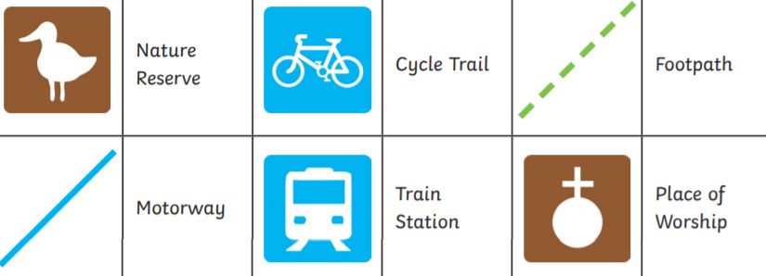
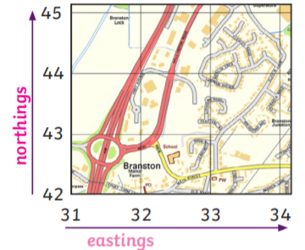
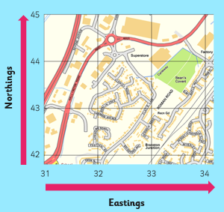
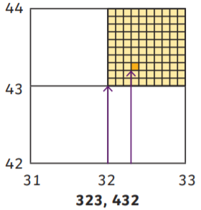
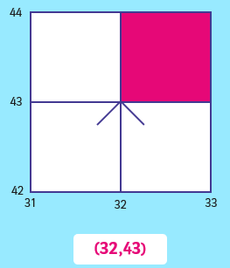
Maps use symbols instead of words to label real-life features.
A key on the map tells you what the symbol means.
These six-digit grid references, e.g. (323,432), tell us more precisely
whereabouts in the square something is.
Grid references can be even more specific by adding an extra digit to
both the easting and northing numbers.
The easting and northing numbers are put together to create a four-digit grid reference, e.g. (32,43), which refers to the bottom left corner of a square on the map.
The grid and squares help to narrow a search area so you can locate
features on a map.

Key Vocabulary
Atlas | A collection of maps often of each country in the world.
Compass | A tool used for showing direction.
Digital map | A map that uses technology such as a satnav.
Easting | The numbers used in a grid reference that run west to east.
Grid references | The numbered squares on a map used to locate a place.
National Grid | A system used to split Great Britain into 100km squares.
Northing | The numbers used in a grid reference that run south to north.
Ordnance Survey maps | Detailed maps of Great Britain where each square represents 1km squared (1km²).
Symbols | Small pictures, letters or lines that represent a feature.

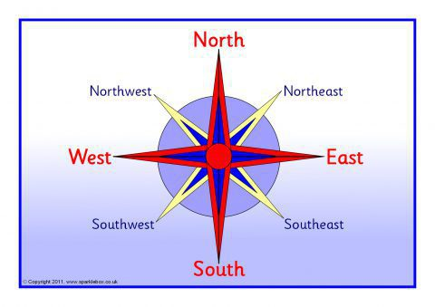
Four- Point Compass
N - north
E - east
S - south
W - west
Eight-Point Compass
north (N) north-east (NE) east (E) south-east (SE) south (S) south-west (SW) west (W) north-west (NW)

