Year 6
Trade and Economics

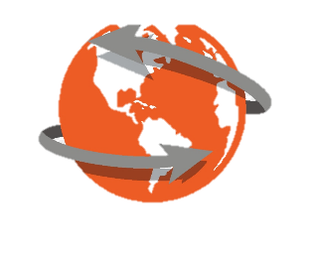

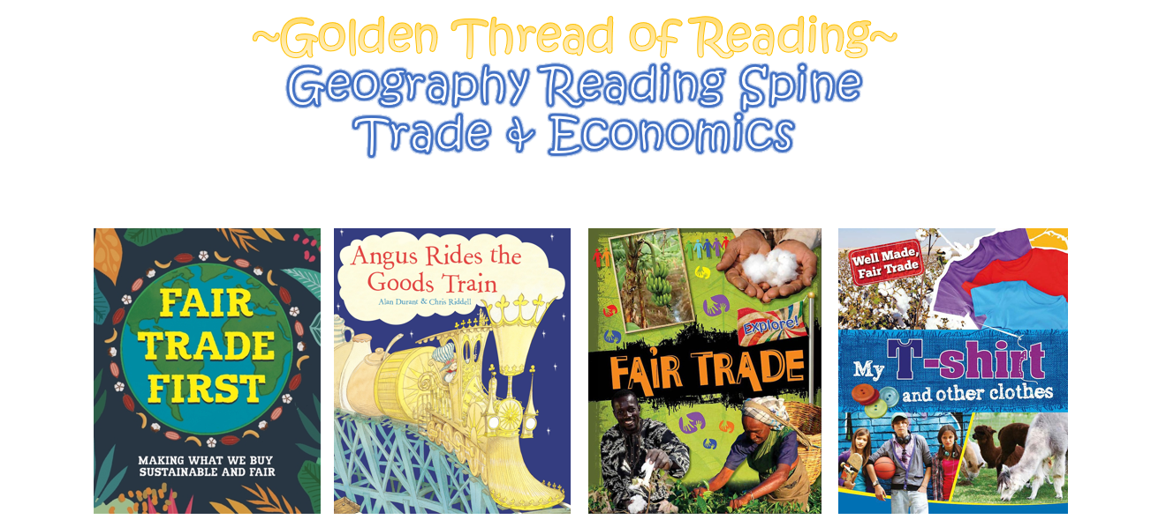

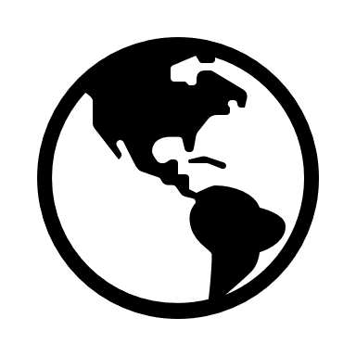

Key Vocabulary

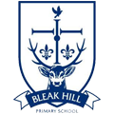
Geography | Year 6 | Trade and Economics
Key Vocabulary
Trade | The action of buying and selling goods and services.
Location | A particular place or position.
Economics | Information about the production, consumption and transfer of wealth including the condition of a region or group’s material prosperity (wealth).
Import | Goods or services purchased from one country and brought into the UK.
Export | Goods or services made in the UK and sold to another country.
Goods | Items that can be bought and sold. Sometimes they are called products.
Global | Around the world.
Skills covered this half term:
- Use an atlas to find countries and locate El Salvador on a map.
- Analyse evidence and draw conclusions; considering the impact and influence on people/everyday life.
- Describe route and direction, location, linking 8 points of a compass to degrees on a compass.
- Reflect on the impact that trade has on an area and generate ideas for cause and effect.
What does the UK trade?

The UK trades a lot of goods and services. Some of the goods the UK exports are: scrap iron, whisky, tartan kilts, medicines, aircraft parts, cars, computers, oil and gas. Some of the goods the UK imports are: coffee beans, bananas, medicines, aircraft parts, cars, computers, oil and gas.

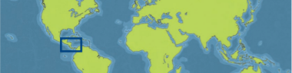
Fair trade exists to make sure that people are not exploited. Look out for the fair-trade logo when buying things so that you know that people have been paid fairly for their work.
The Global Economy

Globalisation has meant that more goods travel around the world before being sold in a shop. Sometimes, parts of the product are made in different countries and assembled in another before being finally sold somewhere else. . Many companies are now recognised worldwide. These are multinational
companies and they can have both a positive and a negative impact on society. Positives may include the creation of new jobs for people. Negatives
may include greater damage to the environment (due to differences in the safety rules and environmental standards of different places).
How has trade changed through history?

Trade has changed a lot through history. This is partly due to developments in transportation but also due to the changing relationships of the UK with other countries. In Tudor times, the UK traded with the Americas, whereas in Victorian times, the UK mainly traded with other countries who were in the British Empire.

Key Vocabulary
Fair trade | A way of putting goods designed to make sure than the producers of these goods in developing countries are paid a fair and stable price for the goods that we buy from them.
Globalisation | The spread of trade and ideas worldwide.
Global supply chain | The different places a product and its parts come from, and travel to, on its way to the consumer (the person who is buying the product).
Multinational | Something that operates in more than one country. A multinational business is based in more than one country.
Economy | The word used to explain how money is made and spent in a particular area. This could be within a country of across the world.

