Year 6
Our Changing World

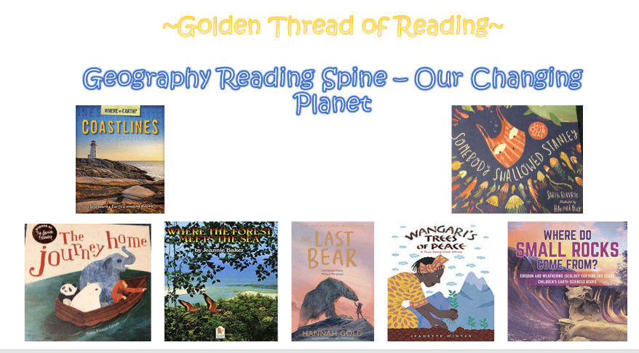

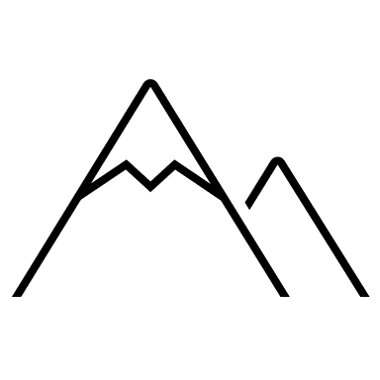

Key Vocabulary

Geography | Year 6 | Our Changing World

Skills covered this half term:
- Identify coastal features of the UK
- Can explain how the make up of the UK has changed over time
- Explain how landscapes change over time
Physical Weathering:

Water gets into cracks into the rock. It can freeze causing the water to expand and create cracks in the rocks.

Biological Weathering:

Caused by animals and plants. Roots can grow under rocks cause damage, animals can wear away paths, dig holes etc.

Many countries and borders across the world have and are still changing due to humans and physical activities.
Why do boundaries change?
Key Vocabulary
Acidic | A chemical substance, usually a liquid, which reacts with other substances to form salts. Some acids burn or dissolves other substances that they come into contact with.
Border/boundary | The outer part or edge of a region or country that divides it from another.
Deposition | When material/sediment is moved and dropped off in a different place.
Dissolve | When a solid substance mixes with a liquid to make a solution.
Erosion | When natural materials are worn away and transported to a different place.
Weathering | The process of wearing away rocks by the weather.

Landscapes can change over time for many different reasons: • New houses/buildings and roads are built • Old buildings are demolished or updated • Areas of land may be cleared for farming or building Some landscapes are important and there are things in place to stop development such as: • Listed buildings • National/country Parks • Green belt/conservation areas • Sites of Special Scientific Interest • World Heritage Sites

Human Political Activity:
Tribes claiming areas of land as their own.
Invasion/ war.
Migration of other settlers.
Royal/political unions

Human Political Activity:
Rising sea levels.
Natural processes and events e.g. changing river courses, volcanic eruptions, glacial shifts.

Weathering and Erosion:
Weathering is the process of wearing away rocks by the weather. There are three different types of weathering:
• physical weathering
• chemical weathering
• biological weathering.
Erosion is where natural materials are worn away and transported by environmental features such as water, wind and ice.

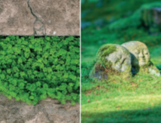
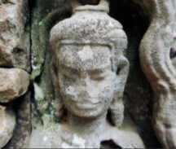
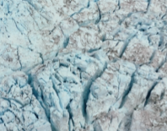
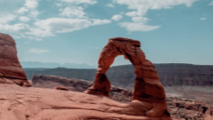
Erosion:

Wind blows loose particles away or into other rocks causing the rocks to be worn away.

Chemical Weathering:

Slightly acidic rainwater can cause a chemical reaction and over time this can dissolve some of the rock.

