Year 3
India

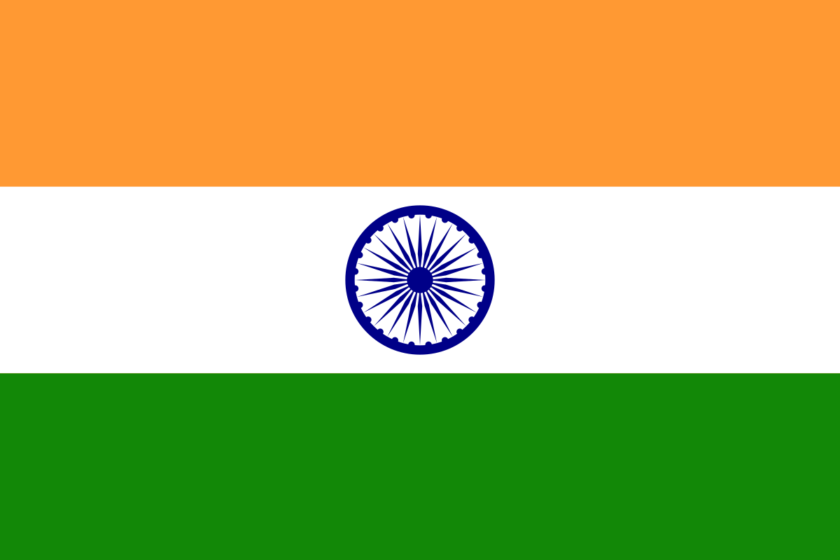

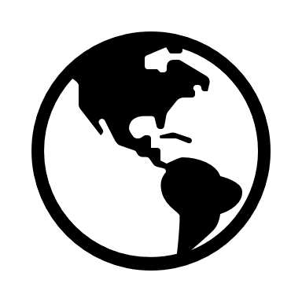
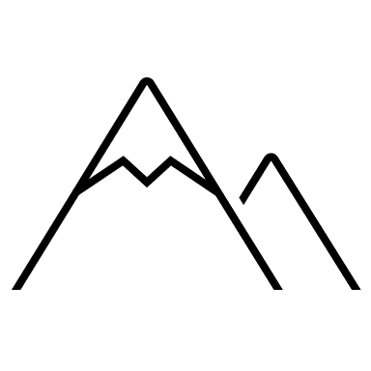

Key vocabulary

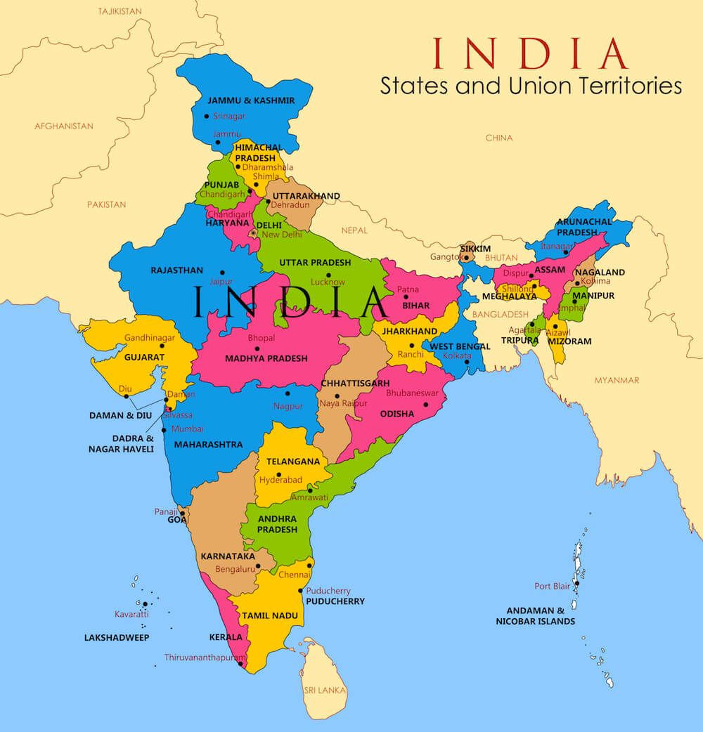
India is bordered to the north by the Himalayan mountains – the highest mountain range in the world.

The Ganges is the longest river that flows through India at 2,601km.

The climate of India varies from place to place, with arid, desert climates in the west, temperate areas in the north and tropical and subtropical regions in the south.
Geography | Year 3 | India
Skills covered this half term:
- Analyse an historic map of the British empire and compare to a presentday map of the world
- compare maps with different scales
- Analyse and draw conclusion from data about India's weather conditions
- Present comparative data about India’s climate alongside that of the UK
- Analyse historical trade maps of the silk road and draw conclusion about the significance of India’s location.
- Use key to make deductions about landscape/ industry/ features etc.
- Locate information/ place from sources with speed and accuracy
Key Vocabulary
Asia | The continent in which India is located.
Indian Ocean | The Ocean that India borders.
Bay of Bengal | The North-eastern part of the Indian Ocean,
New Delhi | The Capital of India
Mumbai | A city located on the West coast of India.
Ganges | The main river that flows through India.
Arabian Sea | The Arabian Sea is a region of the northern Indian Ocean bounded on the north by Pakistan and Iran.

Population = 1.5 billion people

Rupees are the currency used in India. The symbol is ₹.

7th largest country in the world.

New Delhi
It has a population of around 30 million people, making it the second-most populated urban area in the world.
Today, it is an important modern city, with a financial centre filled with business and is a popular location for tourists.

