.
Year 4
Spain and Catalonia

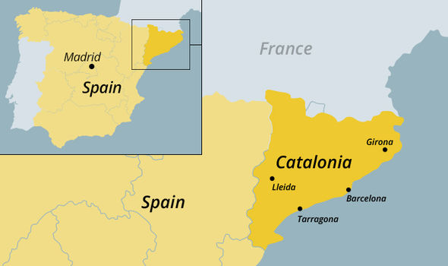

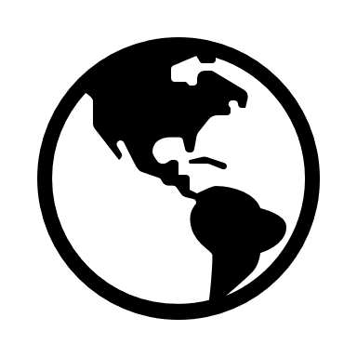

Key Vocabulary

Key Vocabulary
Culture | The traditions and beliefs that a group of people practice in their daily lives.
Capital city | A capital city (or capital town or just capital) is a city or town, specified by law or constitution, by the government of a country, or part of a country, such as a state, province or county. It usually serves as the location of the government's central meeting place and offices.
Climate | The long-term pattern of weather in a particular area.
Autonomous communities | Spain is split into regions called ‘autonomous communities’ which means each region has the autonomy to decide how it is governed.
Tourism | Travel for pleasure or business; the practice of touring, the business of attracting, accommodating, and entertaining tourists,
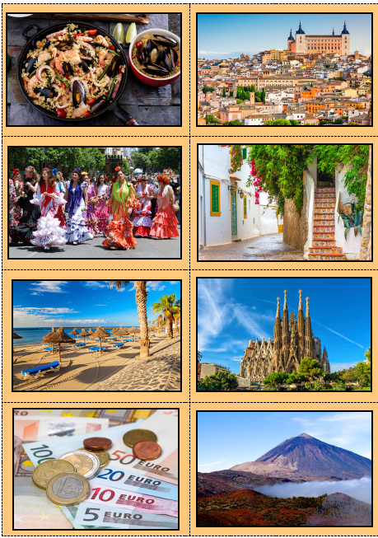
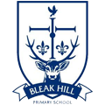
The Pyrenees is a 491km long mountain range that forms a natural border between Spain and France.
Geography | Year 4 | Spain and Catalonia
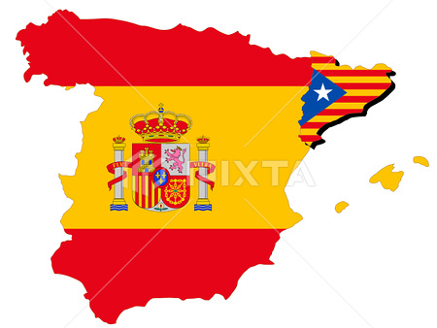
Tourism keeps many of Spain’s traditions alive. Money that tourists spend help local businesses. Facilities are maintained for visitors, which benefits the locals too. Some people think that foreign themed bards are contributing to Spain’s culture being lost.

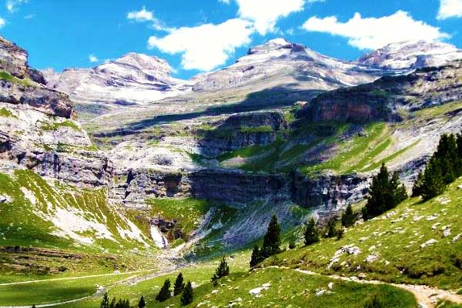

Catalonia is a region in Spain, it has two main languages and is home to approx. 7.5 million people.
Catalonia is on the east coast of Spain. Catalonia has its own capital city, flag and government.
Some Catalans want independence from the rest of Spain.

Skills covered this half term:
- Use maps, atlases, globes and digital/computer mapping to locate countries, states and geographically significant land features.
- To use a map scale to understand the significance of the size of Britain compared to the size of the Spain and Catalonia.
- To locate autonomous communities of Spain.

