Skills covered this half term:
- Observe the weather.
- Record observations in a weather diary.
- Describe what weather forecasts show.
- Work cooperatively (with a partner) to present a weather forecast for parts of the UK.
- Use 5 new key words to talk about the different types of weather and can explain what these words mean to my partner.
- Begin to locate a hot and cold county on a world map.
- Can research the Arctic with my partner and present facts to class friends.
- Use map skills to locate hot and cold places.
- Locate (find) the Arctic on a world map or a globe.
- Begin to locate other places such as the North Pole, South Pole and Antarctic.
Key Vocabulary
20th Century | The 20th century was between 1900 - 1999
21st Century | We are in the 21st century. It started in 2000 and will end in 2099.
Metal toys
Paper toys | Some toys like paper windmills were made from paper.
Plastic toys | Modern toys such as dolls, soldiers and cars are ade of plastic.
Metal toys | Tin soldiers and model cars were made from metal.
Victorian | The time when Queen Victoria ruled between 1837 and 1901.
Wooden Toys | Lots of toys were made from wood. Toys such as boats, trains, ball and cup and blocks used wood. Some are still made of wood today.
Key Vocabulary
Seasons | The year is divided into four seasons: spring, summer, autumn and winter.
Observations | What you notice when you look carefully at something.
Record | Keep information about something that has happened, e.g. in writing or pictures.
Temperature | A measure of how hot or cold something is.
Thermometer | An instrument used to measure temperature.
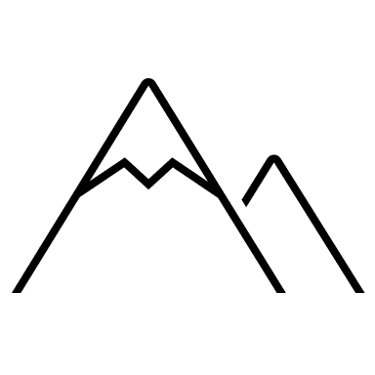
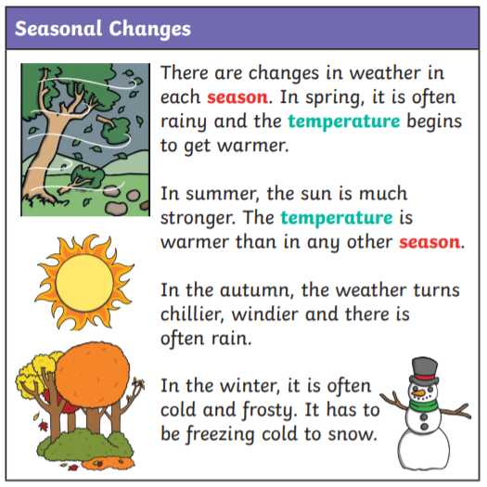
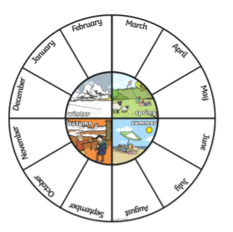
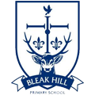
Blizzard
Climate
Hurricane
Flooding
Heatwave
Drought
Your ideas:
Year 1 – Weather Patterns

