Skills covered this half term:
- Use globes, maps and atlases to locate the countries and capital cities of the U.K.
- Use a growing range of subject specific vocabulary.
- Compare geographical features of towns and the countryside using their existing observations, maps and photographs.
- Use aerial photographs to begin to locate countries.
- Use basic geographical vocabulary to refer to human and physical features.
Key Vocabulary
20th Century | The 20th century was between 1900 - 1999
21st Century | We are in the 21st century. It started in 2000 and will end in 2099.
Metal toys
Paper toys | Some toys like paper windmills were made from paper.
Plastic toys | Modern toys such as dolls, soldiers and cars are ade of plastic.
Metal toys | Tin soldiers and model cars were made from metal.
Victorian | The time when Queen Victoria ruled between 1837 and 1901.
Wooden Toys | Lots of toys were made from wood. Toys such as boats, trains, ball and cup and blocks used wood. Some are still made of wood today.
Key Vocabulary
Countryside | Land that is not in towns or cities.
Population | How many people live in one particular place.
Town | A town is a place where people live and work.
Country | An area of land with its own government, rules and borders.
Island | An area of land surrounded by water.
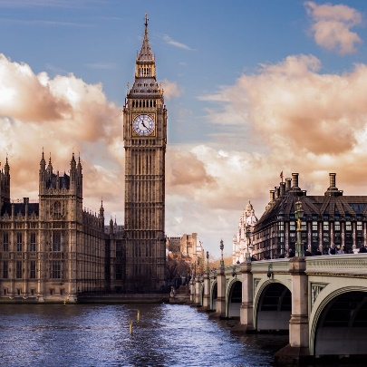
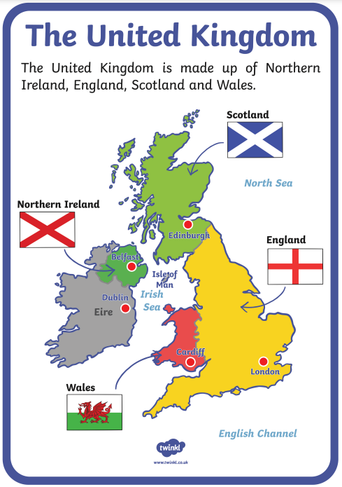
London – The Capital City of England
London is a very busy and built-up city with lots of important buildings.
London has lots of famous landmarks. These include the London Eye, Big Ben, the Houses of Parliament, Tower Bridge and Westminster Abbey.
Your ideas:
Year 1 – UK Our Country

