Out of School Club – September 2023 onwards

The Governing Body have agreed that from the 5th September 2023 all out of school club bookings must be paid in advance of the place being taken. There will be no option to reserve and pay later. This is in line with many other schools across the borough.

What this means for you:

Debit/Credit Card Payments: On booking a session you will be required to make payment via your debit/credit card at the time of booking. Alternatively, parents may choose to add credit via the club top up on their child(ren) account. You will then be able to use this credit when making bookings.

Childcare Vouchers: In order to book sessions, parents will need to ensure that their child(ren) account is in credit. In order to do this we are asking parents to send additional voucher payments to ensure your child(ren) is in credit for September 2023. This will mean your child(ren) account will be in credit when returning in September. We must stress that your child(ren) account will need to be in credit to book places using childcare vouchers and if this is not the case you will be required to pay by debit/credit card at the time of booking.

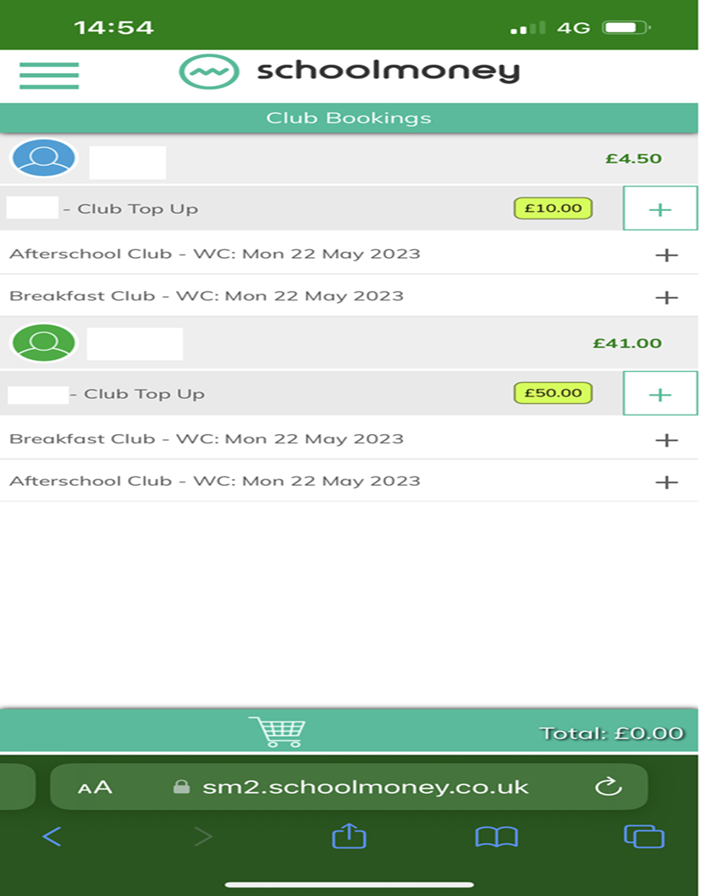
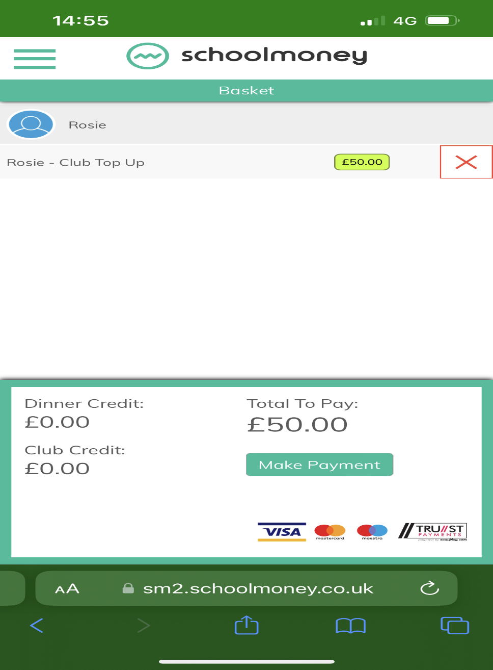
You can overtype this to suit an amount you wish to add to your child’s account
Your child’s name will be displayed here

NB - This is what credit balance will look like
NB - This is what credit balance will look like

Emergency On the Day Bookings: Parents will need to contact the school office to book emergency childcare places. If your child(ren) account is not in credit, the office will process payment via the phone to secure your child(ren) booking, subject to a place being available.

Please note:

- If you choose to collect to your child(ren) early from club the full cost of the session booked will still stand.

- If you collect your child(ren) later than the session booked, the additional charge will be processed by Out of School Club Supervisor on collection.

